3
Characteristics of the Victims
This is a template for what a chapter should look like. Note that we will use “styles” and each paragraph has its own style. Firstparagraph is like this one right here; it has no indentation and follows a major header.
Regular paragraphs have Normal2 as the style; double-spaced, indented.
When we get to a table, we create the table as follows, with all but the note to the table clicked on the tab “keep with following” so that it automatically all stays on the same page. Use the “normal” style to get it to be single-spaced, not indented, etc. When we want to cite something, we can say Snell (2014) and make sure that is in the list of references.
Table 3.1 Template for a table.
Topic | Column1 | More data here | More data here
Tables are 6.5 inches wide | These columns are justified lower-right
Left column is justified lower-left
Total N
Total % | 100.00 | 100.00 | 100.00
Note: Explain whatever needs to be explained here, also using “normal” as the style.

Follow with the next paragraph, and then let’s insert a figure.
Figure 3.1 this is a cool graph I think.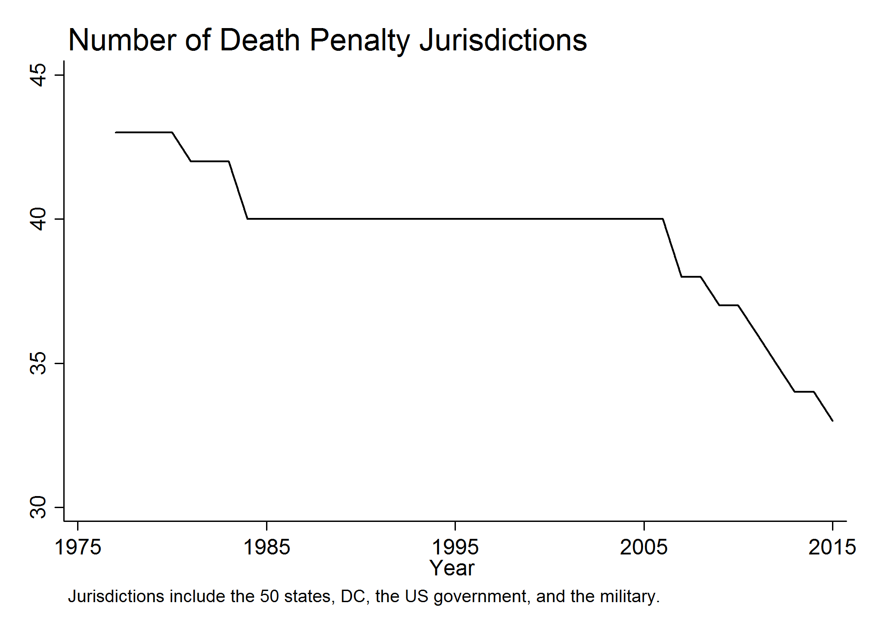
Note: The graph is 6.5 inches wide as well, and is just a PNG file dropped in. All graphs have a Title line and a Note. The Note explains what the graph is, for example where the data come from. Note that we will be updating these and when we finalize the list of tables and graphs we will want the PNG, DTA, and DO files all collected with names that look like this: Fig3-1-number-of-jurisdictions.do.

Now we go back to the main text.

We use Heading 1 to make major section breaks
These are followed by Firstparagraph, which does not indent
Regular text

Second-level (B) header
First paragraph again
The reason we want these things is that we can use the “outline view” in word to see just the outline of the entire chapter this way.

Section Three goes here
Great idea to just put in place-holders for topics that are not ready to go yet, but where we know that we are going to have to add a section. Just say “to be completed” or something like that. Then we know what the overall structure of the chapter will be, and how many missing pieces there are.

References
References go in Biblio2 style and you should keep them for each chapter but we will revise and combine into a single set of references at the end. Use this format:
Radelet, Michael L. 1989. Executions of Whites for Crimes against Blacks: Exceptions to the Rule? The Sociological Quarterly 30, 4: 529–544.
Blume, John H. 2005. Killing the Willing: “Volunteers,” Suicide and Competency. Michigan Law Review 103: 939–1009.
Snell, Tracy L. 2014. Capital Punishment, 2013 – Statistical Tables. US Department of Justice, Bureau of Justice Statistics (December), NCJ 248448, downloaded on August 27, 2015 from http://www.bjs.gov/content/pub/pdf/cp13st.pdf.

We will use footnotes to keep track of questions and comments to ourselves. By the end of the draft chapter, there should hopefully be no footnotes.

