SECOND AND THIRD ADJACENT CHANNEL

INTERFERENCE STUDY OF FM BROADCAST RECEIVERS

------------

Project TRB-99-3
Interim Report

July 19, 1999

Technical Research Branch
Laboratory Division
Office of Engineering and Technology
Federal Communications Commission

OET Report Prepared by:
FCC/OET TRB-99-1 William H. Inglis
July 1999 David L. Means

Project TRB-99-3 JULY 19, 1999

2ND AND 3RD ADJACENT CHANNEL
INTERFERENCE STUDY OF FM BROADCAST RECEIVERS

Interim Report

Executive Summary

This report presents the results of the first phase of a study intended to produce independently developed data for the public record in Mass Media Docket No. 99-25 and other proceedings affecting FM broadcast service. Because of the need to develop some information quickly, this phase of the study is limited in scope to issues of second and third adjacent channel interference performance of analog FM receivers with respect to analog FM interferers. Additionally the study was limited in size to a fairly small sample of 21 receivers. Follow-on work is anticipated to expand the study sample as well as to broaden the scope to include digital interferer issues and investigation of the effectiveness of additional proposed methods to mitigate interference.

Certain conclusions have been drawn concerning the study sample. First, nearly all the receivers in the sample appear to meet or exceed the 40 dB second adjacent channel protection criterion and exceed the third adjacent channel protection criterion by a substantial margin. Further, there appears to be an 8-10 dB improvement in overall interference immunity between the second and third adjacent channels across the sample. Last, investigating the effect of reducing the maximum FM deviation on the interfering signal indicates that a small improvement in immunity can be expected for most receivers to second and third adjacent channel interference.

Background

Currently there are two ongoing proceedings before the Commission involving the future of the FM Broadcast radio service which raise common technical issues requiring objectively gathered data on receiver performance. The first of these is Mass Media Docket No. 99-25 regarding creation of a Low Power Radio Service. A Notice of Proposed Rule Making was released February 3, 1999, requesting comment on a variety of issues, both technical and non-technical, on a proposal to create three new classes of licensed FM broadcast stations: a 1,000-watt ERP primary service, and 100-watt and 1-to-10-watt ERP secondary services. The NPRM proposes that low power FM (LPFM) stations not be subject to certain technical rules currently applied to other classes of radio service. It states that the Commission believes that third adjacent channel spacing restrictions are not required, and seeks comment on whether second adjacent channel restrictions might be disregarded as well. Comment was also requested on whether tightened occupied bandwidth and spectral mask restrictions would be appropriate for LPFM stations to reduce the potential for causing interference.

On October 9, 1998, USA Digital Radio Partners, L. P. (USADR) submitted a Petition for Rule Making requesting that the Commission initiate a rule making proceeding to amend Part 73 to permit the introduction of digital AM and FM radio broadcasting. Comments on the Petition were due December 23, 1998, and reply comments were due January 25, 1999. USADR proposes the introduction of digital signals on the FM band using a technique whereby a station would transmit both its analog signal and two digital signals of lesser amplitude -- one on each side of the existing FM signal -- but within the allowed spectrum mask. Other systems are under development use similar configurations and are commonly called "in-band, on-channel" or IBOC systems. With regard to second adjacent channel interference, USADR states that an analog second adjacent interferer will have a negligible effect on the performance of the digital signal, and that the interference effects of second adjacent channel IBOC signals to FM signals should also be negligible. Regarding third adjacent channel interference, USADR states that digital reception is essentially not susceptible to third adjacent channel interference, nor is IBOC likely to increase the potential for causing such interference to analog stations.

The National Association of Broadcasters (NAB) and others have expressed strong concerns that IBOC increases the potential for an IBOC station to interfere with reception of the analog signal from a third adjacent channel station due to the addition of energy around the host FM signal. NAB concludes that third adjacent channel spacing requirements cannot be modified and also raises concerns about second adjacent channel IBOC-to-IBOC interference.

Scope of the Initial Study

Because of the need to get some objective data into the record as quickly as possible, fairly narrow limits were imposed on the scope of the initial study effort, both in the size of the sample of receivers tested and in the range of tests performed. This initial study was limited to analog interferer to analog victim cases because of the unavailability of IBOC test signal sources and receivers. We plan, as follow-on tasks, to both enlarge and broaden the receiver sample and to explore the extent to which we can conduct tests more directly relevant to IBOC digital implementation issues.

This initial study investigates the ameliorating effect on interference of limiting the maximum deviation of the interfering signal. Theoretically, similar effects could be achieved by limiting the maximum modulating frequency of the interfering signal. This was not confirmed experimentally in the initial study because of lack of equipment on hand to properly band limit the modulation of the interfering signal. This investigation will also be a subject of follow-on work.

The Receiver Sample

Considering the universe of available FM broadcast receiver types, we have created the following four broad categories of receivers and assigned each receiver in the sample to the appropriate category:

I. Small, inexpensive receivers with integral antenna

II. Small, moderate-cost receivers with antenna connection

III. Dash-mount automobile receivers

IV. Moderately expensive audio component receivers for high quality stereo sound systems

No Category I receivers were selected for the test sample because of the difficulty of providing test signals at accurately controlled levels to this type of device. It may be possible to generate meaningful data on undesired-to desired signal ratios for Category I receivers by radiating a composite signal for reception by the device through its integral antenna, but such tests were prohibited by time constraints.

The test sample included five Category II receivers, seven Category III receivers, and nine Category IV receivers, as tabulated in Table 1. All receivers in the sample are less than twenty years old. Because of the very small sample sizes in each category, extreme caution must be exercised in interpretation of the data until sufficient additional examples can be tested to improve statistical significance.

Characterization of the sample was limited to measurements of the sensitivity of each receiver at the 50 dB quieting level. The results of these measurements are also presented in Table 1.

Table 1. Receiver Sample

FM Broadcast Receiver Sample Quieting Sensitivity Data

Make Model S/N Cat 50 dB quieting data*

Panasonic SA-AK20 P7FF72002 II 18.2 uV
Sharp CD-C460 70673438 II 32.1 uV

Sony HCD-RX100AV 8013673 II 16.6 uV
Aiwa CX-NA71U 509PM7330068 II 15.6 uV
Soundesign 5868-A 10614521 II 60.2 uV
Model 5868-A measured 35 dB quieting
Pioneer KEH-1060 SGTRO177570C III 1.6 uV
Sony CDX-2250 3509959 III 3.4 uV
Kenwood KRC-1007 81201333 III 0.75 uV
Clarion RAX-3410 0091203 III 1.8 uV

Note: The test modulation for the quieting measurements was L= -R in accordance with the procedure in IEEE Std 185-1975.
* Except as noted

Table 1. Receiver Sample (continued)

FM Broadcast Receiver Sample Quieting Sensitivity Data

Make Model S/N Cat 50 dB quieting data*
Jensen CS-1000 YT55020 III 63.8 uV
Model CS-1000 measured 38 dB quieting
Jensen JS-6100 YT71586 III 5.6 uV
Model JS-6100 measured 37 dB quieting
JVC KS-FX240 104X2417 III 2.7 uV
Technics SA-EX110P-K GY8KA43249 IV 15.6 uV
Sony STR-DE310 8153385 IV 20.2 uV
Onkyo TX-8211 5809070044 IV 17.6 uV
Kenwood 103AR 81000511 IV 50.6 uV
Model 103AR measured 35 dB quieting
Denon DRA355 60342821 IV 73.2 Uv
Aiwa AV-D55 555PM9450004 IV 53.0 Uv
Pioneer SX-205 TCDIO21147US IV 26.3 uV
Model SX-205 measured 35 dB quieting
Pioneer TX-950 FA3610551 IV 16.0 uV
Model TX-950 measured 39 dB quieting
Sherwood 59400CP 940-842825 IV 446.0 uV

Note: The test modulation for the quieting measurements was L= -R in accordance with the procedure in IEEE Std 185-1975.
* Except as noted

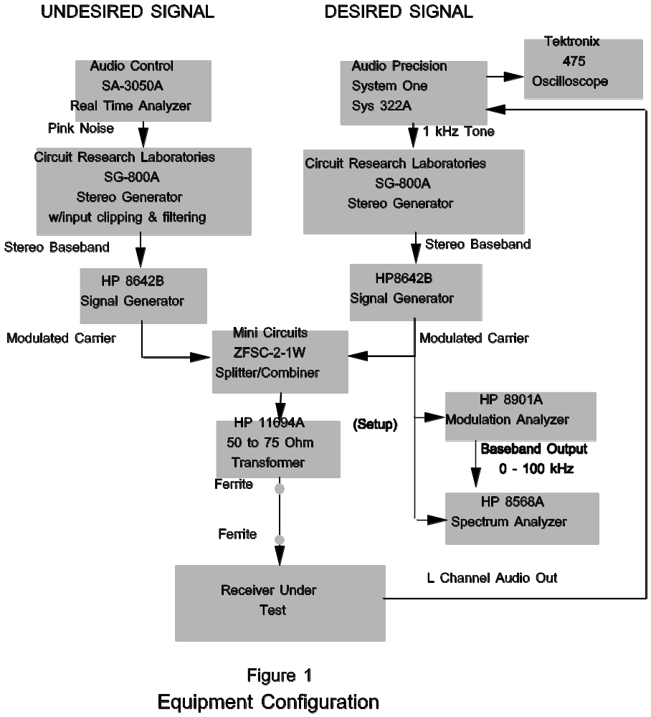

Test Procedure

The interconnection of the test equipment and the equipment under test is diagrammed in Figure 1.

The basic methodology involved operating each receiver with a desired signal consisting of an RF carrier which was FM modulated with a 1 kHz tone in both of the stereo channels. Two desired RF signal levels were used: the first corresponding to the level which would be experienced by the receiver if it were operating at the 60 dBu protected contour of a full-power FM broadcast station. The level of distortion measured with a desired signal level of 330 uV without impairment was used as the baseline distortion for each receiver. The second desired signal level is the noise limited operating point specific to the receiver under test. This point was arrived at by reducing the desired signal level until the unimpaired baseline distortion increased by 1%.

An undesired signal was created on first the 2nd and then the 3rd upper adjacent channel using a stereo generator with baseband modulation consisting of clipped pink noise. The undesired channels were modulated with equal L and R signals without the stereo pilot because this is often the worst-case interference condition. The undesired channels were then modulated with stereo left channel only in order to fully exercise the audio baseband and to maximize the amount of energy in the L - R sidebands. The level of the undesired signal was increased until distortion levels on the 1 kHz audio tone were measured at 1% and 3% over unimpaired baseline levels for the 330uV desired signal level, and the corresponding undesired signal levels were recorded. Similarly, for the noise limited measurements, the undesired signal levels were recorded at a 1% and 3% increases in distortion, and the undesired-to-desired signal (U/D) ratios were computed. The tests were repeated at peak modulation deviations of both +/- 75 kHz and +/- 50 kHz on the undesired signal to determine the relative effect of reduced modulation levels.

The desired signal for each test was created by FM modulating an RF carrier at 97.5 MHz with a 1 kHz tone. In order to exercise both the main channel and and stereo subchannel, the inputs were set at a 3dB differential level for the left and right channels of the broadcast stereo generator. Reducing the L input moves 10% of the power from the main channel to the L-R stereo subchannel. Distortion was measured on the left channel audio output of the test receiver in both cases of undesired signal. The level of the audio signal fed to the distortion analyzer was maintained at approximately 0 dBm to operate the audio amplifiers in the linear portion of their output power range.

Precautions were taken to ensure against direct pickup of high-level ambient RF signals by conducting the measurements inside a shielded room, as well as by placing ferrites on either end of the cable connecting the combiner to the antenna input of the receiver under test. An isolation transformer was used on the power mains for AC-powered receivers as well as the power supply for DC-powered receivers. An audio linear transformer was used to isolate the audio output signal from equipment ground.

Observations on the Data

The immunity data is presented in tabular form in Tables 2 through 5 for desired signal levels at the equivalent of the protected signal contour, and in Tables 6 through 9 for desired signal levels at the receivers' noise limited operating level. The same data is presented graphically in Figures 2 through 5, and 6 through 9, respectively.

It should be noted that several of the receivers, because of their circuit design, switched from stereo to mono reception before the 1% or 3% distortion level or the maximum undesired signal level was reached. In these cases, the U/D value recorded in the data tables represents the value at which the receiver switched modes. In the cases of receivers which reached the maximum undesired signal level before the 3% distortion level was obtained, the U/D ratio was recorded at the maximum signal level. This tends to underestimate the receiver’s ability to reject the interfering signal for those receivers. Ten of the samples have a maximum undesired level of 16.5 dBm which limits the maximum U/D to 73.5 dB and twelve of the samples have a maximum undesired level of 10.5 dBm which limits the maximum U/D to 67.5 dB.

In general the receivers which reached the maximum undesired signal level were Category III receivers for 3rd adjacent channel interference. The effect shows up in the graphs as equal amplitude U/D ratios for several measurements at one of the two referenced levels.

 |  |  | Table 2
 | 2nd Adj U/D Ratios for 21 Rcvrs at 60 dB Contour
 | DES Stereo L + R , UNDES Stereo L only
 |  | 75 kHz Deviation, |  | 50 kHz Deviation,
 | Sample # | Dist 1% | Dist 3% | Dist 1% | Dist 3%
 | 1 | 36.2 | 45.3 | 42.6 | 53.2
 | 2 | 24.8 | 26.3 | 24.6 | 27.4
 | 3 | 52.3 | 55.1 | 54.2 | 57.1
 | 4 | 42.6 | 46.7 | 47 | 52.1
 | 5 | 30.2 | 36.5 | 30.2 | 37.1
 | 6 | 55.1 | 57.1 | 56 | 57.1
 | 7 | 58.2 | 61.7 | 60.3 | 66.5
 | 8 | 57.5 | 61.1 | 63.5 | 66.8
 | 9 | 67.5 | 67.5 | 67.5 | 67.5
 | 10 | 47.4 | 53.2 | 50.5 | 56.1
 | 11 | 43.5 | 63.5 | 63.9 | 66.4
 | 12 | 55 | 55.9 | 55.4 | 56.4
 | 13 | 44.7 | 52.9 | 50.5 | 56.2
 | 14 | 47.2 | 53.8 | 52.2 | 57.8
 | 15 | 36.4 | 41.7 | 41.7 | 51.5
 | 16 | 36.5 | 45.9 | 37.4 | 50.3
 | 17 | 49.1 | 51.6 | 50 | 53.6
 | 18 | 36 | 47.1 | 42.8 | 48.4
 | 19 | 44.8 | 50.5 | 48 | 53.3
 | 20 | 48.8 | 56.3 | 53.2 | 59.7
 | 21 | 42.6 | 44.7 | 47.4 | 51.7

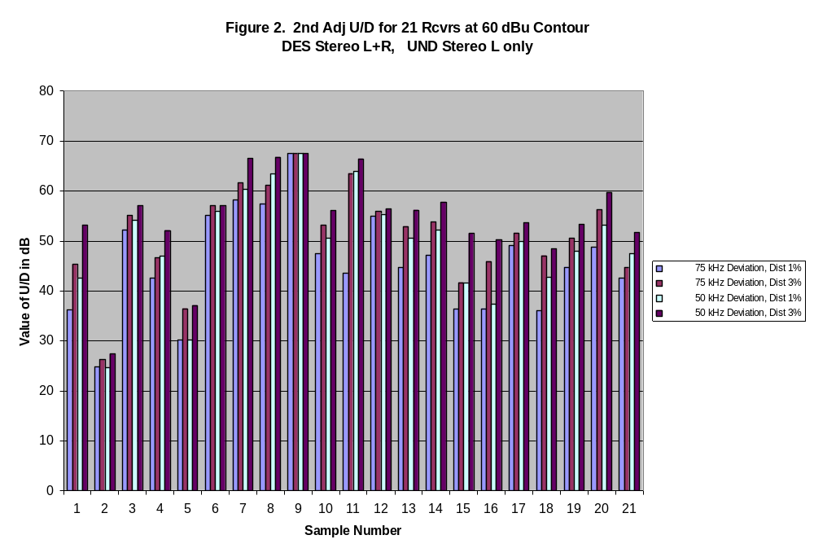

 |  |  | Table 3
 | 2nd Adj U/D Ratios for 21 Rcvrs at 60 dB Contour
 | DES Stereo L + R , UNDES Mono L + R
 |  | 75 kHz Deviation, |  | 50 kHz Deviation,
 | Sample # | Dist 1% | Dist 3% | Dist 1% | Dist 3%
 | 1 | 34.3 | 39.8 | 41.1 | 52.2
 | 2 | 25.4 | 26.5 | 26.3 | 28
 | 3 | 52.8 | 55.5 | 56.5 | 60.4
 | 4 | 42.3 | 45.3 | 48.4 | 51.5
 | 5 | 30.9 | 37.3 | 32.1 | 38.1
 | 6 | 54.3 | 56.6 | 56.1 | 58.5
 | 7 | 53.5 | 60.1 | 60.5 | 67.5
 | 8 | 56.5 | 58.9 | 66.6 | 67.5
 | 9 | 62.9 | 65 | 66.9 | 67.5
 | 10 | 56.6 | 66.7 | 67.5 | 67.5
 | 11 | 66.8 | 67.5 | 67.5 | 67.5
 | 12 | 54.5 | 56.1 | 55.4 | 56.2
 | 13 | 45.7 | 53 | 53.8 | 58.9
 | 14 | 47.8 | 52.5 | 54.1 | 58.5
 | 15 | 33.2 | 39.7 | 38.7 | 49.4
 | 16 | 36.8 | 43.1 | 37.4 | 41.9
 | 17 | 55.3 | 60.7 | 57.3 | 63
 | 18 | 48.7 | 49.8 | 49 | 49.8
 | 19 | 53.3 | 56.7 | 54.9 | 56.7
 | 20 | 62 | 67.5 | 65.2 | 67.5
 | 21 | 42.3 | 44.6 | 46.8 | 51

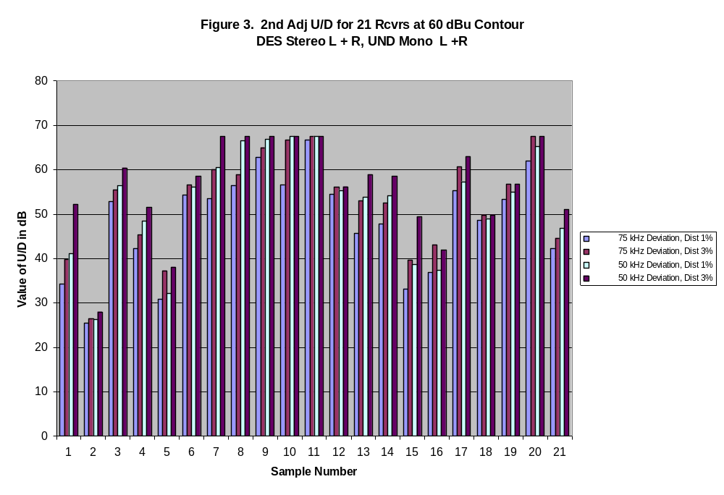
 |  |  | Table 4
 | 3rd Adj U/D Protection Ratios for 21 FM Receivers
 | for 60 dBu, DES Stereo L + R, UNDES Stereo L only
 |  | 75 kHz Deviation, |  | 50 kHz Deviation,
 | Sample # | Dist 1% | Dist 3% | Dist 1% | Dist 3%
 | 1 | 52.5 | 57.9 | 55 | 57.9
 | 2 | 32.8 | 41.7 | 39.3 | 43
 | 3 | 59.3 | 64.4 | 62.4 | 64.8
 | 4 | 51.1 | 54.8 | 51.6 | 54.8
 | 5 | 39.1 | 40.3 | 39.8 | 40.9
 | 6 | 53.5 | 55.9 | 53.6 | 55.9
 | 7 | 63.5 | 67.5 | 63.7 | 67.5
 | 8 | 67.5 | 67.5 | 67.5 | 67.5
 | 9 | 67.5 | 67.5 | 67.5 | 67.5
 | 10 | 57.3 | 67.1 | 60.2 | 67.5
 | 11 | 66.5 | 67.5 | 67.5 | 67.5
 | 12 | 58.8 | 59.6 | 58.9 | 59.7
 | 13 | 56.7 | 63.3 | 59.3 | 64.8
 | 14 | 56.5 | 63.4 | 58.4 | 66.4
 | 15 | 50.5 | 58.3 | 54.4 | 62.1
 | 16 | 50.5 | 56 | 53.2 | 59.2
 | 17 | 54.4 | 60 | 57.6 | 63.7
 | 18 | 43 | 48.4 | 49.5 | 49.5
 | 19 | 54.7 | 57.7 | 57.6 | 57.7
 | 20 | 62.5 | 67.5 | 66.4 | 67.5
 | 21 | 52.4 | 60.8 | 56.5 | 63.4

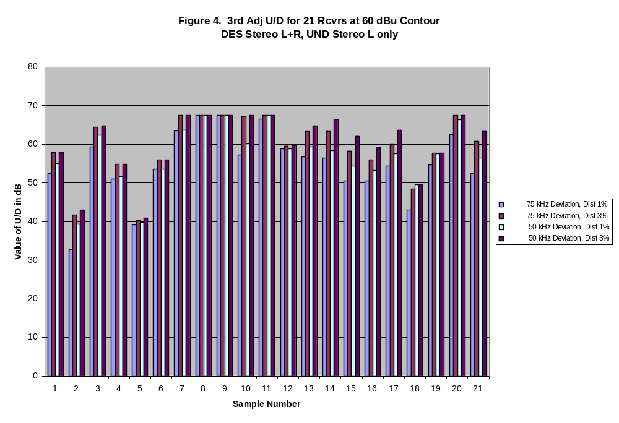
 |  |  | Table 5
 | 3rd Adj U/D Protection Ratios for 21 FM Receivers
 | for 60 dBu, DES Stereo L + R, UNDES Mono L + R
 |  | 75 kHz Deviation, |  | 50 kHz Deviation,
 | Sample # | Dist 1% | Dist 3% | Dist 1% | Dist 3%
 | 1 | 56.7 | 57.9 | 57.3 | 57.9
 | 2 | 34.8 | 41.9 | 38.5 | 42.5
 | 3 | 63 | 64.9 | 64.5 | 64.9
 | 4 | 51.6 | 54.9 | 51.6 | 54.8
 | 5 | 41.1 | 41.3 | 41.4 | 41.7
 | 6 | 53.4 | 55.8 | 53.4 | 55.9
 | 7 | 63.6 | 67.5 | 63.5 | 67.5
 | 8 | 67.5 | 67.5 | 67.5 | 67.5
 | 9 | 63 | 67.5 | 67.5 | 67.5
 | 10 | 61.7 | 67.5 | 62.6 | 67.5
 | 11 | 67.5 | 67.5 | 67.5 | 67.5
 | 12 | 58.7 | 59.5 | 58.9 | 59.6
 | 13 | 59.9 | 64.9 | 60.9 | 64.8
 | 14 | 59 | 67.5 | 59.7 | 67.5
 | 15 | 60.5 | 67.5 | 63.7 | 67.5
 | 16 | 56.9 | 62.7 | 59.3 | 62.8
 | 17 | 58.6 | 64.9 | 61.1 | 65.2
 | 18 | 49.4 | 49.4 | 49.4 | 49.4
 | 19 | 57.7 | 57.7 | 57.7 | 57.7
 | 20 | 65.6 | 67.5 | 67.5 | 67.5
 | 21 | 66.7 | 67.5 | 67.5 | 67.5

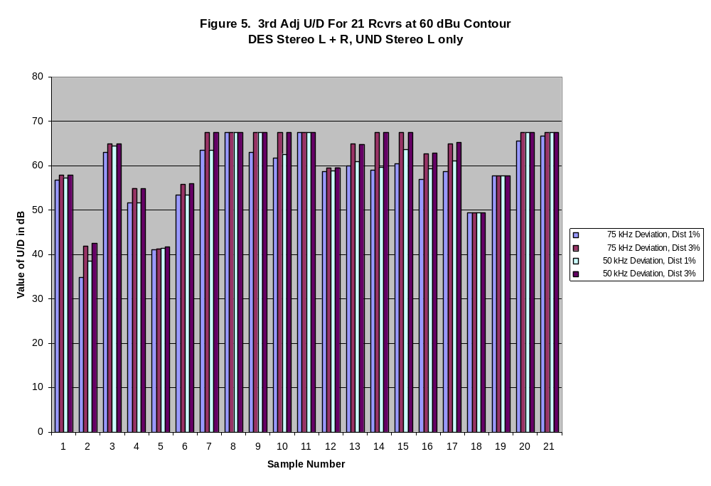
 |  |  | Table 6
 | 2nd Adj U/D Ratios for 21 Rcvrs at Noise Limited Contour
 | DES Stereo L + R , UNDES Stereo L only
 |  | 75 kHz Deviation, |  | 50 kHz Deviation,
 | Sample # | Dist 1% | Dist 3% | Dist 1% | Dist 3%
 | 1 | 41.6 | 45.8 | 47 | 51.8
 | 2 | 36.4 | 39.2 | 38.1 | 41.8
 | 3 | 46.9 | 53.5 | 51.6 | 58.7
 | 4 | 46.4 | 49.1 | 51.3 | 51.7
 | 5 | 33 | 38.9 | 33.1 | 40
 | 6 | 55.3 | 56.7 | 56 | 57.5
 | 7 | 58.3 | 60.2 | 59.5 | 61.5
 | 8 | 43.4 | 55.3 | 43.4 | 55.9
 | 9 | 59.5 | 63.5 | 63.2 | 67.2
 | 10 | 50.1 | 56.6 | 53.8 | 60.1
 | 11 | 57.9 | 61.6 | 58.9 | 64.5
 | 12 | 53.2 | 54.6 | 53.6 | 55
 | 13 | 47.1 | 52.3 | 51.6 | 56.9
 | 14 | 46.3 | 49.5 | 51.9 | 57.9
 | 15 | 36.6 | 44.7 | 45 | 51.2
 | 16 | 43.3 | 47.9 | 45.8 | 52.2
 | 17 | 42.8 | 49.3 | 46.2 | 53.4
 | 18 | 45.2 | 47 | 45.9 | 53.6
 | 19 | 50.3 | 55.4 | 53.8 | 57.9
 | 20 | 52.6 | 58.9 | 57.2 | 63.1
 | 21 | 43.5 | 45.5 | 49.7 | 51.8

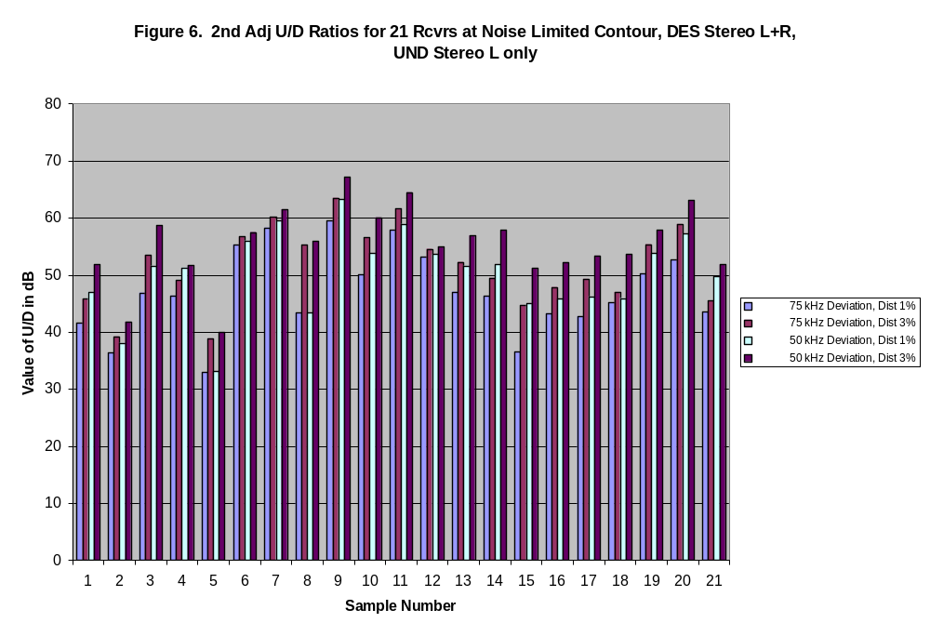
 |  |  | Table 7
 | 2nd Adj U/D Ratios for 21 Rcvrs at Noise Limited Contour
 | DES Stereo L + R , UNDES Mono L + R
 |  | 75 kHz Deviation, |  | 50 kHz Deviation,
 | Sample # | Dist 1% | Dist 3% | Dist 1% | Dist 3%
 | 1 | 39.2 | 43.5 | 45.8 | 50.4
 | 2 | 36 | 38.6 | 37.9 | 41.4
 | 3 | 47.1 | 52.9 | 55.2 | 61.9
 | 4 | 45.2 | 46.8 | 51.4 | 51.8
 | 5 | 33.5 | 38.8 | 33.6 | 40.2
 | 6 | 54.3 | 56.3 | 56.2 | 57.7
 | 7 | 55.5 | 59.6 | 59.7 | 62.2
 | 8 | 44.7 | 55.1 | 50.2 | 57
 | 9 | 69.3 | 70.9 | 69.6 | 71
 | 10 | 62.8 | 68.5 | 64.8 | 70.6
 | 11 | 67.2 | 69.5 | 67.3 | 71.6
 | 12 | 53.1 | 54.4 | 53.6 | 54.9
 | 13 | 46.8 | 50.4 | 54.2 | 58.1
 | 14 | 44.9 | 46.8 | 53.3 | 56.5
 | 15 | 36.3 | 41.9 | 42.9 | 48.9
 | 16 | 39.8 | 48.2 | 45.8 | 52.3
 | 17 | 49.3 | 57.1 | 51.4 | 57
 | 18 | 46 | 47.5 | 45.6 | 52.6
 | 19 | 57.5 | 59.9 | 58.8 | 59.9
 | 20 | 66.3 | 66.6 | 66.6 | 66.6
 | 21 | 43.4 | 45.4 | 48.8 | 51.1

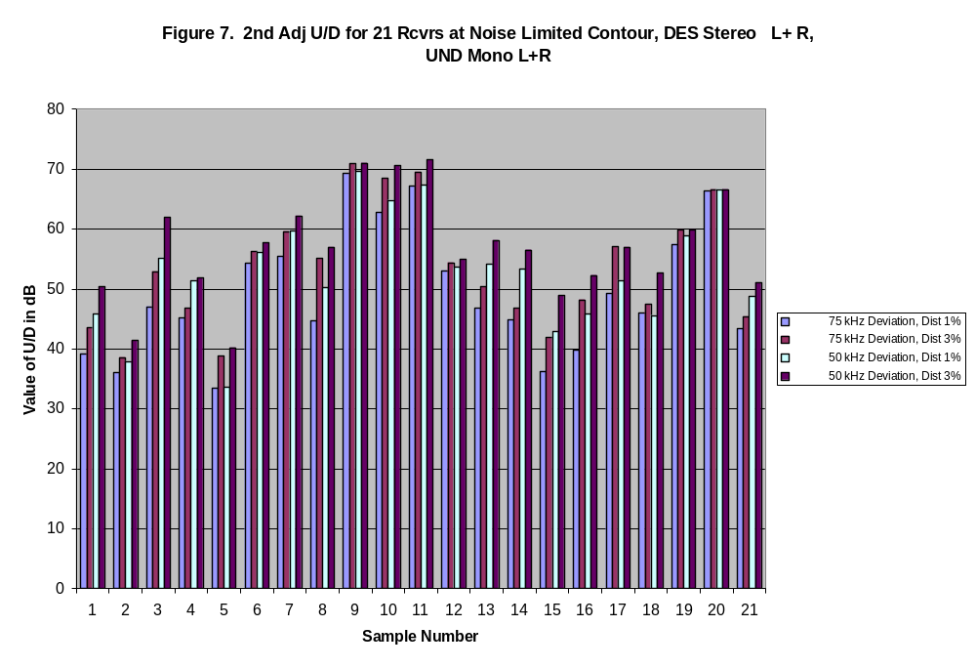

 |  |  | Table 8
 | 3rd Adj U/D Ratios for 21 FM Receivers at Noise Limited Contour
 | DES Stereo L + R, UNDES Stereo L only
 |  | 75 kHz Deviation, |  | 50 kHz Deviation,
 | Sample # | Dist 1% | Dist 3% | Dist 1% | Dist 3%
 | 1 | 54 | 58.3 | 56.1 | 58.3
 | 2 | 52.5 | 55.3 | 53.5 | 55.6
 | 3 | 60.7 | 65.2 | 63.6 | 65.3
 | 4 | 52.6 | 52.9 | 52.6 | 52.8
 | 5 | 53.1 | 54.5 | 53.8 | 55
 | 6 | 53.9 | 55.2 | 53.7 | 55.2
 | 7 | 63.5 | 66.1 | 63.6 | 66.3
 | 8 | 54.4 | 57.2 | 54.4 | 57.2
 | 9 | 69.6 | 71.7 | 71.1 | 72.4
 | 10 | 62.6 | 69 | 66 | 72.2
 | 11 | 64.9 | 69.2 | 68.1 | 72.1
 | 12 | 58 | 59.3 | 58.1 | 59.4
 | 13 | 58.9 | 66.5 | 61.2 | 68.4
 | 14 | 59.2 | 67.1 | 62.3 | 68.2
 | 15 | 52.8 | 59.3 | 56.6 | 63.3
 | 16 | 53.6 | 59.6 | 56.9 | 62.9
 | 17 | 54.1 | 57 | 57 | 57
 | 18 | 51.8 | 63.4 | 52.3 | 66.4
 | 19 | 55.2 | 57.4 | 57.4 | 57.4
 | 20 | 65.5 | 68.9 | 68.1 | 68.4
 | 21 | 54.7 | 61.4 | 58.9 | 64.9

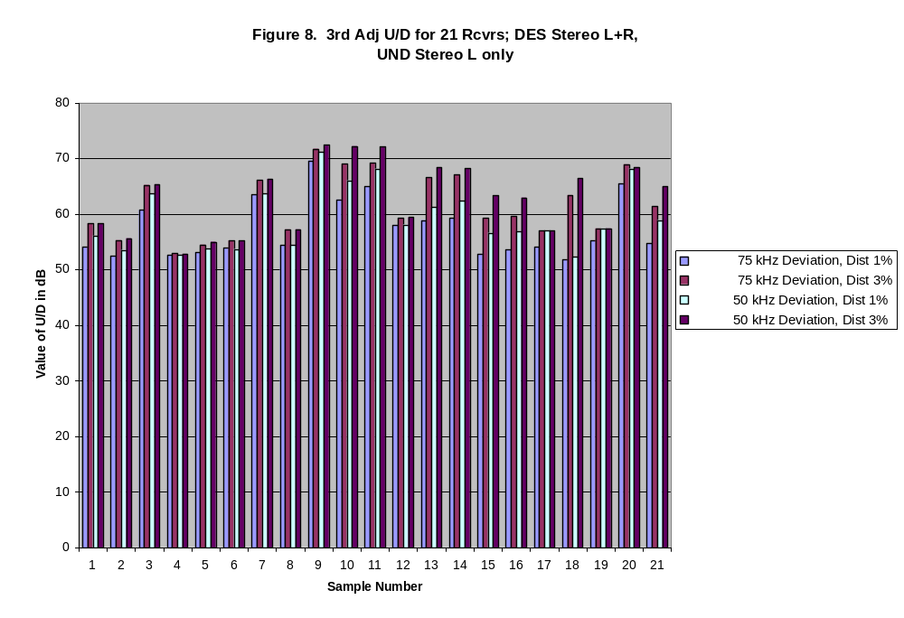
 |  |  | Table 9
 | 3rd Adj U/D Ratios for 21 FM Receivers at Noise Limited Contour
 | DES Stereo L + R, UNDES Mono L + R
 |  | 75 kHz Deviation, |  | 50 kHz Deviation,
 | sample # | Dist 1% | Dist 3% | Dist 1% | Dist 3%
 | 1 | 58.2 | 58.2 | 58.4 | 58.4
 | 2 | 53.8 | 55.4 | 53.3 | 55.6
 | 3 | 64.3 | 65 | 64.7 | 65.1
 | 4 | 52.5 | 52.8 | 52.6 | 52.9
 | 5 | 53.8 | 54.8 | 54.6 | 55.2
 | 6 | 53.7 | 55.3 | 53.7 | 55.3
 | 7 | 63.4 | 66.1 | 63.7 | 66.3
 | 8 | 52 | 56.4 | 56.3 | 54.6
 | 9 | 70.8 | 72.4 | 71 | 72.5
 | 10 | 67.5 | 73 | 67.7 | 73.3
 | 11 | 71.4 | 75.5 | 72.5 | 76.1
 | 12 | 57.8 | 59.1 | 58 | 59.4
 | 13 | 62.7 | 68.2 | 63.9 | 68.3
 | 14 | 62.8 | 69 | 62.9 | 69
 | 15 | 63.4 | 69.3 | 64.3 | 70.2
 | 16 | 61.9 | 64 | 62.2 | 64.2
 | 17 | 57 | 57 | 57 | 57
 | 18 | 49.8 | 66.3 | 52 | 66.9
 | 19 | 57.4 | 57.4 | 57.4 | 57.4
 | 20 | 68.1 | 68.3 | 68 | 68
 | 21 | 67.9 | 67.9 | 67.9 | 67.9

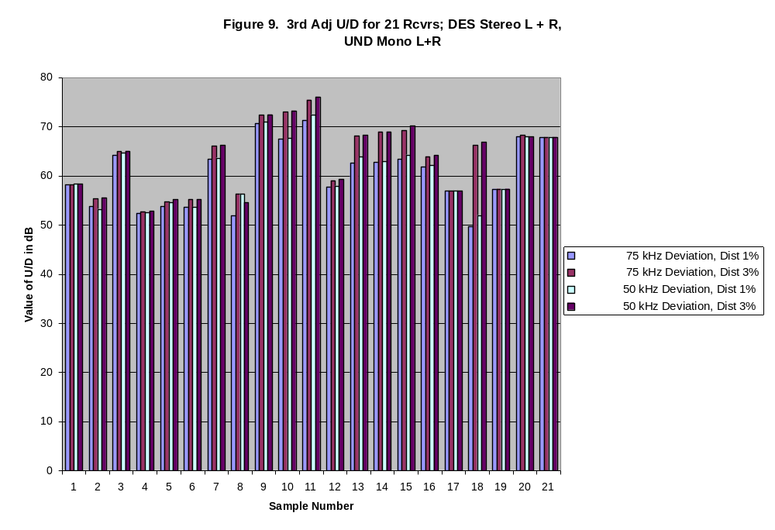

Conclusions

Caution must be exercised in extending sweeping conclusions from the data to the general population of receivers due to the small sample size. However, some observations can conclusively be made for the sample at hand.

Section 73.215 of the Commission’s rules provides that the predicted field strength of a potentially interfering station can be no more than 40 dB stronger than the protected field strength along a station’s protected contour. At the 3% distortion level all the receivers in the sample, except for two (samples #2 & #6), appear to meet or exceed the 40 dB second adjacent channel protection criterion and to exceed the 40 dB third adjacent channel protection criterion by a substantial margin. For the third adjacent channel, that margin was similar for most of the receivers at the noise limited desired signal level and at the 60 dBu contour.

As one would expect there are substantially greater U/D ratios for third adjacent channel interference, because of the frequency separation and the receiver selectivity. Overall, there appears to be approximately 10 dB better interference performance at the third adjacent channel than at the second.

For both second and third adjacent channel interference, there appears to be some ameliorating effect, generally on the order of several dB, produced by reducing the maximum deviation on the undesired signal from +/- 75 kHz to +/- 50 kHz. However, the amount of improvement varies widely from receiver to receiver (probably due to differences in selectivity).

Acknowledgements

The authors would like to acknowledge the gracious assistance provided by the following:
Gary Hendrickson of the Measurements and Calibration Branch for assistance with the experimental setup and the data collection; Joycelyn Walls of the Laboratory Divison for her help with the data spreadsheets and graphs; and Kenneth Nichols and James Higgins of the Compliance and Information Bureau for help with the study design and procurement of equipment.

Equivalent to 330 uV at the antenna terminals assuming a half-wave dipole antenna at ten meters with a 10 dB antenna factor, including line losses. The antenna factor was empirically derived for the Roberts antenna at the FCC Laboratory.

