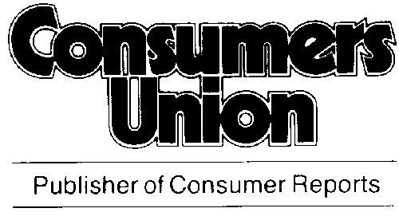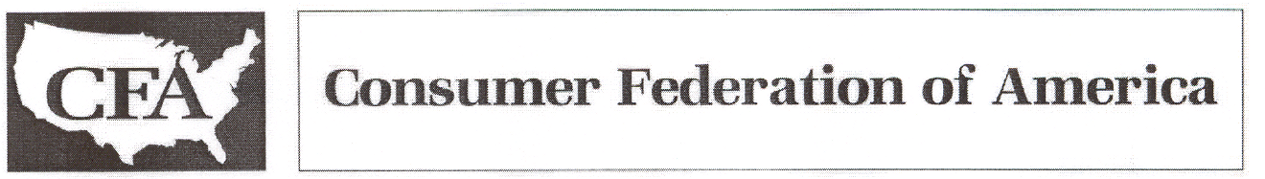
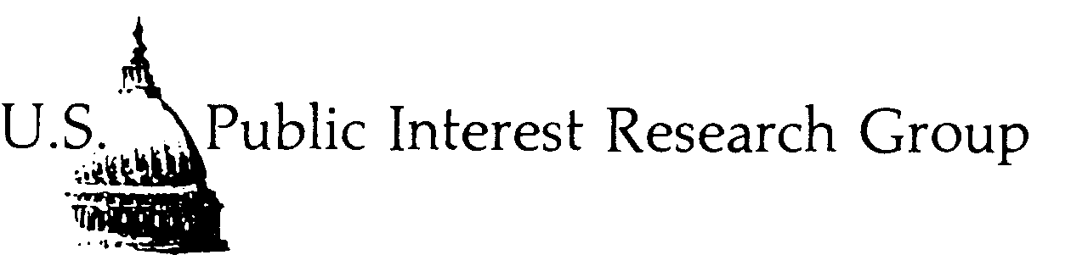

Derivatives Study Center

March 8, 2002

Dear Senator:

We are writing to express our support for the amendment being offered by Senators Feinstein, Cantwell and Wyden to the comprehensive energy bill entitled S. 517. This amendment will provide regulatory oversight and anti-fraud and anti-manipulation authority over previously “exempt” over-the-counter derivatives on commodities such as energy. The Commodity Futures Trading Commission (CFTC), which has served as the principle federal regulator of derivative transactions since its founding in 1975, will provide the oversight, surveillance and enforcement of anti-fraud and anti-manipulation laws.

Derivatives are highly leveraged transactions, and some of them are highly complex and difficult to understand, even for seasoned securities traders and investors. Enron used over-the-counter derivatives extensively in order to hide the nature of just what it was doing to make money. Now, far too many former employees, investors and retirees are paying the price for Enron’s desire to operate through murky, confusing, and unregulated transactions. In addition, energy company stocks are being roiled and they are having difficulty raising capital to fund investments in future energy production. Given the misunderstanding pervading the investor community over derivatives, and the quick and precipitous collapse of Enron, it is clear that derivatives merit closer scrutiny by federal regulatory authorities.

This amendment would help ensure that over-the-counter traders in commodity derivatives operate with proper federal oversight that makes the market more stable and transactions transparent. It is appropriate to place this oversight authority within the CFTC, an agency already charged with dealing with investment instruments such as derivatives. The CFTC has the expertise to handle the complexity of these financial transactions and develop the necessary protections. Moreover, requiring the cooperation of the Federal Energy Regulatory Commission, the entity charged with overseeing the energy markets, will provide a further safety net for the investing public.

At a time when we are all wondering how a high-flying company like Enron could keep so many analysts in the dark, we should take care to ensure that the public is protected from any further costly Enron-like collapses. This amendment will help do that.

March 8, 2002
Page Two

Thank you for considering this important amendment.

Sincerely,

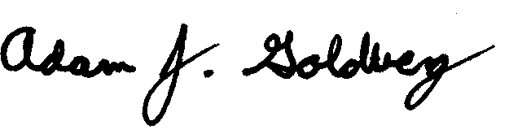

Adam J. Goldberg Mark N. Cooper
Policy Analyst Director of Research
Consumers Union Consumer Federation of America
1666 Connecticut Avenue, NW 1424 16th Street, NW
Suite 310 Suite 604
Washington, DC 20009 Washington, DC 20036
(202) 462-6262 (202) 387-6121

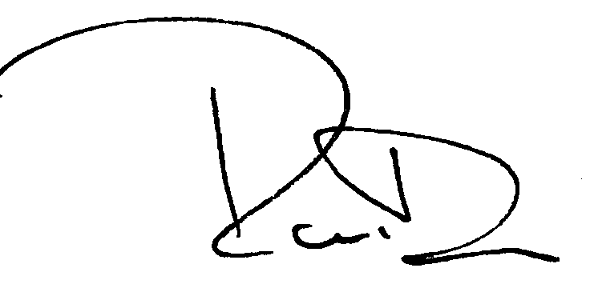

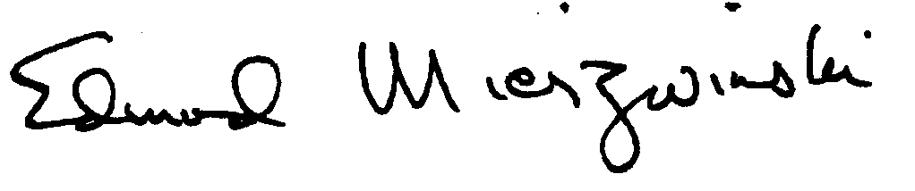

Edmund Mierzwinski Randall Dodd
Consumer Program Director Director
U.S. PIRG Derivatives Study Center
218 D Street, SE 1401 H Street, NW
Washington, DC 20003 Suite 560
(202) 546-9707 Washington, DC 20005
(202) 326-8555

