Education in the Islamic World:
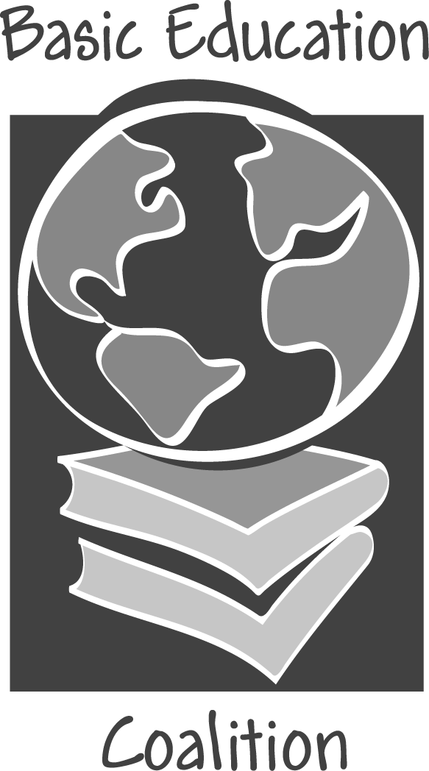

Challenges and Opportunities

1 out of every 5 people in the world is a Muslim.

Region | Muslim Population
Asia: including Indonesia, Bangladesh, Pakistan | 810,400,000
Africa: including Nigeria, Algeria, Ethiopia, Sudan | 320,000,000
Middle East: including Egypt, Iran, Saudi Arabia | 230,800,000
Europe and North America | 26,000,000
Islamic countries have extremely young populations. More than 39% of people in Saudi Arabia, Nigeria, Pakistan, Ethiopia, and Sudan are under the age of 15.^{1, 2}

Education in the Islamic World
- Educational attainments in the Islamic world—from literacy rates to mathematical and science achievements—are well below global standards.³

- There are 65 million illiterate adult Arabs, and two-thirds of them are women.⁴

- One out of every four South Asian children attending school drops out each year because of poverty.⁵

- Educational enrollment for Arab countries rose from 31 million in 1980 to approximately 56 million in 1995. Yet despite this increase, 10 million Arab children between the ages of 6 and 15 are currently not in school.⁴

- Many educational systems in Muslim countries widen the gap between rich and poor: while rich students attend excellent private schools, poor children receive grossly inadequate schooling.⁶

- The Ministries of Education for 16 of the 20 Middle East and North African countries have written an Education for All (EFA) assessment and committed to the goal of Education for All by 2015.⁵

Women and Education
- While 66.4% of men in South and West Asia are literate, only 43.6% of women in the same region can read and write. In the Middle East and North Africa, the difference is even greater: 71.7% of men and only 47.8% of women are literate.⁷

- According to a recent UNDP report, women in the Muslim world have the lowest economic and political participation of any group of women in the world. To combat this poverty and gender inequality, basic education must be provided to all.⁴

- Although more than half of all Arab women are illiterate, the region has shown the fastest improvements in female education of any region. Women’s literacy rates have increased threefold since 1970.⁴

Health and Education
- Gains in women’s education account for an estimated 43% reduction in child malnutrition between 1970 and 1995.⁸

- Educated mothers are more likely to better space births, to have adequate prenatal care, and to immunize their children.⁸

Economics and Education
- Education quality has a sharp impact on economic growth. An improvement of one standard deviation in math and science skills appears to boost economic growth by more than 1%.⁹

- Poor educational systems in the Islamic world hinder the future economic prospects of these states, and widen the development gap between the Islamic world and the West.³

- Despite problems related to economic development, it is human development, or the potential for people to live productive and creative lives, that is the acute problem in the Muslim world. Basic education is the key to spurring human development.³

To Best Address the Issue, Governments Should:
- Strengthen their commitment to educational reforms.

- Focus educational policy on improving the quality of education. This can be accomplished through increasing teacher training, creating curriculum more relevant to modern society, and improving standards for both secular and religious schools.

- Incorporate secular subject matter into religious institutions. Closing these schools is not an option; instead viable public schools must be provided.

- Prioritize the education of girls at both the primary and secondary schooling levels.

- Devote a higher percentage of educational budgets to basic education.

— — —

¹ www.cia.gov The World Fact Book 2002.
² www.infanca.org The World Fact Book 2000.
³ The Brookings Institution. October 2002. “Economic Outreach Initiative.” Project on U.S. Policy towards the Islamic World.
⁴ UNDP. 2002. Arab Human Development Report.
⁵ Huong, Matteo, and Pangalos. 2002. “Principles of NGO Management.” Unpublished paper.
⁶ Haqqani, H. November 2002. “Education in the Muslim World: What’s Next?” Academy for Educational Development, The AED Global Learning Group.
⁷ UNESCO. 2002. EFA Global Monitoring Report 2002.
⁸ UNFPA. 2002. State of World Population 2002. Advance Press Copy.
¹⁰ Herz, B. 2002.“Universal Education: What Works?” Prepared for the Basic Education Coalition.

