Education:
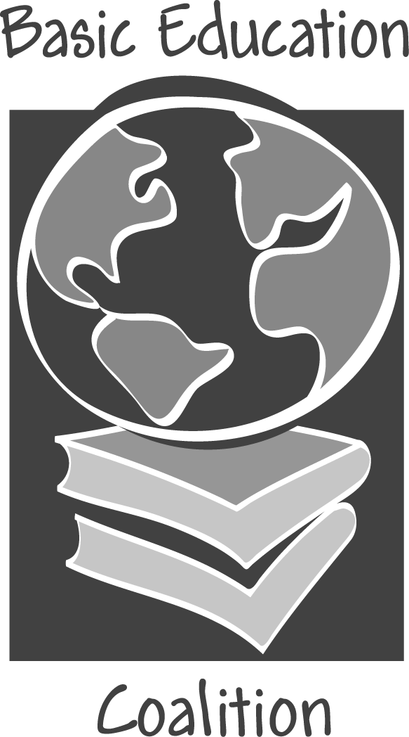

The Best Vaccine Against HIV/AIDS

- Currently 42 million people worldwide live with HIV/AIDS.
- Half of the 15,000 new infections every day occur among 15–24 year olds.
- Over 15.6 million children are AIDS orphans—a number that is expected to double by 2010.³
- n sub-Saharan Africa alone, 29.4 million people live with HIV/AIDS, 58% of them women.^{4,5}
- Within the next 10 years, the focal point of the pandemic is expected to shift from central and southern Africa to Nigeria, Ethiopia, Russia, India and China. The number of infected people in these countries will grow from around 14–23 million currently, to an estimated 50–75 million by 2010.⁶

How Does HIV/AIDS Affect Education?

Schools lose teachers
- An estimated 860,000 children in sub-Saharan Africa lost teachers to AIDS in 1999. For every teacher who dies of AIDS in this region, an entire classroom is left without instruction.
- Central African Republic sustained such high losses among teachers that more than 100 educational institutions were closed by the late 1990s.¹

Students are forced to leave school
- As parents fall ill and die of AIDS, family burdens shift to children. Students—particularly girls—leave school to take on adult responsibilities, such as earning money, procuring food, and caring for the ill.⁴
- Orphaned girls are extremely vulnerable; forced to quit school, many become victims of sexual violence or become prostitutes to earn money to support younger siblings.⁵
- In one South African province where adult HIV prevalence exceeds 30%, researchers found that first grade enrollment dropped 24% in 2000.1

School systems have additional financial burdens
- Zambia estimates the financial burden on the educational sector for 2000–2010 due to AIDS will be $25 million. Mozambique estimates twice that amount.³
- If Swaziland hired and trained enough staff to replace the teachers lost to HIV/AIDS, the estimated cost would be $233 million.³

Education as Vaccine

The future trajectory of the global HIV/AIDS epidemic depends on whether the world can protect young people everywhere from the disease and its aftermath.⁴

Children Ages 5–14 | Youth Ages 15–24
This age group is the least likely to be infected with HIV/AIDS. Basic education during this time has strong impact—it can equip children with the skills and knowledge to remain HIV free during their vulnerable young-adult years.³ | This high-risk group accounts for 60% of all new infections in many countries, yet ignorance about HIV/AIDS remains dangerously high. For this group, education efforts can yield maximum results.³

Education Protects
- Education is highly cost effective as a preventive mechanism. It brings together students, teachers, parents and the community, all of whom play a role in AIDS prevention.³
- In 17 African and 4 Latin American countries, better-educated girls tended to delay having sex and were more likely to require their partners to use a condom.³
- According to a World Bank study of 32 countries, women with post-primary education were three times more likely than uneducated women to know that HIV can be transmitted from mother to child.³

Success: Fighting HIV/AIDS Through Education

THAILAND  Thailand’s success in combating HIV has come from a high commitment at both the regional and national levels. The HIV prevention program launched in 1991 has included: life-skills training for teens, mass media HIV/AIDS education campaigns, peer education, workplace AIDS programs, and vocational opportunities to keep young women from becoming sex workers. From 1993–1997, HIV infection rates among 21-year-old military conscripts dropped from 4% to 1.5%.⁷ | UGANDA  The Ministry of Education responded to the HIV epidemic in Uganda with new curriculum and improved teacher training, as well as sex education programs in school and on the radio. Behavior change programs, which include counseling and testing, also have been instituted. According to Uganda’s AIDS Commission, this commitment to combating the disease through education has helped to lower the rate of new infections among 15–19 year olds by almost 50%.^{3,1}

The Epidemic’s Next Stages: Nigeria, Ethiopia, Russia, India, and China
- According to UNAIDS, Asia alone is likely to surpass sub-Saharan Africa in the absolute number of AIDS cases by 2010.6
- India is likely to have 20 to 25 million AIDS cases by 2010—the highest estimate for any country.⁶
- In Ethiopia and Nigeria, heterosexual contact is the primary mode of transmission, suggesting that the disease has moved significantly into the general population. Because these governments have little means to respond, HIV is expected to infect as many as 10 to 15 million people in Nigeria and 7 to 10 million in Ethiopia by 2010.⁶
- The future of HIV/AIDS in Nigeria, Ethiopia, Russia, India and China is a special cause for concern. The governments of these countries have not yet demonstrated the commitment necessary to combat the disease.⁶ Improvements in basic education in these regions today could help prevent the predicted explosion of new HIV/AIDS infections in the coming decade.

“Facing the HIV/AIDS Pandemic,” Population Reference Bureau, Sept 2002
www.worldbank.org, “In Turning the Tide Against HIV, Education is Key,” Oct 2002
Education and HIV/AIDS: A Window of Hope, The World Bank 2002 ⁴ “AIDS Epidemic Update,” UNAIDS/WHO Dec 2002 ⁵ “Fatal Vulnerabilities: Reducing the Acute Risk of HIV/AIDS among Women and Girls,” CSIS 2003 ⁶ www.cia.gov, “The Next Wave of HIV/AIDS: Nigeria, Ethiopia, Russia, India, and China,” Sept 2002 ⁷ www.worldbank.org, “HIV/AIDS Prevention and Care Strategies for HIV”

