Your name here
Date
Prof. Baumgartner, POLI 421
Assignment 1 on graphing some data

Various keywords using the same media source will produce different results. Baumgartner generated a time-series of New York Times stories from 1980 through 2014 on the issue of inflation by using this search string: “inflation AND price AND ("United States" OR US)” and showed that attention to inflation and prices was highest in the early period. I replicated their data but revised the keywords to be as follows: xxx. Figure 1 shows the results.

Figure 1. Two Measures of Media Attention to Inflation.
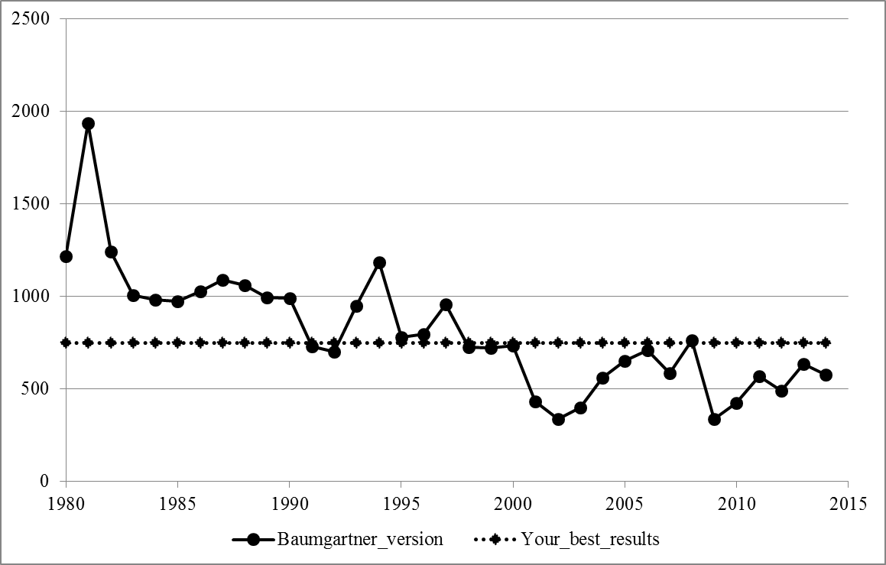
Note: The figure shows attention in the New York Times, using xxx web site made available through the UNC libraries.

As the figure makes clear, my search has not really been done yet but this is the template for the class assignment. When my data become clear, I can write a paragraph describing whether my findings are similar to the other series, or not. Then discuss some possible reasons why. Which search do you think is probably more accurate, and why do you think so? Are there ways to improve accuracy? The goal is to get stories on rising prices, inflation, etc.

