Framing the Poor
Media Coverage and US Poverty Policy, 1960–2008

Max Rose
Autry Fellow
MDC
307 W. Main Street
Durham, NC 27701-3215, USA
Mrose@mdcinc.org

Frank R. Baumgartner
Richard J. Richardson Distinguished Professor of Political Science
The University of North Carolina at Chapel Hill
Chapel Hill, NC 27599-3265, USA
Frankb@unc.edu

Abstract
Public policy toward the poor has shifted from an initial optimism during the War on Poverty to an ever-increasing pessimism. Media discussion of poverty has shifted from arguments that focus on the structural causes of poverty or the social costs of having large numbers of poor to portrayals of the poor as cheaters and chiselers and of welfare programs doing more harm than good. As the frames have shifted, policies have followed. We demonstrate these trends with new indicators of the depth of poverty, the generosity of the government response, and media framing of the poor for the period of 1960 to 2008. We present a simple statistical model that explains poverty spending by the severity of the problem, GDP, and media coverage. We then create a new measure of the relative generosity of US government policy toward the poor and show that it is highly related to the content of newspaper stories. The portrayal of the poor as either deserving or lazy drives public policy.

Keywords: policy change, framing, poverty policy, content analysis

Forthcoming, 2012 Policy Studies Journal

Framing the Poor
In 1960, 22 percent of the American public, some 40 million people, earned an income below the poverty line. Fifteen years later, the rate had been reduced to 12 percent as spending on poverty assistance increased from three to about eight percent of US government spending. The War on Poverty had a dramatic impact. Poverty, especially among the elderly, was indeed reduced, and substantially so (for a thorough discussion of how various demographics faired during the decades after the War on Poverty, see Danziger and Weinberg 1994). The poor were seen as victims of an economic system that had no place for them, trapped in dysfunctional schools, plagued by racial barriers to progress, and a potential threat to social stability and peace if their needs were not addressed. Poor Americans were “people who lack education and skill, who have bad health, poor housing, low levels of aspiration and high levels of mental distress,” wrote Michael Harrington in The Other America: Poverty in the United States, which provided an important intellectual framework for the War on Poverty (Harrington 1962). Government response was urgent, and it came in dramatic fashion.
By the late-1960s, that conversation began to change. So much so that beginning in California and later as a presidential candidate, Ronald Reagan tapped into a widespread feeling that the poor were not deserving of such government generosity. In his 1976 campaign for president, Reagan spoke at every stop about Linda Harris, a 47-year-old Chicago woman who he said had “80 names, 30 addresses, 12 social security cards and is collecting veterans benefits on four nonexisting deceased husbands” (The New York Times 1976). The poor needed to work harder, to throw off their pessimism about their chances in the American economy, and to free themselves from dysfunctional government programs that encouraged laziness, the break-up of families, and dependency. Government policy followed this shift in focus, we will show. Action declined then remained stagnant in the face of increasing numbers of poor, and deeper poverty among them. Fifteen years later a Democratic candidate declared his intention to “end welfare as we know it,” and proceeded to revamp cash assistance (Berke 1992). By the mid-1990s, policy was dramatically altered from the optimism of the Kennedy and Johnson eras.
Beginning in the earliest years, but accelerating in the 1970s, public discussion of the poor began to focus on the poor as cheaters, as lazy or unwilling to work, and on the dysfunctions of government efforts to help them. From less than 10 percent of all discussion of poverty in the nation’s news media, these “stingy frames” have grown steadily over time, so that today they represent the most prominent way of talking about the poor. Perhaps the most surprising element in the data we will present is the tremendous focus on the plight and anger of the poor and other elements that justified a more generous approach to poverty in the 1960s and 1970s. We trace how the nation’s conversation about the poor has changed over almost 50 years, and we demonstrate that these shifting frames constitute a simple and compelling explanation for equally substantial changes in the relative generosity of US policy toward the poor.
Our paper is organized as follows. In the following section, we develop a set of quantitative indicators of how the media has discussed the poor; this documents the shift in focus from those explanations that hold the poor relatively blameless for their plight to an emerging set of frames that justifies a more “stingy” response. In the next section we develop new measures of the degree of poverty and of total government spending on the poor. Then we show the statistical relation between media framing and government spending on the poor, controlling for other factors such as growth in the economy and the degree of poverty. We then develop a new indicator, the Government Generosity Index (GGI), which represents the degree of government spending on the poor controlling for the severity of the poverty problem. This Index can be predicted statistically very well with just a single indicator: our measure of the “stinginess” of news media discussion of poverty. We conclude with a discussion of the methodological and substantive implications of our study.

Media Framing
Any American of a certain (middle) age can attest to dramatic changes in the tone of discussion of government programs to help the poor. Like any set of government programs, poverty programs are diverse, with similarly multi-dimensional discussion. Advocates for greater aid to the poor often focus on structural factors that make it difficult for individuals to find jobs in an increasingly advanced economy. If the lack of access to a quality job is understood to be because of racial discrimination, a geographic mis-match between where the poor live and where the jobs are available, or any other system-level factor, this suggests a more generous stance toward the poor. In this view, the poor may be less to blame for their lack of a job than they are victims of a social or economic system that has let them down. Of course, for each advocate who frames the debate around structural factors there may be another who draws attention to other elements: Adverse incentives in government programs that reward individuals for not working, a lack of effort by those who are poor, counter-examples of individuals who have “pulled themselves up by the bootstraps” despite adversity, a “culture of poverty” in certain communities that simply does not value work, or waste, fraud, and abuse in those government programs that seek to address poverty. All of the arguments enter the public discourse at one time or another. Some arguments may be used to justify relatively “generous” responses; others, relatively “stingy” attitudes.
Scores of popular and journalistic works have addressed the potential impact of framing on public policy. The way in which the American public sees and talks about any population affects policy directed towards the group in question. Anne Schneider and Helen Ingram (1993) are among the first to use a “social construction” approach to understanding public policy. Social construction of a target population is 1) the recognition of shared characteristics and 2) the attribution of specific values, symbols and images to those characteristics. The authors present a grid suggesting that populations are either strong or weak, and may be viewed either positively or negatively. In that framework, the poor are obviously weak as opposed to strong, but this work suggests that if they are viewed positively (e.g., like widows, children, and the handicapped), then they can be seen as “dependents.” If however, the poor are viewed negatively (e.g., like drug addicts, cheaters, or criminals), then they are “deviants.” If the poor have moved, in Schneider and Ingram’s terms, from the category of dependent to that of deviant, then we would expect policy to shift from relatively generous to relatively stingy. Our study can be seen as a relatively straightforward demonstration that Schneider and Ingram identified an important element of the determinants of public policy. (At the same time we are sensitive to Leiberman’s [1995] criticism that Schneider and Ingram’s theory must be seen in dynamic terms, and indeed we demonstrate that the categories can shift over time; indeed that is our most important point.)
To some authors such as George Lakoff (2004), the effective choice of frames that resonate widely with members of the public explains not only the direction of public policy, but the long-run dominance of the Democratic or Republican parties. Others argue that re-framing a debate is not that easy, especially as the other side can fight back (see Druckman 2001; see also Chong and Druckman 2007; Entman 2007; and Nelson et al. 1997). Here, we have a simpler question, which is whether we can document changes over time in the framing of poverty and if these changes relate to the degree of government generosity toward the poor.
Studying the evolution of a policy frame over time differs substantially from studying the ability of a given political actor to “re-frame” a debate. While various political actors are constantly attempting to re-frame the debates with which they deal, we need not assume that any one of them can do so in order to understand that the dominant social understanding of an issue can shift over time. Frank Baumgartner and Bryan Jones referred to this social understanding as the “policy image” in their study of several policies, including nuclear power, smoking, and pesticides. In each case, they show, using very simple content-analytic techniques, that media attention shifts dramatically from a focus on relatively benign or positive elements of the industry to a highly critical stance, and that the direction of public policy follows (1993).
Baumgartner and colleagues developed a much more complex methodology for the study of framing in their book-length examination of the death penalty (2008). They classified thousands of articles on capital punishment in the New York Times Index from 1960 to 2006. The authors found 65 unique frames, which they placed within seven different dimensions such as morality, constitutionality, and fairness (107). They then used the “net tone” of the media coverage to predict changes in the public policy, which they measured as the number of death sentences per year. They found that media framing had a substantial impact on the trace of public policy over time.
Quantitative and qualitative studies have examined how the framing of the poor changes public policy or the attitudes of the public or policy elites, often focusing on the discussion of the poor as “deserving” or “undeserving” or on race as a determinant of public support (for example, Avery and Peffley 2003; Gilens 1999; Gilens 2003; Hancock 2004; Johnson 2003; Handler and Hasenfeld 1991, 1997, 2007; Katz 1989). Much of that literature has documented a shift around the1960s in the perceptions of poverty, but authors describe the shift in different ways.
Several studies have examined the connections between changing elite discourse, public opinion and the national agenda on poverty policy, although not all have suggested that shifting public opinion led to policy change. Gilens (1999) argues that the media’s disproportionate tendency to show welfare recipients as blacks, starting in the mid-1960s, has led directly to public misconceptions of the poor and a decrease in public support. And Gilens demonstrates that states with higher proportions of blacks receiving welfare tend to provide lower benefits, which he associates with that shift in public perception. More recently, Schneider and Jacoby (2005), in an analysis of national polling data, noticed a temporary decrease in public support for welfare spending in the mid-1990s, around the time of welfare reform. Through an analysis of the New York Times Index and major television broadcasts, they suggest that the key factor in that temporary change was elite political discourse. On the other hand, Cook and Lomax (1994), in interviews with members of Congress and the general public, found that while the changing rhetoric had affected opinions on welfare more generally, support for the safety net and specific programs remained remarkably strong, which allowed for the maintenance of most programs. Perhaps even more than in other areas of public opinion, the presentation of the survey question has a strong effect on reported support for government aid to the poor. Poverty assistance programs elicit many different responses in the mind of the public, which is why we focus here on shifting frames as opposed to any single public opinion indicator.
Other scholars describe a more inter-sectional framing of the poor, as involving race, gender, class and other factors. Ange-Marie Hancock (2004), in her book about the political battle surrounding Welfare Reform in 1996, examines newspaper articles and congressional arguments and finds that the media and politicians constructed a public identity of AFDC recipients as “Welfare Queens,” defined by stereotypes such as laziness and a tendency to have many children. Hancock determines that this framing helped to play a role in the final policy of Welfare Reform. Misra and colleagues (2003) examine randomly selected magazine articles from eight time periods between 1929 and 1996, finding changing prominence in the dependency frame and a particular increase in the 1960s and 1970s. Guetzkow (2010), in his study of the Congressional hearings surrounding both the Great Society and Clinton’s Welfare Reform, suggests that poverty in the 1960s was framed as a breakdown of the community, while poverty in the 1980s and even more in the 1990s was framed by family breakdown, caused by inefficiencies in the welfare system.
Lawrence Mead disputes the effect of elite framing on support for welfare policies, instead associating decreasing public support for poverty policies with the public’s experience with people who do not work. Mead argues that since the beginning of the national debate on poverty in the 1960s, the focus has slowly shifted from economic equality to dependency (Mead 1992). In an important recent analysis that expands on this work, Mead (2011) examines witnesses at congressional hearings surrounding six episodes of welfare reform between the years 1962 and 1996. Here, Mead analyzes the arguments presented and documents a steady decline in “ideological” reasoning and a dramatic rise in “paternalist” arguments: that government programs for the poor need better safeguards against cheating, more work incentives, and additional measures to ensure that those poor who can work do so. In Mead’s view, the debate has shifted from abstract issues of our views of “the good society” to more practical questions of how to design programs that work (348). He documents impressive shifts in elite testimony over time. Ideological argumentation is present consistently, but “paternalistic” arguments move from only about 20 percent of the total in episodes of policy reform in the 1960s to over 80 percent in the 1980s and 1990s. Finally, he notes that these shifting frames were indeed reflected in changes in the substance of the programs (353). Like us, Mead cannot say why the discourse changed. But, like us, he shows a strong correspondence between shifting frames and changing public policies. Our coding differs from his, so we cannot say if our “stingy” frames correspond to his paternalistic arguments. But our results concerning media coverage run in parallel with his impressive analysis of congressional testimony.
Previous literature has looked quantitatively at selected periods of times, or at a single program, or at changes in the racial composition of recipients. In this study, we examine the multi-dimensional framing during an uninterrupted period of almost 50 years and present a model to connect that framing with the public policy. We see a similar shift in framing, beginning in the mid-to-late 1960s, as that identified by other authors, and show that shift continues to become more negative even to the present day. We develop a similar argument here to that used by Baumgartner and colleagues (2008) in their study of capital punishment, but we make key adjustments to their methods. Most importantly, our coding of media coverage is based on a sophisticated set of key-word counts, not manual coding from the printed Index as the previous authors did. We explain our coding procedures below.

New York Times Stories on Poverty
Our first task is to identify all stories from 1960 to 2008 on the topic of poverty in the United States. First, we identified the common terms used to refer to situations of poverty, such as “poverty,” “welfare,” “low-income,” and “impoverished,” and developed an initial string of search terms. We developed these terms interactively over several weeks of searching, experimenting, and paying attention to the validity of the terms in different historical periods. We examined the New York Times Index for years in each decade, adjusting the string of terms in each decade to reflect the changing terms used to discuss poverty. Based on becoming familiar with the terms used by perusing the annual indices over the entire time period of our study, we then used the on-line version of the New York Times available through ProQuest, and limited our search to the abstract or citation so as to find the articles that focus primarily on poverty. The data covers the period between 1960 and 2007, the most recent year available through ProQuest. The searches restrict the occurrence of “false hits,” those stories that do not focus on US poverty, by excluding articles that include one of a number of different terms. Like our primary keywords, the string of excluded terms varies for each decade. For example, the search for the 1980s excludes stories that mention the Cold War because they generally relate to poverty in the Soviet Union. Determining the final sets of excluded terms required 200 different searches. Our test, based on reading a systematic sample of the stories retrieved, revealed that 92.3 percent of the stories were “true hits”—stories about US poverty issues. Table 1 shows our string of search terms.
(Insert Table 1 about here)
To determine whether the New York Times reflected a general focus that appeared in many newspapers across the country, or followed its own idiosyncratic trends with respect to welfare and poverty coverage, we compared it to four other newspapers: Baltimore Sun, Washington Post, Los Angeles Times and Chicago Tribune. We chose those newspapers for their political and geographic diversity, as well as the availability of their archives through ProQuest (and therefore the ability to precisely replicate the methods used in The New York Times). The Chicago Tribune is traditionally identified as a conservative newspaper. By including the remaining newspapers, spread across the country, we demonstrate the existence of national trends in focus on poverty. The search terms for the other newspapers are identical to those outlined in Table 1, with a few additional exclusions to prevent counting articles multiple times. Figure 1 shows the number of stories over time.
(Insert Figure 1 about here)
Figure 1 shows the results of searching according to the terms laid out in Table 1 for five different newspapers, as indicated. The New York Times, in the dark solid line, peaks with over 1,000 articles in the late-1960s and declines from there. Other newspapers are available only for shorter time periods but they show remarkably similar trends, suggesting that media attention to the War on Poverty was not the invention of a single newspaper but truly reflected a national mood toward greater concern during the period of heightened governmental focus on this issue. Once we identified the total number of articles on poverty for a given year, we did additional key-word searches to identify what frames of poverty were most prominent in the debate.

Five Frames
By reading some 560 articles in The New York Times that resulted from our search, we were able to see the many different arguments about poverty and group them into broad themes. We identify five distinct frames. Each of these encompasses considerable diversity, but we can summarize them as follows:
- Misery and Neglect: the poor constitute a separate society living in urban slums.
- Social Disorder: the poor commit crimes or riot in the streets, causing policymakers to focus on the dangers of failure to address the concerns of the poor.
- Economic and Physical Barriers: the poor are without money because of temporary economic conditions, disabilities, or old age.
- Laziness and Dysfunction: the poor avoid work and are content to stay at home and have children.
- Cheating: the poor take advantage of the welfare system, to get rich and reap undeserved benefits.
Each of those five frames encompasses many subframes. For example, the misery and neglect frame includes articles about homelessness and slum living. The laziness and dysfunction frame includes single mothers and welfare dependency. Through reading dozens of articles as well as a review of the relevant literature, we identified the language that most often accompanies each frame in newspaper articles. In an interactive manner similar to how we refined our searches for poverty stories in general, we developed a string of search terms for each of the five frames, and these are shown in Table 2.
(Insert Table 2 about here)
Table 2 shows the different search strings we used to identify the five ways of thinking about poverty that are common in the US discourse. Figure 2 shows the trends for the New York Times in how many times each frame occurred over time. (See Appendix B for a discussion of how closely the framing found in the New York Times data corresponds to that in other newspapers.)
(Insert Figure 2 about here)
Figure 2 shows the percent of stories identified by frame in a stacked-area format, summing therefore to 100 percent for each year. The frames are ordered with the three more generous ones at the bottom and the two stingy frames at the top. The data make very clear that the early period of media discussion of poverty was marked by a distinctly positive tone of discussion. The poor were discussed in terms of the notion of “misery and neglect;” there was significant discussion of the threat of violence and social disorder associated with hopelessness and despair; and the economic and physical barriers to rising out of poverty were important elements of the debate. Together, these positive or generous frames toward the poor constituted over 90 percent of the coverage in the first years of the series. Attention to “welfare queens” and other “cheating” or “lazy” frames was rare at first but grew significantly in the 1970s. The “cheating” frame grew especially quickly in the 1970s and declined in later years; it may never have had the numerical dominance in the debate that it may have had in some elements of popular culture and scholarship (at least not in the mainstream media sources surveyed here). The “lazy” frame grew throughout the period, from a tiny percentage of the total to the single largest element of the debate by the early 21st century.
The way in which the public views a public issue determines the possible solutions, according to Kingdon (1984). Kingdon starts with thinking about which items reach the political agenda out of all the problems on which policymakers could focus. After identifying those problems, policymakers have a number of alternatives for government action (Kingdon 1984, 4). If lawmakers believe that welfare keeps recipients from working, than they would look for alternatives that involve a stingier government, because reducing aid would solve the issue of dependency. On the other hand, if the problem with poverty stems from economic barriers, the alternatives would likely advocate a more generous government, creating jobs or investing in education. In this study, the misery and neglect and economic and physical barriers frames would likely lead to consideration of alternatives associated with more expansive government programs, so we call those “generous frames.” The laziness and dysfunction and cheating frames would result in the consideration of more restrictive alternatives, and we call those “stingy frames.”
The social disorder frame is more complex, as many scholars have debated whether rioting and protest lead to contraction or expansions in the welfare state. To Frances Fox Piven and Richard A. Cloward (1971), the welfare state expands for the purpose of maintaining social disorder, so it should be a generous frame. However, Durnam (1973) and Albritton (1979) found disorder to be unrelated to the expansion of the rolls of Aid to Families with Dependent Children (AFDC). In a state-level analysis of AFDC rolls, Fording (1997) found evidence that this disorder can bring expanded relief, but that this relief is dependent on the strength of the group’s electorate and of the group’s resistance. Here, we find that the disorder frame emerged in two waves: first, with the urban riots of the 1960s and secondly, with the Los Angeles riots of the early 1990s. In the first case, the frame is associated with a large increase in government generosity, while the second wave correlates with the continuing decrease that has occurred for much of the last 30 years. In the end, we include our disorder frame as part of the generous frame but we recognize that public understanding of it may well have shifted; clearly the response to the LA riots was different from that of those of the 1960s, as Americans were much less supportive of the uprising.
There is no doubt that media discussion of the poor has shifted. While there is no single date on which we can pinpoint a shift in framing, we see a gradual movement from greater focus on the structural causes of poverty, individual barriers to moving out of poverty, and the collective dangers of having too many people living in conditions of despair. Slowly, elite conversations shifted to focus on the poor exploiting the welfare system for un-deserved financial gains and the dysfunctional nature of poverty assistance programs. This may be part of a larger process in which individual rather than collective frames have become increasingly prominent, and they may correspond to an increase in what Mark Smith has dubbed “The Right Talk” in which conservative rhetoric has simply become more prominent over the decades (see Smith 2007). Robert Cox has suggested that this shift, from social policy based on universality and solidarity to social policy based on individuality, has taken place throughout the Western world because of the collective impact of small changes to the welfare state (Cox 1998). Michael Katz cites three factors contributing to a new policy and rhetoric: the use of market models, a dispersion from federal to the states of authority for making policy, and a coordinated effort against perceived dependency (Katz 2001). Rather than focus here on where these shifting frames came from, in the next sections we address the question of what effect they may have had on public spending toward the poor.

Measuring Poverty and the Scope of Governmental Response
Having documented important shifts in how we discuss the poor, we want to know if this is related to government spending to alleviate poverty. To do this we first need to have adequate measures of the severity of the problem, then of the size of the response. In this section, we develop a new measure of the amount of domestic poverty and then a measure of total government spending on the poor. This allows us to assess the generosity of government spending, controlling for the severity of the problem.

The Poverty Gap
There is no agreement on the best way to measure poverty, and scholars use a variety of different approaches (see Burtless and Smeeding 2001, 32–34). One approach, measuring poverty using wealth, uses the value of assets in a given household. While wealth provides a useful measure of available resources, little reliable historical data exists, so we cannot develop a consistent historical measure of it. Researchers have sometimes used social or housing indicators, such as whether a person lives in a heated residence, has indoor plumbing, a refrigerator, or a car. However, several problems beset the use of these social indicators: They depend on the preferences; they treat a new Mercedes the same as a used Chevy; and most importantly they trend over time, as things that were luxuries in one decade (refrigerators or TV sets) are considered necessities one or two generations later. Other scholars have defined poverty based on consumption, or based on the access to services like health care or housing.
The most reliable data defines poverty based on income. In 1961, Mollie Orshansky, an economist in the Social Security Administration, began to develop what would become the national poverty line by multiplying by three the minimum income required for a basic diet. Although many scholars have pointed out flaws in this measure and suggested revising the thresholds to reflect changing expenses (for example, Burtless and Smeeding 2001; Citro and Michael 1995), the national income thresholds have the most reliable historical data. They do not completely show the degree of poverty because, for example, they do not incorporate non-cash income (such as a vegetable garden or a farm), consider geographical differences in the cost of living, or recognize that non-food living expenses of an average household have changed greatly over time. So there is nothing perfect about the income approach to the definition of poverty thresholds. However, the national poverty levels provide a single indicator that is available over a long period of time, allowing assessment of trends. Even if the official poverty line may wrongly suggest that one person is poor and another is not, newly developed measures have shown similar amounts and changes in poverty over time. Therefore, the official levels may accurately measure the trends in the number of poor. Another value of the official poverty rate, no matter what its level of accuracy, is that policymakers are “judged by their success or failure in reducing the officially measured prevalence of poverty,” as James Tobin predicted upon its adoption (O’ Connor 2001, 185). That is, if we want to know the nature of the response to poverty, we should know the understanding of the problem. And there is no doubt about that. For better or worse, Orshansky’s poverty measure has become the official indicator of the number of poor.
Each year, the U.S. Census Bureau, in the Current Population Survey and more recently the American Community Survey, calculates the nation’s poverty statistics based on thresholds for different family sizes. The Bureau produces various ways of viewing income poverty. The most commonly used measure of United States poverty is the rate, the percentage of Americans living below the defined income threshold for the number of people in their family (e.g., a single person, a couple, or a family with a certain number of children). However, using the thresholds, the Census also produces estimates describing the number of poor people and the “income deficit,” or the average distance of people in poverty from the poverty line.
The “income deficit” is a useful concept because it incorporates something that the poverty rate does not: the depth of poverty. If the poor are close to the poverty line it would not take much to bring them out of poverty. At the same poverty rate, but with the poor further below the income threshold, the deficit is greater. From the income deficit, many have calculated the poverty gap, or the difference between the total aggregated income of the poor and the poverty threshold. This can be thought of as the amount of money that would have to be transferred to the poor to bring every person in poverty to the poverty line. It is a single indicator of the depth of poverty and has been used by scholars of all ideological stripes to measure the depth of poverty (Burtless and Smeeding 2001, 52; Scholz and Levine 2001; Weinberg 1985, 1987; Ziliak 2003, 2006). The Census has calculated annual numbers for the income deficit since 1975.
Because of disagreements as to what income should count towards the poverty gap, several different versions exist (Weinberg 1987). However, the most cited measure lines up with Census estimates by using the income level calculated after receiving certain government benefits (Weinberg 1987, 231). That measure trends closely with the poverty gap measured before government benefits, which we outline in Appendix C. Because it makes little difference for our purposes, we use the post-transfer version of the gap, with data provided by Arloc Sherman, a senior researcher with the Center for Budget and Policy Priorities (CBPP), a left-leaning think tank that works on poverty and fiscal issues. Sherman’s data extends between 1975 and 2005.
Our period of coverage is 1960 to 2008, so we must extend this series, and we do so through a simple regression procedure. The CBPP measure can be predicted almost perfectly with a linear regression based on three variables: 1) the number of poor; 2) the poverty rate; and 3) the amount of government spending on non-medical poverty assistance. For the 31 years when the official Census-based poverty gap data are available, our three-variable regression explains more than 98 percent of the variation in the poverty gap. We therefore extend the Census-based measure backwards to 1960 and forward to 2008, as shown in the thinner line in the upper-left graph in Figure 3.
(Insert Figure 3 about here)
The upper-right graph in Figure 3 shows two more common measures of poverty: the number of poor, and the percentage of Americans living in poverty. The number of poor (indicated by the solid line and measured on the left-hand scale) declined from 40 million to below 25 million from 1960 to 1970; since then it has increased almost to its previous value. Of course the US population has increased dramatically since then as well, so the poverty rate is generally considered a more revealing indicator. Shown in the dashed line, the rate declined even more dramatically during the early period of our study, from 22 percent to approximately 11 percent, and since then it has fluctuated between approximately 11 and 15 percent. The poverty gap incorporates the number of poor as well as the depth of their poverty, after government transfers have been taken into account. It is a more complete measure of the extent of poverty. In the middle of the War on Poverty and Nixon’s time as president, the gap declined by more than 20 percent, before beginning to climb in the mid-1970s. The post-1970s poverty gap tells a story of consistently increasing poverty, with only small decreases in times of low unemployment.
The bottom graph in Figure 3 allows us to compare all three measures of poverty and to note how they tell different stories. The three indicators are all presented as a percentage of their values in 1960. Therefore numbers below 100 can be interpreted as the percentage below the 1960 value, and numbers above 100 indicate increases compared to the value in 1960.
Beginning in 1960, the number and the percent of Americans living in poverty declined dramatically. By 1973, the poverty rate had fallen by half, and the number of poor had declined to 58 percent of its previous value. During this time the poverty gap also declined, though never so dramatically. The poverty gap rose above its starting point in the late-1970s and since that period has continued to increase. At the end of the series, in 2008, this measure of the degree of poverty in the US stands at more than twice its value from 1960. That means that in spite of significant decreases in the rate of poverty, the depth of poverty has gotten much worse. Before the creation of the various programs of the Great Society, 22 percent of Americans were living in poverty. That number has been significantly reduced, which is a major accomplishment. On the other hand, the number of poor is relatively similar to what it was, and the poverty gap is more than twice what it was in 1960. The poor have gotten poorer. The poverty gap, rather than the poverty rate, gives a more complete summary of the size of the poverty problem. The problem was successfully, if incompletely, addressed during the early years of the Great Society, but since the late-1970s it has been growing steadily more severe.

Government Spending on the Poor
The United States government confronts poverty through a combination of different programs, not all of which are aimed exclusively at the poor. For example, elders of all income levels benefit from Social Security and Medicare, and millions of poor have been lifted from poverty by these programs. However, they are not focused on the poor, and we include only means-tested programs in our measure. One could argue that an attempt to show changes in government generosity should include these entitlements because the poor receive a substantial amount of the funds. We focus only on means-tested aid for two reasons: 1) It is difficult to calculate the portions of Social Security and other non means-tested entitlements that go to the poor; and 2) we seek a measure of the degree to which government prioritizes the fight against poverty, and programs that benefit the middle class have a very different political logic than those that are focused only on the poor.
More than 70 means-tested programs appear in the United States budget, with varied levels of income eligibility and focus. The main types of means-tested programs are (Levitan et al. 2003, 32–35):
1) Cash support, such as TANF
2) Provision or subsidization of necessities, such as health care or food
3) Educational programs for youth, such as Head Start
4) Employment-related programs, such as job training, economic development, or direct public employment.
Most means-tested programs provide assistance to people with a range of incomes, as high as several times the poverty threshold. Program eligibility can be determined by a number of factors, including the poverty line, state and local laws, area median income, or enrollment in other programs (Spar 2006, 16–22). The national, state and local governments have collective responsibility for poverty policy, so this study combines those three levels. In the 2008 fiscal year, the federal government provided 73 percent of means-tested aid and the state government accounted for 27 percent (Rector et al. 2009, 5). More than three-fourths of the state aid goes to a single program, Medicaid (5). While many of the programs require local control, the municipalities and counties have little funding responsibility.
A large percentage of government spending on poverty assistance is through health care programs such as Medicaid. While this is undoubtedly of fundamental importance to the poor, costs associated with health care have risen starkly over time. Health aid for the poor expanded due to a combination of: 1) Increasing enrollment, because of more poverty and eligibility expansion; and 2) rising health costs, due to increased services offered, the costs of those services, and creative billing from the states (Swartz 2009). Figure 4 shows how medical and non-medical spending on poverty assistance have compared over time.
(Insert Figure 4 about here)
Figure 4 shows the huge and continued growth of medical poverty spending, a trend that has affected government aid just as in other areas of the economy. Non-health related poverty spending has increased much more slowly than the health-care component, as the figure makes clear. Health-related poverty spending expanded dramatically with the creation of the Medicaid program, quickly reaching an equal share with all other forms of poverty assistance combined. Although originally limited by the stigma coming from its attachment to AFDC, the number of Medicaid recipients has grown steadily, along with the costs of coverage (Currie 2006, 36–37). There is no doubt that increased spending on health care has been a great benefit to the poor, but increased health spending for the poor has been driven in part by factors relating to health economics and automatic spending changes, and only in part by concern for people in poverty (particularly adults). The logic of health poverty policy differs greatly from other types of spending in the area. For these reasons, we exclude this type of spending from our measure of government generosity.
The solid line in Figure 4 presents the percentage of all US government spending focused on the poor, excluding medical assistance. The series begins at about three percent of total spending and rises quickly to approximately eight percent by the late-1970s. This is a substantial change, reflecting almost a tripling of the collective spending on the poor at all levels of government. Since approximately 1980, the figure shows relative stagnation. Government spending has grown (especially at the state and local levels), the economy has grown, but the percentage of government spending on means-tested programs (excluding health care) has remained between six and eight percent; never has it gone higher than its value in 1980.

Explaining Total Government Spending on the Poor
Having developed a measure of the depth of the issue of poverty, a comprehensive measure of government spending, and a measure of media framing of the poor, it is a simple matter to assess the relations among these. Figure 5 shows the results of a regression where we predict the values in Figure 4 (total nonmedical poverty assistance, from all levels of government) based on our measure of the poverty gap, the GDP, and the net tone of media coverage (defined as the number of “generous” minus the number of “stingy” stories, using the data presented in Figure 2).
(Insert Figure 5 about here)
Figure 5, and the accompanying regression table, shows that we can understand poverty spending as an inertial process affected by the size of the economy, by the severity of the problem, and by the tone of our collective conversation about the poor. The coefficient for net tone, approximately 0.087, combined with an understanding of how media coverage has changed over the years, allows us to understand the relative impact of framing, controlling for other factors. For example, GDP growth assesses both the increased size of the population as well as tax revenues available to government, and this has of course a very sizable impact on poverty spending. Similarly, the size of the poverty gap is a powerful predictor. Holding these factors constant, a movement from approximately +400, where the net tone of media coverage was in the 1960s, to about zero, where it is toward the end of the series, suggests an impact of over $50 billion. Considering that overall spending is about $300 billion, this is a very sizable impact.

An Index of Government Generosity
In order to understand more completely the impact of framing on policy in the case of poverty, here we develop a single Index of Government Generosity (GGI). The GGI is the percent of total government spending on non-medical means-tested programs divided by the poverty gap. We call it the “generosity” index because it incorporates both the severity of the problem as well as the amount of spending. If the problem is getting worse, but spending is flat, then that suggests that the government is becoming less generous to the poor. If the spending were to increase with no increase in the severity of the problem, the spending would be more generous. If the spending were directly proportional to the severity of the problem, our index would show no change in generosity. Figure 6 presents the measure in terms of percentage of its 1960 value.
(Insert Figure 6 about here)
Beginning in the mid-1960s, government generosity toward the poor grew dramatically and the poverty rate was substantially reduced. From a starting value of 100 in 1960 the index reaches a peak of more than 250 by 1975, with most of the increase coming between 1964 and 1974. Given the scope of the problem, the share of all government spending on the poor increased by over 150 percent. As we saw in Figure 3, poverty-assistance increased from three to eight percent of all government spending. The preoccupation with helping the poor was short lived, however. It remained at historically high levels through the end of the 1970s, beginning to decline at the end of the decade.
The final Carter years and the beginning of the Reagan administration saw dramatic declines in the GGI. Figure 6 shows that this decline was particularly steep from about 1979 through 1983, at which point the index had declined from 250 to approximately 150. From 1984 on, the index shows a continued but slow decline as government spending on poverty assistance has dwindled slowly, controlling for the scope of the problem. In 2008, the GGI is at a level of 108, just 8 percent higher than it had been in 1960. In 1978, it reached its peak value of 267. Comparing the data in Figure 3 with that in Figure 6 shows that spending as a percent of government budgets has been relatively flat, but our index has steadily moved downward during this time. This is because the depth of poverty has continued to increase and government assistance to the poor has not kept pace. The numbers in Figure 6 thus provide us with a simple indicator of the degree of prioritization of poverty, controlling for the scope of the problem. It tells a story of increased concern, dramatic aid increases, and then an equally dramatic reversal: a slow withering away of public and government concern with helping the poor.

Stinginess and Generosity
The regression we presented with Figure 5 showed that, controlling for relevant factors such as the growth of the economy and the depth of poverty, the tone of media coverage was a significant predictor of government spending on the poor. Figure 7 shows the linkage even more clearly.
(Insert Figure 7 about here)
Figure 7 presents a simply overlay of the GGI with our media variable, the net tone of media stories (that is, the number of generous stories minus the number of stingy ones). In the table below the figure, we present a simple regression reflecting the ten-year lag that is statistically the best fit between the two series presented. This simple regression predicts over 80 percent of the variation in our measure of government generosity. The period of great expansion of the War on Poverty is associated with a dramatic increase in the GGI, and indeed with a very positive and optimistic media portrayal of the problems of the poor. This media portrayal shifts steadily toward a more negative stance, and, about 10 years later, government policy responded with a similarly timed and gradual decline in generosity.
We can predict the relative generosity of government policy toward the poor with an index of media framing for the period of ten years before. The ten-year lag best fits the data, although we have no a priori explanation for why the relevant lag would be so long. If the national media reflect an on-going elite debate about the nature of poverty in America, we expect changes in that debate eventually to be reflected in policy outputs, though we have no clear theory about the length of any delay in response. Baumgartner and colleagues found significant results with just a one-year delay in their study of the annual number of death sentences (2008). Mead (2011) found that elite testimony in hearings was simultaneously reflected in the policy outputs of Congress in his analysis of six episodes of welfare policymaking. So the precise lag structure that appears in our analysis is unexplained. But the larger results strikingly confirm our expectation that framing matters.
The results of our very regression may surprise, as the story appears too simple. But recall that our measure of generosity incorporates the number of poor, the depth of their poverty, and the percentage of all government spending on alleviating poverty. Similarly our framing indicator combines the level of attention (e.g., how many stories are printed) with the tone of that attention. One way to understand these surprisingly simple results is to focus on how they summarize and put into context what many qualitative and quantitative studies have shown us over the decades: after The War on Poverty, the discussion turned towards a more negative view of the poor and the policies that support the poor, making them easy targets when looking for spending cuts. These trends have occurred slowly, steadily, and represent a dramatic retreat from the optimistic (and effective) attitudes of the 1960s and 1970s.

How the Poor Got Framed
In 2008, the poverty gap stood at $140 billion dollars and was growing dramatically; in 1960, before the establishment of most poverty assistance programs, the gap (measured in constant 2005 dollars) was about $60 billion and was reduced from there. There is little chance that future policymakers will move to address the poverty issue in the next decade. Conservative attacks on government spending, concerns about the size of the deficit, and “fiscal responsibility” will keep spending from growing even though we can expect poverty to increase dramatically. With unemployment hovering at over 9 percent and little prospect for a quick economic recovery, many will remain in poverty and that poverty may become deeper and deeper. Further, as Mead (2011) has shown, the new elite discourse on the poor is not simply conservative or ideologically right-wing. Rather, he argues that it has shifted from an abstract ideological stance to one more focused on more operational issues of “what works” and on a long-standing unease at the idea of recipients not working for the benefits they receive. Our data suggest that this focus on the individual, as opposed to the system, may be one of the most important elements of the general ideological ascendance of neo-liberalism in American politics since the 1970s. The “stingy” frames we have documented are part of a larger trend toward skepticism of governmental activism, especially that directed toward the disadvantaged.
All public policies incorporate many possible ways of thinking about them, and public attention can shift from one aspect of the issue to another over time. Policymakers, members of the public, and journalists once focused on aspects of poverty that are beyond the control of those who find themselves with dire economic prospects or which focus on the collective costs to all Americans from having large numbers of poor. This resulted in a large decrease in the amount of poverty in this country. From this initial focus, associated with optimistic efforts to alleviate poverty and which justified massive interventions and spending, the public has given up, tired, frustrated, and discouraged. Collectively, attention now focuses on what we have called the “stingy” frames: the poor are individually responsible for their problems, and government efforts to help them may do more harm than good. We have shifted from an overwhelming focus on one side of the coin to an equally disproportionate focus on the other side. And policy has followed the framing.
Our focus has been on a narrow definition of media framing that obviously cannot capture all aspects of public discussion. This is because we wanted to develop a single indicator of the state of public or media discussion of poverty and associate that with an indicator of the policy response to it. The two indicators do indeed correspond, indicating that measures of media framing can be very helpful in explaining government spending priorities, even in a statistical sense. The ten-year lag is a surprise, as the existing literature does not suggest that policy should take so long to follow framing changes. However, it suggests that there may be a different dynamic when dealing with issues of spending than with a policy like the death penalty. At a time like today, when there is a focus on balanced budgets and reducing the deficit, it is easy to imagine large cuts in means-tested spending with little attention to the poor. Government generosity might decrease when the media simply pays less attention, with what little there is focused on a negative social construction. Perhaps the surprise in our story is not the gradual decline in generosity, but the initial surge. Building political support for the large-scale efforts to fight poverty in the 1960s was associated with extraordinary social discussions about the need to do so; our data make this clear and also how unusual that period was. The early post-war years saw a number of bold programs designed to harness the great power of the US government, often in conjunction with the private sector, to solve a number of ills. Nuclear power was going to create electricity “too cheap to meter;” pesticides would usher in a new era a agricultural bounty and put an end to hunger world-wide (see Baumgartner and Jones 1993); the civil rights movement seemed destined to transform society; and so on. Perhaps it is best to view our collective enthusiasm about the War on Poverty in light of these other efforts. In the case of poverty, as in these others, the initial enthusiasm associated with the earlier period has given way to great pessimism. In contrast to the dangers of nuclear power or the excesses of the “green revolution,” in the case of poverty we may currently be overlooking the degree of success that the initial programs had. Poverty was decreased by a substantial degree. But enthusiasm for government action faded away nonetheless.
We make no claims that our simple indicators capture the entire story. But we do think they capture some essentials, allowing us to look over two generations of poverty policy, and contributing to an explanation of a set of conundrums, such as why the War on Poverty took place, and why it has been abandoned. While our measures of framing do not capture all aspects of the public debate, we think that readers familiar with congressional debates surrounding President Clinton’s welfare reform, those wondering why President Obama has not introduced proposals to fight poverty, those who can remember President Reagan’s claims about “young bucks” using their welfare checks to buy T-bone steaks, or those who know about President Johnson’s urgent appeals to create a “war on poverty” should be able to see a correspondence between our simple measures and a broader reality. Public focus has changed. And policy has followed.

Tables and Figures
Table 1. Search Terms Used to Identify Poverty-Related Stories, 1960–2007.
Decade | Search Terms
2000s | ENHAI(welfare OR poverty OR "low-income" OR "public housing" OR needy OR ghetto OR indigent OR impoverished) AND PDN(>1/1/2000) AND PDN(<12/31/2007) AND NOT ("endangering the welfare" OR Haiti OR Nazi OR Brazil OR China OR Africa OR India OR Iraq OR Europe OR Afghanistan OR animal) AND NOT AT(review)
1990s | ENHAI(welfare OR poverty OR low-income OR "public housing" OR ghetto OR needy OR indigent OR impoverished) AND PDN(>1/1/1990) AND PDN(<12/31/1999) AND NOT (Haiti OR "endangering the welfare" OR "Cold War" OR Iraq OR "United Nations" OR Brazil OR China OR Africa OR India OR Europe OR animal OR Soviet OR Russia OR Holocaust) AND NOT AT(review)
1980s | ENHAI(ghetto OR welfare OR poverty OR low-income OR "public housing" OR needy OR indigent OR impoverished) AND PDN(>1/1/1980) AND PDN(<12/31/1989) AND NOT (Rome OR Nazi OR Germany OR Panama OR "Central America" OR "Latin America" OR Haiti OR "Cold War" OR United Nations OR Brazil OR China OR Europe OR animal OR Soviet OR Russia OR India OR Africa) AND NOT AT(review)
1970s | ENHAI(ghetto OR (welfare AND NOT "Health, Education and Welfare") OR poverty OR low-income OR "public housing" OR slum OR needy OR indigent OR impoverished) AND PDN(>1/1/1970) AND PDN(<12/31/1979) AND NOT (Ireland OR Nazi OR Cuba OR Iran OR Germany OR Rome OR Brazil OR "Cold War" OR United Nations OR China OR India OR Europe OR animal OR Soviet OR Africa) AND NOT AT(review)  For 9/5/1973 – 5/31/1978:  ENHAI(ghetto OR (welfare AND NOT "Health, Education and Welfare") OR poverty OR low-income OR "public housing" OR slum OR needy OR indigent OR impoverished) AND PDN(>9/5/1973) AND PDN(<5/31/1978) AND NOT (Ireland OR Nazi OR Cuba OR Iran OR Germany OR Rome OR Brazil OR "Cold War" OR United Nations OR China OR India OR Europe OR animal OR Soviet OR Africa) AND NOT AT(front_page OR review)
1960s | ENHAI(ghetto OR (welfare AND NOT "Health, Education and Welfare") OR poverty OR low-income OR "public housing" OR slum OR needy OR indigent OR impoverished) AND PDN(>1/1/1960) AND PDN(<12/31/1969) AND NOT (Israeli OR Japan OR Russia OR Nazi OR Europe OR Germany OR Brazil OR Rome OR "United Nations" OR China OR India OR Cuba OR Soviet OR animal OR Africa) AND NOT AT(Review)
Note: The study uses two different strings of search terms for the 1970s because an error in ProQuest caused indexed in the database as “front_page” to be counted twice. ENHAI limits the search to the abstract, and citation, not the full text.

Table 2. Identifying Five Frames of Poverty through Electronic Search Terms
Frame | Search Terms
Misery and Neglect | poverty-stricken OR "urban renewal" OR despair OR shelter OR bleak OR blight OR hunger OR ghetto OR "neediest cases" OR homeless OR slum
Social Disorder | anger OR police OR killing OR violence OR "civil right" OR crime OR gang OR riot OR demonstrator OR (strike W/3 rent OR welfare OR worker OR union) OR protest OR ("community action" AND NOT "community action agency")
Economic and Physical Barriers | (student W/1 aid OR needy OR loan OR disadvantaged) OR industrial OR wage OR economy OR "affordable housing" OR "unemployment rate" OR disabled OR "poor children" OR elderly OR aged
Laziness and Dysfunction | able-bodied OR dependency OR "work requirement" OR mother OR "welfare family" OR father OR "welfare hotel" OR (drug AND NOT Medicaid OR Medicare OR company OR prescription) OR abortion OR "child welfare" OR workfare OR "welfare to work"
Cheating | chiseler OR cheat OR fraud OR ineligible OR overpayment OR corruption OR audit
Note: These searches were run on the results obtained after searching for poverty-related stories through the search terms reported in Table 1.

Table A.1 Data for the Government Generosity Index
Year | Poverty Spending |  |  | Total US Government | Poverty Gap
 | Total | Medical | Nonmedical | Spending | Actual | Predicted
1960 | 33.35 | 7.00 | 26.35 | 896.0 |  | 63.01
1961 | 36.37 | 8.01 | 28.36 | 947.8 |  | 63.77
1962 | 41.39 | 10.52 | 30.87 | 1021.1 |  | 65.39
1963 | 46.30 | 12.36 | 33.94 | 1057.6 |  | 64.81
1964 | 49.49 | 13.80 | 35.69 | 1119.5 |  | 67.28
1965 | 54.94 | 15.92 | 39.02 | 1127.8 |  | 64.13
1966 | 67.18 | 19.18 | 48.00 | 1230.9 |  | 57.77
1967 | 82.05 | 37.02 | 45.03 | 1369.4 |  | 57.71
1968 | 102.47 | 49.84 | 52.63 | 1478.8 |  | 55.13
1969 | 115.54 | 58.79 | 56.75 | 1488.4 |  | 53.24
1970 | 115.10 | 43.70 | 71.40 | 1501.5 |  | 57.16
1971 | 143.29 | 51.40 | 91.89 | 1569.1 |  | 59.57
1972 | 167.17 | 61.93 | 105.24 | 1654.4 |  | 58.19
1973 | 169.39 | 59.04 | 110.35 | 1654.8 |  | 55.95
1974 | 176.94 | 71.93 | 105.01 | 1650.0 |  | 57.45
1975 | 205.42 | 73.95 | 131.47 | 1814.3 | 63.3 | 63.77
1976 | 225.33 | 78.42 | 146.91 | 1911.1 | 60.9 | 62.79
1977 | 238.73 | 87.34 | 151.39 | 1957.8 | 61.1 | 62.74
1978 | 245.18 | 87.12 | 158.06 | 2008.7 | 63.2 | 63.34
1979 | 251.86 | 91.29 | 160.57 | 1986.4 | 70.7 | 70.61
1980 | 262.13 | 99.50 | 162.63 | 2022.9 | 82.1 | 79.09
1981 | 277.11 | 108.45 | 168.66 | 2070.7 | 92.1 | 85.93
1982 | 254.87 | 100.55 | 154.32 | 2141.2 | 97.5 | 93.04
1983 | 260.87 | 100.10 | 160.77 | 2246.9 | 98.1 | 96.94
1984 | 263.02 | 99.66 | 163.36 | 2284.8 | 93.0 | 94.04
1985 | 268.40 | 106.18 | 162.22 | 2445.6 | 92.4 | 93.77
1986 | 268.75 | 109.74 | 159.01 | 2546.9 | 91.4 | 92.86
1987 | 277.60 | 117.54 | 160.06 | 2555.8 | 94.0 | 93.36
1988 | 315.24 | 119.07 | 196.17 | 2612.0 | 94.7 | 94.32
1989 | 290.14 | 122.80 | 167.34 | 2676.4 | 93.9 | 94.33
1990 | 307.41 | 133.60 | 173.81 | 2782.6 | 101.3 | 101.296
1991 | 337.87 | 157.36 | 180.50 | 2844.8 | 105.4 | 108.26
1992 | 392.54 | 191.55 | 200.99 | 2899.3 | 115.9 | 117.54
1993 | 408.45 | 202.32 | 206.13 | 2888.4 | 123.4 | 123.00
1994 | 442.55 | 210.01 | 232.54 | 2926.2 | 118.4 | 121.23
1995 | 455.25 | 219.36 | 235.90 | 2970.4 | 112.4 | 116.88
1996 | 449.59 | 220.23 | 229.36 | 2975.9 | 114.4 | 118.24
1997 | 456.14 | 223.22 | 232.92 | 3012.0 | 115.9 | 116.21
1998 | 453.84 | 229.16 | 224.68 | 3064.9 | 112.8 | 114.48
1999 | 461.04 | 240.02 | 221.02 | 3131.6 | 108.7 | 110.86
2000 | 479.43 | 254.66 | 224.77 | 3210.2 | 107.5 | 108.72
2001 | 493.25 | 272.16 | 221.09 | 3289.3 | 115.9 | 113.19
2002 | 541.75 | 302.09 | 239.66 | 3483.1 | 121.1 | 120.47
2003 | 567.74 | 316.24 | 251.49 | 3643.4 | 129.9 | 125.19
2004 | 587.29 | 328.39 | 258.90 | 3732.4 | 134.7 | 130.33
2005 | 606.19 | 332.56 | 273.63 | 3860.1 | 132.2 | 131.43
2006 | 596.31 | 321.54 | 274.77 | 3989.8 |  | 130.96
2007 | 596.58 | 327.18 | 269.40 | 4040.3 |  | 134.05
2008 | 647.71 | 337.68 | 310.03 | 4234.3 |  | 144.02
Notes: Total US spending on poverty programs comes from The Heritage Foundation, which put together measures of total poverty spending as part of a report, “Obama to Spend $10.3 Trillion on Welfare.” Thank you to Rachel Sheffield, a research assistant and co-author of the report, who provided the data and helped in repeated requests for additional parts of the data that went into their calculation.
Poverty Gap from Center for Budget and Policy Priorities, which calculated the gaps from Census data. Thank you to Arloc Sherman, a senior researcher, who provided data the data and answered follow up questions.
Overall government spending: White House Office of Management and Budget. Table 15.1 – Total Government Receipts in Absolute Amounts and as Percentages of GDP: 1948–2010. Washington D.C.
Number of poor and poverty rate: U.S. Census Bureau. Table 2. Poverty Status, by Family Relationship, Race, and Hispanic Origin. Washington D.C.
All numbers are reported in billions of 2005 dollars.
Table B.1 Exclusions from the searches by newspaper.
Decade | Search Terms
Los Angeles Times | NOT sec(San Fernando, San Gabriel, Orange County, San Diego, valley)
Chicago Tribune | NOT sec(SW OR NW OR W OR N OR West OR North OR Southwest OR Northwest OR “South Central”) AND NOT ti(Legal Notices)
Washington Post | NOT page(MD, N, M, section Maryland OR Virginia)
Baltimore Sun | No Exclusions

Table C.1. Estimating the Pre-Transfer Poverty Gap.
Variable | Coefficient | St. Error | T | Prob.
Poverty Rate | –22.14 | 1.09 | –20.23 | .000
Number of Poor | 13.73 | 0.35 | 39.57 | .000
Constant | 60.24 | 14.56 | 4.14 | .000
N = 31; Adj. R² = 0.981

Table C.2. Predicting A Revised Measure of Government Generosity Index with Framing.
Variable | Coefficient | St. Error | T | Prob.
Net Tone (lagged 10 years) | .240 | .018 | 13.23 | .000
Constant | 109.60 | 3.44 | 31.86 | .000
N = 39; Adj. R² = 0.821

Figure 1. Attention to Poverty in Five US Newspapers.
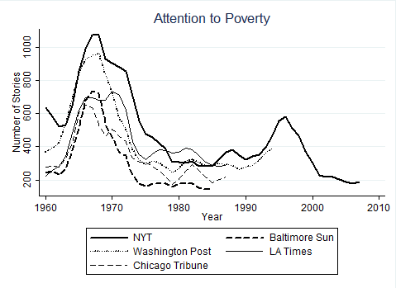
Figure 2. Five Frames of Media Attention to Poverty.
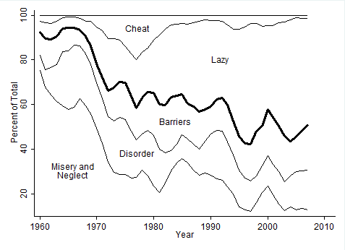

Figure 3. Three Measures of Poverty.
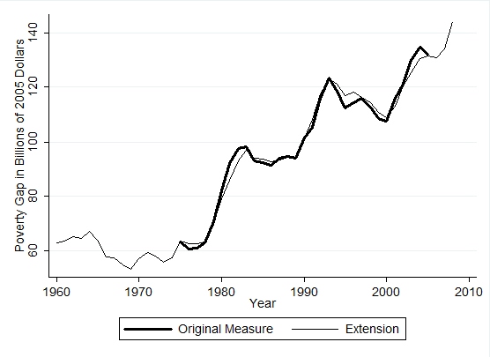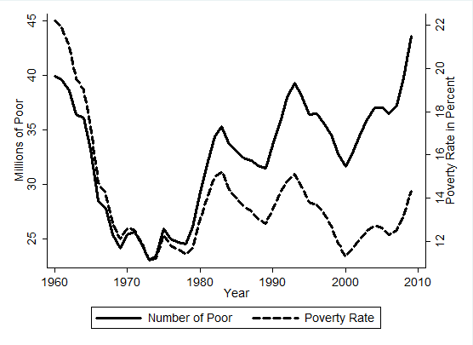
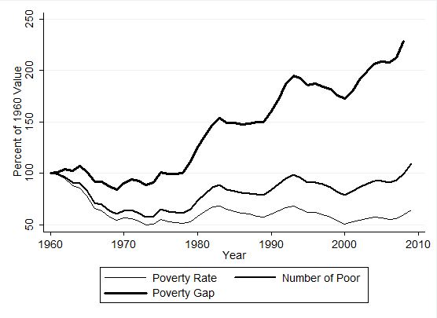
Note: The upper-left figure shows the original poverty gap in the thick line, from the Center for Budget and Policy Priorities, available for the period of 1975 to 2005, and in the thinner line our regression-based extension for the full time period of our study. The upper-right figure shows the number of poor and the percentage of Americans in poverty. The lower figure takes all three series and presents them on a single scale: their value as a percentage of the value in 1960.

Figure 4. Percent of Government Spending on Medical and Non-Medical Poverty Assistance.
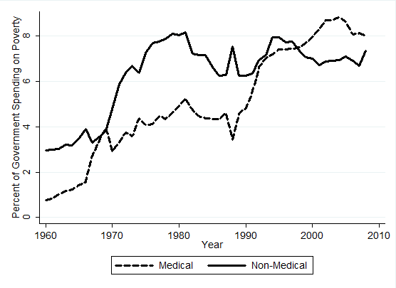

Figure 5. Predicting Total Spending on Poverty Assistance.
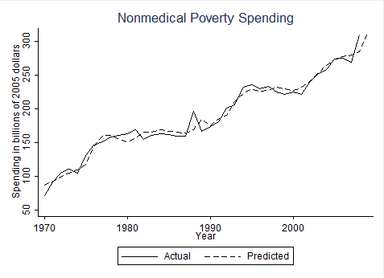

Note: The figure shows that the following regression predicts total spending almost perfectly.
Variable | Coefficient | St. Error | T | Prob.
Spending (lagged 1 year) | .349 | .124 | 2.82 | 0.008
Poverty Gap (lagged 1 year) | .745 | .198 | 3.76 | 0.001
GDP (lagged 1 year) | .008 | .002 | 3.54 | 0.001
Net Tone (lagged 10 years) | .087 | .023 | 3.71 | 0.001
Constant | –51.14 | 15.50 | –3.30 | 0.002
N = 39; Adj. R² = 0.97; Breush-Godfrey LM test Chi-2 1.75, prob = 0.1815; DW = 2.064.

Note from the discussion of the creation of our measure of the poverty gap that there is a potential issue of collinearity, as the extension of the original measure was based on some of the same variables used here. Below is the same regression using observed, not estimated, numbers for the poverty gap. Note that the number of observations is slightly lower but that the coefficients are very similar.
Variable | Coefficient | St. Error | T | Prob.
Spending (lagged 1 year) | .312 | .152 | 2.05 | .051
Poverty Gap (lagged 1 year) | 1.08 | .287 | 3.77 | .001
GDP (lagged 1 year) | .008 | .003 | 2.93 | .007
Net Tone (lagged 10 years) | .083 | .024 | 3.49 | .002
Constant | –45.17 | 18.14 | –2.49 | .020
N = 31; Adj. R² = 0.95

Note: the identical model without the lagged dependent variable shows results that can be interpreted in a similar manner. The lagged dependent variable corrects for the trending nature of the data. Residuals from this specification show no correlation with the dependent variable (r = –0.0000) or over time (r = –0.0035).

Figure 6. An Index of Government Generosity toward the Poor.
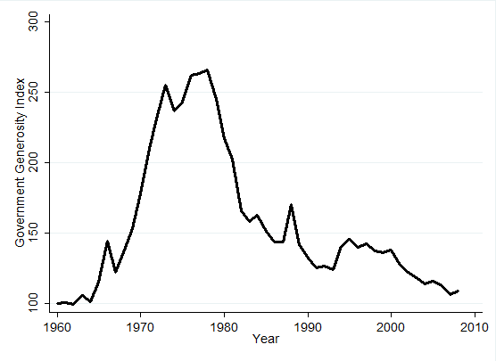

Figure 7. Media Framing and Government Generosity toward the Poor.
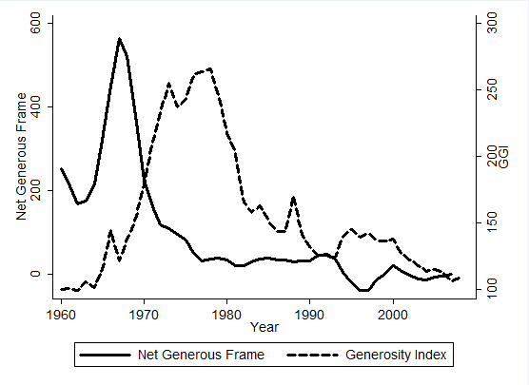
Note: The Government Generosity Index can be predicted with the value of the net tone of newspaper coverage of poverty ten years previously. This simple model explains 82 percent of the movement in the GGI.
Variable | Coefficient | St. Error | T | Prob.
Net Tone (lagged 10 years) | .305 | .02 | 13.13 | .000
Constant | 129.9 | 4.41 | 29.48 | .000
N = 39; Adj. R² = 0.82

Figure B.1. Percent Generous Poverty Coverage in Five US Newspapers 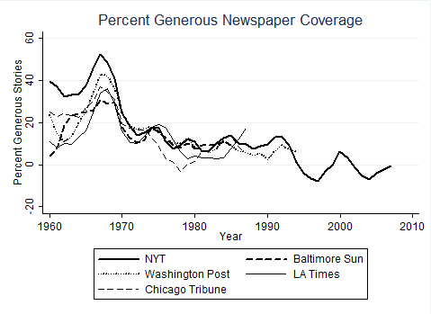

Figure C.1. Extending the Pre-Transfer Poverty Gap Measure.
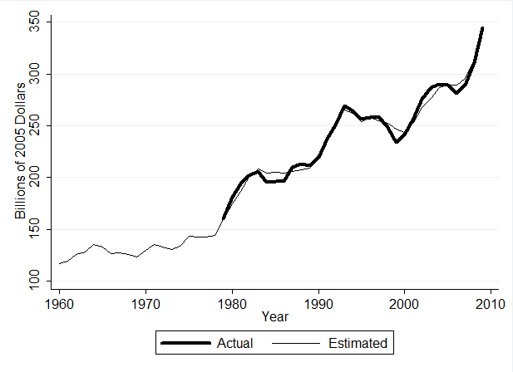

Figure C.2. Pre- and Post-Transfer Estimates of the Poverty Gap.
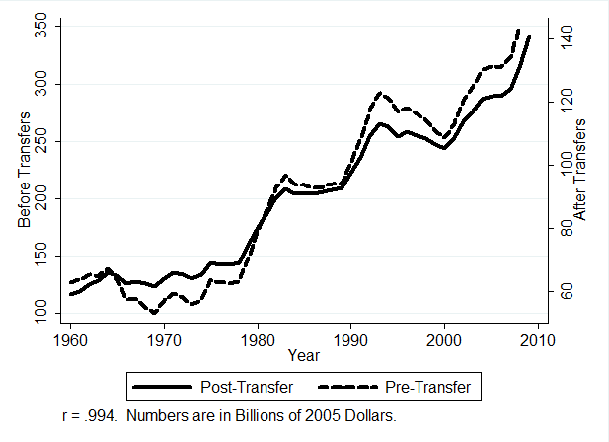

Figure C.3. Predicted and Actual Government Generosity Index based on Regression Estimate from Figure 7; Revised Using Pre-transfer Poverty Gap
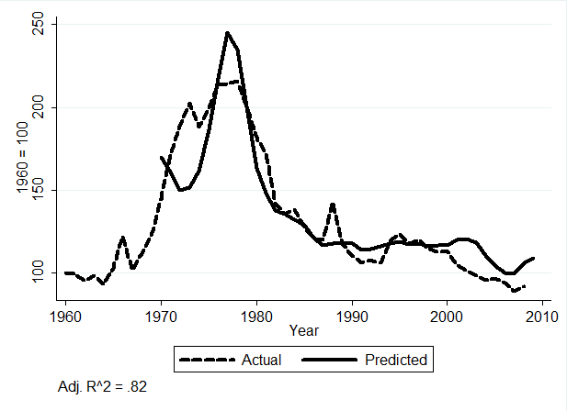

References
Albritton, Robert B. 1979. “Social Amelioration through Mass Insurgency? A reexamination of the Piven and Cloward Thesis.” American Political Science Review. 4(December): 1003–1011.
Avery, James M., and Mark Peffley. 2003. “Race Matters: The Impact of News Coverage of Welfare Reform on Public Opinion.” In Race and the Politics of Welfare Reform, ed. Sanford Schram, Joe Soss, and Richard C. Fording. Ann Arbor, MI: University of Michigan Press, 131–150.
Baumgartner, Frank R., Suzanna L. De Boef and Amber E. Boydstun. 2008. The Decline of the Death Penalty and the Discovery of Innocence. New York: Cambridge University Press.
Baumgartner, Frank R., and Bryan D. Jones. 1993. Agendas and Instability in American Politics. Chicago: University of Chicago Press.
Berke, Richard L. 1992. “The 1992 Campaign: The Ad Campaign: Clinton Getting People off Welfare,” The New York Times: Sept. 10, 1992.
Blank, Rebecca M. 1997. It Takes a Nation: A New Agenda for Fighting Poverty. Princeton, NJ: Princeton University Press.
Burtless, Gary, and Timothy M. Smeeding. 2001. “The Level, Trend and Composition of Poverty.” In Understanding Poverty, ed. Sheldon H. Danziger and Robert H. Haveman. New York: Russell Sage Foundation, 27–68.
Cancian, Maria, and Sheldon Danziger. 2009. “Changing Poverty and Changing Antipoverty Policies.” In Changing Poverty, Changing Policies, ed. Maria Cancian and Sheldon Danziger. New York: Russell Sage Foundation, 1–32.
Chong, Dennis, and James N. Druckman. 2007. “Framing Theory.” Annual Review of Political Science 10 (June): 103–26.
Citro, Constance F., and Robert T. Michael. 1995. Measuring Poverty: A New Approach. Washington, D.C.: National Academy Press.
Cox, Robert Henry. 1998. “The Consequences of Welfare Reform: How Conceptions of Social Rights are Changing.” Journal of Social Policy 27 (1): 1–16.
Currie, Janet M. 2006. The Invisible Safety Net: Protecting the Nation's Poor Children and Families. Princeton, NJ: Princeton University Press.
Danziger, Sheldon H. and Daniel H. Weinberg. 1994. “The Historical Record: Trends in Family Income, Inequality, and Poverty.” In Confronting Poverty: Prescriptions for Change, ed. Sheldon H. Danziger, Gary D. Sandefur and Daniel H. Weinberg. New York: Harvard University Press, 18–50.
Druckman, James N. 2001. “On the Limits of Framing Effects: Who Can Frame?” Journal of Politics 63, 4 (November): 1041–66.
Durnam, Eugene. 1973. “Have the Poor Been Regulated: Toward a Multivariate Understanding of Welfare Growth.” Social Science Review 47 (September): 339–359
Entman, R. M. 2007. “Framing Bias: Media in the Distribution of Power.” Journal of Communication 57 (March): 163–173.
Fording, Richard C. 1997. “The Conditional Effect of Violence as a Political Tactic: Mass Insurgency, Welfare Generosity and Electoral Context in the American States.” American Journal of Political Science 41(January): 1–29
Gilens, Martin. 1999. Why Americans Hate Welfare: Race, Media and the Politics of Antipoverty Policy. Chicago: University of Chicago Press.
Gilens, Martin. 2003. “How the Poor Became Black: The Racialization of American Poverty in the Mass Media.” In Race and the Politics of Welfare Reform, ed. Sanford Schram, Joe Soss, and Richard C. Fording. Ann Arbor, MI: University of Michigan Press, 101–130.
Guetzkow, Joshua. 2010. “Beyond Deservingness: Congressional Discourse on Poverty, 1964–1996.” Annals of the American Academy of Political and Social Science 629 (May): 173–97.
Hancock, Ange-Marie. 2004. The Politics of Disgust: The Public Identity of the Welfare Queen. New York: New York University Press.
Handler, Joel F., and Yeheskel Hasenfeld. 1991. The Moral Construction of Poverty: Welfare Reform in America. Newbury Park, CA: Sage Productions.
Handler, Joel F., and Yeheskel Hasenfeld. 1997. We the Poor People: Work, Poverty and Welfare. New Haven, CT: Yale University Press.
Handler, Joel F., and Yeheskel Hasenfeld. 2007. Blame Welfare: Ignore Poverty and Inequality. New York: Cambridge University Press.
Harrington, Michael. 1962. The Other America: Poverty in the United States. New York: Pelican Books.
Johnson, Mark. 2003. “Racial Context, Public Attitudes, and Welfare Effort in the American States.” In Race and the Politics of Welfare Reform, ed. Sanford F. Schram, Joe Soss, and Richard C. Fording. Ann Arbor, MI: University of Michigan Press, 151–170.
Katz, Michael B. 2001. The Price of Citizenship: Redefining the American Welfare State. New York: Metropolitan Books.
Katz, Michael B. [1986] 1996. In the Shadow of the Poorhouse: A Social History of Welfare in America. 2nd Ed. New York: Basic Books.
Katz, Michael B. 1989. The Undeserving Poor: From the War on Poverty to the War on Welfare. New York: Pantheon Books.
Kendall, Diana. 2011. Framing Class: Media Representations of Wealth and Poverty in American. Lanham, Maryland: Rowman & Littlefield Publishers, Inc.
Kingdon, John W. 1984. Agendas, Alternatives, and Public Policies. New York: HarperCollins.
Lakoff, George. 2004. Don’t Think of an Elephant! White River Junction, Vermont: Chelsea Green Publishing.
Lieberman, Robert C. 1995. “Social Construction.” American Political Science Review 89 (June): 437–41.
Mead, Lawrence M. 1986. Beyond Entitlement: The Social Obligations of Citizenship. New York: The Free Press.
Mead, Lawrence M. 1992. The New Politics of Poverty: the Nonworking Poor in America. New York: Basic Books.
Mead, Lawrence M. 2011. “Welfare Politics in Congress.” PS: Political Science & Politics 44 (April): 345–356.
Misra, Joya, Stephanie Moller and Marina Karides. 2003. “Envisioning Dependency: Changing Media Depictions of Welfare in the Twentieth Century.” Social Problems 50 (November): 482–504.
Nelson, Thomas E., Rosalee A. Clawson, and Zoe M. Oxley. 1997. “Media Framing of a Civil Liberties Conflict and Its Effect on Tolerance.” American Political Science Review 91 (September): 567–583.
O’Connor, Alice. 2001. Poverty Knowledge: Social Science, Social Policy, and the Poor in Twentieth-Century U.S. History. Princeton, NJ: Princeton University Press.
Piven, Frances Fox and Richard Cloward. 1971. Regulating the Poor: the Functions of Public Welfare. New York: Vintage Books.
Rector, Robert, Katherine Bradley, and Rachel Sheffield. 2009. “Obama to Spend $10.3 Trillion on Welfare: Uncovering the Full Cost of Means-Tested Welfare or Aid to the Poor.” The Heritage Foundation.
Scholz, John Karl and Kara Levine, 2001. “The Evolution of Income Support Policy in Recent Decades.” In Understanding Poverty, ed. Sheldon H. Danziger and Robert H. Haveman. New York: Russell Sage Foundation, 193–228.
Schneider, Anne and Helen Ingram. 1993. “Social Constructions of Target Populations: Implications for Politics and Policy.” The American Political Science Review 2(June): 334–347.
Schneider, Saundra K and William G. Jacoby. 2005. “Elite Discourse and American Public Opinion: The Case of Welfare Spending.” Political Research Quarterly 58 (3): 367–379
Shapiro, Robert Y., Kelly D. Patterson, Judith Russell and John T. Young. 1987. “The Polls: Public Assistance.” Public Opinion Quarterly 51 (Spring): 120–130
Smith, Mark A. 2007. The Right Talk: How Conservatives Transformed the Great Society into the Economic Society. Princeton: Princeton University Press.
Spar, Karen. 2006. “Cash and Noncash Benefits for Persons with Limited Income: Eligibility Rules, Recipient and Expenditure Data, FY2002–FY2004.” Congressional Research Service.
Swartz, Katherine. 2009. “Health Care for the Poor: For Whom, What Care, and Whose Responsibility?” Changing Poverty, Changing Policies, ed. Maria Cancian and Sheldon Danziger. New York: Russell Sage Foundation, 330–364.
The New York Times. 1976. “’Welfare Queen’ Becomes Issue in Reagan Campaign.” Feb. 5.
Trattner, William I. [1974] 1999. From Poor Law to Welfare State: A History of Social Welfare in America. 6th ed. New York: Simon & Schuster.
Weaver, R. Kent, Robert Y. Shapiro and Lawrence R. Jacobs. 1995. “Poll Trends: Welfare.” Public Opinion Quarterly 59 (Winter): 606–627.
Weinberg, David H. 1985. “Filling the ‘Poverty Gap’: Multiple Transfer Program Participation.” The Journal of Human Resources 20(Winter): 64–89.
Weinberg, David H. 1987. “Poverty Spending and the Poverty Gap.” Journal of Policy Analysis and Management 6(Winter): 230–241.
Ziliak, James P. 2003. “Filling the Poverty Gap, Then and Now.” University of Kentucky Center for Poverty Research.
Ziliak, James P. 2006. The Intensity and Inequality of Poverty. Foundations and Trends in Microeconomics. Hanover, MA: Publishers Inc.

Appendix A. Measuring Government Aid to the Poor
The Congressional Research Service (CRS) and the Heritage Foundation have produced the two most thorough datasets of government aid to the poor. CRS, the professional staff that produces research for Congress, writes a regular report on poverty policy, Cash and Noncash Benefits for Persons with Limited Income: Eligibility Rules, Recipient and Expenditure Data (Spar 2006). The report sums the budget totals for 84 government programs to produce an annual estimate from 1975 to 2004. The U.S. House Committee on Ways and Means uses the historical table from this report to produce its quadrennial Green Book, cited widely in policy literature (Levitan et al. 2003, 32–37).
The other set of data comes from the Heritage Foundation, a right wing think tank, as part of calculations for Obama to Spend $10.3 Trillion on Welfare: Uncovering the Full Cost of Means-Tested Welfare or Aid (Rector et al. 2009). The authors only slightly alter the list of programs in the CRS report, eliminating educational programs that also provide aid to higher income levels and adding community grants. The Heritage report calculates poverty expenditures from 1950 until 2008, with predictions through 2018. Presented in a Congressional hearing and available widely on the Internet, the report attempts to cast doubt on the spending choices of the Obama Administration. While they approach the issue with different motivations, CRS and Heritage produce similar calculations.
(Insert Table A. 1 Here)

Appendix B. Media Framing of Poverty in Five Newspapers
In Figure 1 we showed the correspondence of New York Times coverage of poverty issues as compared to four other newspapers. Figure 2 showed the shifting frames of New York Times coverage. Table B.1 shows the terms excluded in the searches of other newspapers, to avoid duplications.
(Insert Table B.1 here)
Figure B.1 shows the percent “generous” frames across these same papers. Note that all papers were not available for the entire time period of interest, which is why we use the New York Times in our analysis. But these data suggest that we would reach very similar results with a broader range of newspapers.
(Insert Figure B.1 here)

Appendix C. Pre- and Post-Transfer Estimates of the Poverty Gap.
A possible concern in the analysis presented in the paper is that our measure of the poverty gap is based on estimates of poverty after the payment of income taxes and the receipt of transfer payments. We therefore test here the robustness of our findings when using a pre-transfer estimate of the poverty gap. We thank Prof. James Ziliak of the University of Kentucky for providing data from 1979 to 2009.

First: Extend the series.
As we did in Figure 3, we start by extending the series to cover our entire time span. We use the same regression as reported above, but we omit government spending on poverty, as that should affect post-transfer numbers, but not those before government transfers have taken place; indeed this is the entire reason for the robustness test we do here. The simple model including the number of poor and the poverty rate explains 85 percent of the variance in Ziliak’s measure of the pre-transfer poverty gap. Table C.1 shows these results and Figure C.1 shows the resulting series.
(Insert Table C.1 and Figure C.1 about here)

Second: Compare Pre- and Post-Transfer Gap
The two measures of the poverty gap are substantially different, as one might imagine. Indeed, the difference between them can be seen as a measure of the effectiveness of the tax and spending system. If spending were sufficient to eliminate the poverty gap, then the pre-transfer number could be substantial but the post-transfer number would be zero. Figure C.2 shows the comparison of the two series.
(Insert Figure C.2 about here)
Measured in Billions of 2005 dollars, the pre-transfer poverty gap is consistently about 2.2 times as large as the post-transfer measure. The dashed line reflects our estimate of the Gap before transfers and it ranges from approximately 100 billion to over 300 billion dollars over the length of our study, as shown on the left scale of the graph. The solid line, measured on the right scale, shows the post-transfer numbers, which range from 60 to 140 billion. The correspondence in growth of the two series over time is obvious.

Third: Re-estimate the Link between Framing and the Government Generosity Index Using the Revised Figures.
Considering what may be a surprisingly close correspondence between pre- and post-transfer indicators of the poverty gap, it will now be no surprise that our estimate of the Government Generosity Index is virtually unchanged when we calculate it using the pre- rather than post-transfer estimates of the poverty gap (the correlation between the two is 0.9948). In Table C.2 and Figure C.3 we re-estimate the regression from Figure 7 and show virtually identical results.
(Insert Table C.2 and Figure C.3 about here)

This is according to post-government transfer measurements of the poverty rate, from the U.S. Census Bureau’s Historical Poverty Tables.
As we will explain further, we use calculations for means-tested spending from the Heritage Foundation and for total government spending from the White House Office of Management and Budget.
As part of a large project to estimate public mood across many policy domains, Frank Baumgartner and Jim Stimson have used all available poverty-related survey questions to estimate a “poverty mood.” This measure is available from 1964 through 2010, and is highly cyclical in its movements. Like the mood more generally, respondents seem to assert that the government is “doing too much” during times when Democrats are in power and “doing too little” when Republicans are in the White House. The measure does not correlate highly with any of our measures, including relatively objective measures of how much government is doing to help the poor. Public opinion is certainly affected by the framing that we describe here, and it certainly affects official actions. But we do not have indicators that reflect this so cannot integrate public opinion into our statistical analyses.
The search strings reported in Table 1 are the result of weeks of interactive adjustments to our procedures. For each year ending in 3, 6 or 9, we read 20 stories from the beginning of the year and 20 from the end. Of the 560 articles read through these procedures, 517 were true hits, reflecting a 92.3 percent accuracy of the searches. Of course, it is impossible to know how many stories we may have missed. We do believe these search terms have accurately assessed the level of attention to poverty across time, however. Even if we missed a certain percentage of all stories, trends over time would not be affected unless the percentage omitted differed across time, which we have no reason to expect.
Note that the terms listed in Table 1 represent the end product of an extensive set of tests and experiments designed to isolate a set of terms that accurately reflect poverty issues. The 92 percent accuracy attests to the refinements we made in the terms based on our initial trial-and-error efforts.
For example, the Los Angeles Times has many different versions, so that identical articles, which appear both in the San Fernando edition and the San Gabriel edition, often appear in a search as different articles. To eliminate this problem, the search in the Los Angeles Times excludes the articles in the San Fernando, San Gabriel, Orange County, San Diego, and valley editions. To mitigate this variability between newspapers, we read dozens of articles in each of the non-New York Times newspapers and excluded articles that contained a number of different terms.
Correlations between the total coverage in the New York Times and the four other papers shown in Figure 1 are: .92, .90, .84, and .92. Other newspapers correlate with each other at similar levels; the lowest correlation among all the newspapers reported is .84.
To check the accuracy of the data, we read 20 New York Times articles in each decade for each frame. Out of the 500 articles, 467, or 93.7%, were positive hits. Because the positive hits represent such a majority of the framing searches, we use all of the articles.
Note that the keyword searches conducted to construct Table 2 are not mutually exclusive. An article selected through the procedures explained in Table 1 might appear in none, one, or more than one of the categories in Table 2. However, despite the non-exclusive and non-exhaustive nature of the search process used, the results do show trends over time that correspond with qualitative research in the area and with our own understandings of shifts in the nature of the debate.
Although the impact of disorder is clearly mixed, we code it as a generous frame because it correlates negatively with the stingy frames. However, the misery and neglect and laziness and dysfunction drive the changes in framing during the time period of this data. Statistically, our count of stories relating to disorder correlates weakly with either the generous frame or with spending. We code it as part of the generous frame partly because doing so underestimates, rather than overestimates, the strength of the changes we document. If we were to revise the coding of these stories in the later part of our series, as may be reasonable, this would only make the shift towards stingy frames even more remarkable.
The National Academy of Science, in a panel chaired by Robert Michael with a study directed by Constance Citro, developed recommendations for an alternative poverty measures, and the U.S. Census Bureau has tracked eight alternative thresholds since 1999, based on those recommendations. In 2009, the official poverty level fell directly in the middle of those eight alternative measures.
Our measure of total government spending on poverty assistance comes from data provided by Rachel Sherman, of the Heritage Foundation, and tracks closely with a Congressional Research Service report. It incorporates spending at the local, state, and federal levels on means-tested programs (see Appendix A for more details).
The Poverty Gap = 8.37582 + (6.11472 x millions of people in poverty) – (8.548732 x the poverty rate) + (.016533 x non-medical poverty spending at all levels of government). Adj. R-sq. = 0.9837; N = 31. Using total poverty spending rather than non-medical spending produces nearly identical results to those shown below (R-sq = 0.9855); we use the non-medical measure for reasons explained below.
Our regression is a measurement model, not a theoretical one. We simply want to extend the series and find that these three variables predict the poverty gap nearly perfectly. Interpreting the coefficients requires understanding that each controls for the other. So increases in the rate of poverty lead to declines in the gap, but only controlling for the incidence of poverty and the amount of spending. Similarly, it seems counter-intuitive that spending on poverty is positively related to the size of the gap, but that may be because the spending has a delayed effect, or because the spending is never enough to address the size of the gap, though it may alleviate it. In any case, the purpose of this regression is simply to establish a longer time series for the poverty gap measure.
The Congressional Research Service report Cash and Noncash Benefits for Persons with Limited Income: Eligibility Rules, Recipient and Expenditure Data, FY2002–FY2004 lists 84 programs, but the Heritage Foundation’s report Obama to Spend $10.3 Trillion on Welfare: Uncovering the Full Cost of Means-Tested Welfare or Aid, used in this study and explained in Appendix A, lists 74. The lists are nearly identical and produce very similar spending estimates, but CRS includes veterans programs and the Stafford Student loan program, not included by Heritage, while Heritage includes several types of community development grants.
We make this distinction for conceptual reasons, but in fact there is little empirical distinction. Because they have both grown over time, the correlation between medical and non-medical poverty assistance spending from 1960 to 2008 is 0.93. Calculating our GGI with medical spending included as compared to excluding it as we do leads to two measures that correlate at the level of 0.998.
Figure 5 is based on total spending in billions of 2005 dollars, where in Figure 4 we presented those numbers as percentages of GDP. The underlying data are the same.

