Driving While Black and the Officer is White

Officer and Driver Characteristics and the Odds of Search following a Routine Traffic Stop

Frank R. Baumgartner*, Kate Bell, Luke Beyer, Tara Boldrin, Libby Doyle, Lindsey Govan, Jack Halpert, Jackson Hicks, Katherine Kyriakoudes, Cat Lee, Mackenzie Leger, Sarah McAdon, Sarah Michalak, Caroline Murphy, Eyan Neal, Olivia O’Malley, Emily Payne, Audrey Sapirstein, Sally Stanley, Kathryn Thacker

Abstract
Using data from two years of traffic stops in Charlotte, NC, we evaluate the factors associated with the officer’s decision to search the driver or vehicle. White male officers, officers with less experience, drivers that fit the “young minority male” criminal stereotype, and traffic stops for investigatory rather than safety purposes and in low-income neighborhoods powerfully affect the odds of search. These go from zero percent to over 30 percent as a given interaction includes more targeting factors. There is little racial effect in the odds of search among women, for either drivers or officers. Among males, however, white officers show more than double the odds of search than other officers, and black drivers are much more likely to be searched than whites. While male officers are particularly likely to be aggressive in their interactions with motorists, a finding that may have wide implications.

Keywords: racial profiling, racial disparity, policing, traffic stops, “driving while black”

Baumgartner is corresponding author
Richard J. Richardson Distinguished Professor of Political Science
UNC-Chapel Hill
Chapel Hill, NC 27599-3265
Frankb@unc.edu

Draft for comments, November 5, 2018

Introduction
Somewhere in Charlotte, North Carolina, a young black male is driving to work; a white male police officer observes. Within the next few blocks, the officer finds a reason to pull the driver over—perhaps a broken tail light, or maybe an expired tag. After pulling the driver over, the officer questions him, and in a short time, must decide whether or not there is a sufficient level of suspicion of criminal activity to conduct a search. Meanwhile, across town, a different officer, not a white male, sees a car run a red light. When this officer pulls the car over, he or she finds that the driver is an older white female. The officer must make the same decision as above—is the driver engaged in some criminal activity that warrants a search, or was the public safety enhanced simply by catching them in an egregious traffic violation?
In Charlotte, North Carolina, during calendar years 2016 and 2017, an incident like the first scenario occurred 6,977 times, of which 1,158, or 17 percent, led to a search. The second situation occurred 1,113 times, of which only four, or 0.36 percent, led to a search. The young black male stopped for an investigatory stop had over 40 times the likelihood of being searched compared to the white female pulled over for a moving violation, though a moving violation is a greater public safety concern than an expired registration tag.
While the actions of the black male did not obviously merit a stop, the older white female endangered the lives around her; in fact, her behavior, by definition, violates the law. Yet being a white female, she does not fit the stereotype of criminality, whereas the young black male driver does. The stereotype outweighs the behavior itself. In both cases, the officers were in “low information” environments where they had to make a decision quickly and without much evidence. In a way, the use of stereotypes is unsurprising and perhaps difficult to avoid. To the extent that visible characteristics of a driver, the officer, their location, and the stop purpose allow us to explain the decision to search, we can understand whether and to what extent such stereotyping profiles are driving police behavior. That is exactly what we do here.
We analyze more than 80,000 traffic stops from two years in the City of Charlotte, North Carolina. We find powerful evidence that the likelihood of police search is largely contingent on certain characteristics, specifically race, gender, and years of experience of the officer, the race, gender, and age of the driver, and the location and purpose of the traffic stop.
We are careful to note the non-linear characteristics in the complex relations between officers and drivers that we analyze. For example, while white, male, and officers with less experience are much more likely to show assertive behavior compared to other officers, other officers show similar racial disparities. Therefore, if all officers share a police culture about the greater odds of a young black male fitting the profile of a stereotypical criminal suspect than other citizens, they act on these suspicions from a different baseline of assertiveness. Similarly, black drivers are targeted for searches more than whites, but this relationship is modest, even trivial, among women while it is extremely powerful among men. Thus, we confirm the expectations and findings from many previous studies, but we provide new insights about the intersections of the different identity characteristics of the officer, the driver, and the conditions of the traffic stop itself.
In all, our study highlights the complexities of identity and to the multiple disadvantages of particular individuals; young black men interacting with white male police officers face very daunting odds indeed. Understanding police-community relations requires that we look carefully at the intersections of race, gender, age, and other influencing factors and that we not only look at the identities of the citizens but of the officers as well. We find powerful effects for both here.

Theories of Disparate Treatment
Nationally, more than 20 million Americans are pulled over for a routine traffic stop each year; in fact, 86 percent of Americans cite a traffic stop as their most recent interaction with a law enforcement officer (Langton and Durose 2013). Traffic stops are “low-information” situations: the officer has just a few minutes, a short conversation with the driver, and a quick computer search of the license tags or operating license to determine whether to conduct a search. In the vast majority of cases, of course, no search is conducted – barely over 4 percent in our dataset. When a search occurs, drivers immediately understand that the officer views them with suspicion. Thus, our collective experiences with traffic stops, the most common citizen-police interactions, tell us a lot about how the police view us. For most Americans, a traffic stop is unwelcome, frustrating, but generally rare and trivial. For some, it is an all-too common and powerful signal that officers view them with suspicion.
Many scholars have noted that in a low-information environment such as a traffic stop, stereotypes and profiles may play an outsized role in police decision-making. Variation among officers is also an important driving force: some demographic groups on the force are more or less likely to assert their authority more aggressively in various situations. And, of course, in the world of policing as in real estate, location matters. Apparent race-of-driver effects could simply be driven by the possibility that the police behave differently in different neighborhoods. It stands to reason that they might be more aggressive in their policing practices in those areas of town where there is more crime. In this section, we briefly review these studies.

Characteristics of the Traffic Stop
In their major study of citizen response to traffic stops, based on a survey of 2,329 drivers in Kansas City metropolitan area, Epp, Moody, and Haider-Markel (2014, see also 2016) make a crucial distinction: Drivers can tell when they were pulled over for a reasonable traffic safety purpose, and when the stop was the outcome of an officer’s “fishing expedition” based on a hunch or a suspicion. Police practices since the 1970s have made clear that any violation of the traffic or vehicle code may be used as a legally enforceable excuse to take a closer look at a driver. Any technical violation of the law, even a slight crack on a reflective light, or a shadow extending over the license plate, may be enforced, at the officer’s sole discretion. If that discretion is used simply as a pretext to investigate a driver, then the driver might well feel that they were being racially profiled. Epp, Moody, and Haider-Markel (2016) refer to “safety” and “investigatory” stops to make this distinction, and they note that blacks are more than twice as likely as whites to be the subjects of these investigatory stops. It is important to note that pretextual use of the law has consistently been found to be legally acceptable by the courts, but drivers may understand that it is not fair (see Epp et al. 2016; Meares et al. 2016; Baumgartner et al. 2018).
Baumgartner, Epp, and Shoub (2018) use the Epp et al. distinction to classify the North Carolina traffic stop purposes into safety and investigatory groups. Traffic safety stops are less likely to lead to search, and the searches that result from them show lower rates of racial disparity. Investigatory stops, on the other hand, show higher racial disparity in the resulting searches. We build on their work here, classifying the 10 traffic stop purposes identified in the Charlotte traffic stops data collection into two groups, safety and investigatory. Investigatory stops may result in searches more often because they could be associated with poverty indicators (e.g., cars in poorer physical condition, resulting in more equipment problems; expired registration tags because the car may be unable to pass the required inspection or the driver may not have the funds to pay the registration fee), or they might simply be excuses for the officer to conduct a legally justified stop, when the driver is breaking no traffic law or even moving.
An important characteristic of the traffic stop is where it occurs. Police leaders often point out that their officers need to be more aggressive in those areas where they respond more often to citizen calls for help. Where crime is higher, police may be more commonly present, and more assertive in their interactions. Of course, these areas may differ by both race and social class, with areas with higher poverty suffering from more crime as well as more aggressive police activity.

Officer Characteristics
Many studies of racial diversity in police departments revolve around the question of whether the organizational culture of the police profession (“blue”) supersedes a more generalized racial identity (e.g., “black”). These studies have pinpointed both ideological and behavioral differences among black and white officers (Dowlet 2005; Moskos 2008; Woods 2014, Morin et al. 2017). This idea of “black v. blue” derives in part from studies of “tokenism,” first proposed by Kanter (1977), who studied women in traditionally male professions. Tokens are members of groups that make up less than 15 percent of their work category. Kanter identifies three prominent characteristics of tokens: visibility, polarization, and assimilation. Kanter and others following up on her ground-breaking work found that female police officers are more visible, subjecting them to negative stereotypes fueling social isolation, reduced peer acceptance (Yoder 1991), and high levels of hostility. This, in turn, causes minority (female) officers to overcompensate by aligning themselves with their non-minority (male) counterparts (Hassel and Brandl 2009). Lundman (2009) also found that minorities tend to adopt the norms of the majority group, whites. Black officers, in sum, are often found to be more “blue than black” (Rowe 2012, Van Maanen 1975, Wilkins and Williams 2008).
This theory of “tokenism” has prompted a series of studies noting the effect of increasing minority police representation on racial disparities in police behavior. Hong (2017) analyzes the relationship between the racial makeup of a police force and their use of racial profiling as a policing tactic. Hong finds that over a 10-year period in which England and Wales enacted a police reform program, which targeted for recruitment of officers from ethnic and minority groups, a one standard-deviation increase (1.58 percent) in the share of ethnic minority police officers was associated with a 20 to 39 percent decrease in the proportion of ethnic minority citizens subjected to stops and searches. These findings would seem to contradict the earlier studies; minority presence on the force does indeed decrease racial disparities in outcomes. However, the UK-focus of the study and the low levels of diversity in the police agencies analyzed generate questions about applicability to the US context.
In a similar study but with contrasting results, Wilkins and Williams (2008) investigate the impact of black police officers on the racial disparity of vehicle stops. They compared the percentage of black officers per police division with the number of vehicle stops of black drivers as a portion of the eligible black residents in the patrol area, finding that increases in black police officers coincided with increases in the racial disparity of vehicle stops. This suggests that the increase in racial disparity is due to the high levels of organization socialization (e.g., the “black to blue” phenomenon) (Wilkins and Williams 2008). Wilkins and Williams (2009) conducted a similar study regarding Latino rather than black officers and had similar results.
Woods (2014) analyzed data from 27 semi-structured interviews with police officers to understand how diversity affects police departments, finding that white officers are more assertive when it comes to stops in order to “punish a person” and “move to the next issue,” instead of assessing each situation (Woods 2014, 162). However, black officers “try to head off unintended escalations” and are less assertive in these situations (Woods 2014, 161). Woods finds these differences are related to the fact that the black officers can relate with the stereotypical driver pulled over, a black young male.
Klahm and Tillyer (2015) analyze the relationship between officer experience and behavioral choices in discretionary situations. The authors studied the search rates of officers in a large police department in the Southwestern United States across two consecutive six-month periods, examining how exposure to certain groups (specifically young, black, males, or those with criminal history), past behavior, and past performance influenced officer behavior. Their findings indicated that all three variables influenced an officer’s decision to initiate a search during a traffic stop, although past performance had a less of an impact than expected. McElvain and Kposowa (2004, 275) showed that veteran officers are less likely to be investigated for use of excessive force, suggesting that officers with less experience may be more assertive and that these tendencies decrease with years of service. Furthermore, Morin et al. (2017) found that officer support for the use of force, or assertive police tactics, was stronger among officers with fewer years of experience. Attitudes soften with experience, apparently.
Brown and Frank (2005) examined the factors that influence the issuance of a citation or arrest in both non-traffic and traffic encounters, looking at 671 encounters that did not result in arrest despite suspicion by an officer in Cincinnati, Ohio from 1997 to 1998. Looking at the final outcomes of traffic stops, they found that that white officers were more likely to make an arrest than black officers, and black citizens were 13 percent more likely to be arrested instead of receiving citations than white drivers in similar situations. Also in Cincinnati, Ohio, Brown and Frank (2006) investigated the behavior of 996 police officers at street-level encounters with citizens between April 1997 and April 1998 in Cincinnati, Ohio. Findings suggest that officers were more likely to arrest suspects who committed a felonious offense, who were intoxicated or disrespectful to the officer, or who were juveniles. In accordance with their previous study, they found that white officers were more inclined to arrest suspects than black officers (Brown and Frank 2006). Similarly, Brown et al. (2009) looked at differences in police treatment of adults and juveniles by the Cincinnati Police Department between 1997 and 1998, finding that white officers were more likely to both assert authority in an encounter with a juvenile, and to make an arrest.
The “warrior mentality,” which is the view that the police are an occupying force, and the role of the police officer is to assert and maintain control, has been adopted by many police departments (Vitale 2017), shifting from the long-held ideology of Guardianship after 9-11 (Rahr and Rice 2015). Neither police departments nor police officers are monolithic; however, these authors point to shifts in police culture normalizing the use of authority to assert control. In this view, police have focused less on using their presence to help foster positive and safe community relations and more on asserting control.
Beyond these broad changes in the police environment, studies reviewed above make clear we should expect many, but complex, differences among officers of different demographic groups. Most assertive officers would likely be the white males; they personify authority, have fewer reasons to expect citizens not to respect it, and expect their views and decisions to be accepted by their peers. Minority and female officers may well adopt the same views of criminality as their white male counterparts, but we can expect them to be less assertive in their dealings with the public. This may be because they are accustomed to using different methods to deal with conflicts, an expectation that citizens may be less likely to accept their authority, or less confidence that fellow officers and superiors will take their side in the case of dispute.

Driver Characteristics
Close and Mason (2006a) use Florida Highway Patrol data on traffic stops from 2000 to 2002 to analyze police interactions based on the demographics of the officers and the drivers. They found that white officers had a higher search rate but a lower contraband hit rate, while black and Latino officers conducted fewer searches and had a higher hit rate. Black and Latino officers were less likely than white officers to request a search based on physical, verbal, or document indicators. White women were the least likely demographic to be searched, whereas black men were the most likely. Close and Mason (2006b) use the same dataset to analyze the impact of officer and driver demographics on the severity of enforcement action by the officers. They found that white women are least likely to receive punitive action, like a felony or misdemeanor charge; conversely, black men and Latinos were more likely to receive punitive action.
Rojek (2012) analyzed the relationship between driver and officer attributes and the rate of traffic stops in St. Louis during 2007, finding that vehicle stops and searches were most likely to occur between a white officer and a black driver and between the hours of 6 am and 6 pm. Officers conducting the traffic stops were most likely to be white, male, 30 years or older, and without a four-year degree while the drivers were likely to be black, male, 30 years or older, and residents outside of the city. This officer/driver combination is five times more likely to result in a search than other combinations, leading Rojek to conclude that “despite the diversification in law enforcement agencies in recent decades—including the agency under consideration in this study—Black citizens continue to receive disparate treatment from the police” (Rojek 2012, 1016). Rosenfeld, Rojek, and Decker (2011) examined approximately 48,000 stops of black male and white male drivers, with a focus on those permitting a discretionary search, which composed 80 percent of all traffic stops. Traffic stops in which the driver was a black male under the age of 30 resulted in search roughly 14 percent of the time compared with 8 percent for their white counterparts. The chances of being searched were lower if the officer was black than if the officer was not black
Tillyer, Klahm, and Engel (2012) found that men and those under 30 were more likely to be stopped compared to women or older drivers. Young, black, males were more likely to be searched for discretionary reasons. They looked at officers as well as drivers, finding that white officers, those assigned to traffic patrol duties, and those with fewer years of experience were more likely to conduct discretionary searches.
Tillyer and Engel (2013) also discuss the specific combinations of drivers’ race, gender, and age, and traffic stop outcomes that are more and less likely to result in arrests or other disciplinary action using data from a multiyear study assessing patterns of traffic stop in a full service, state law enforcement agency with 280,567 total traffic stops. They found that white drivers were warned most frequently while Hispanic drivers were arrested and cited most often. Additionally, female drivers and older drivers were both warned more frequently while male drivers and young drivers were arrested and cited most often. So, the more punitive outcomes were reserved for those who fit the “criminal profile.”

Intersectional Disadvantage
Numerous scholars have noted that race, class, gender, and other identity-related factors do not merely accumulate in an additive manner; rather, the cumulative disadvantage to a person who shares numerous individual characteristics of disadvantage is “more than just the sum of its parts” (for examples and a review, see Collins and Bilge 2016). Thus, we expect not only the nonlinearities by race and gender, but in particular that disadvantage will be cumulative, setting far apart those with many disadvantages from those with just a few.

Hypotheses
Overall, and considering the literature reviewed above, we can expect a number of clear patterns to emerge. Regarding officer-level effects, white male officers and officers with fewer years of service will be more assertive; female and minority officers will be more likely to find alternative means of resolving conflicts; all officers will show similar rates of racial disparity in their interactions with members of the public. Regarding driver effects, we can formulate the “criminal stereotype” or “criminal profile” hypothesis. We can also note, however, that the interactions of age, race, and gender need not be linear. In particular, while younger drivers are more likely to “fit the profile” than older drivers, no matter the race or gender, racial effects are stronger among men than women. That is, the “criminal profile” is targeted by age, race, and gender. A young minority male is at a greater disadvantage compared to a young white male than a young minority female is, compared to a young white female. Regarding the characteristics of the stop, we expect significant differences by the type and location of the stop. Investigatory stops may be targeted at individuals more likely to fit the “criminal stereotype”, and policing patterns will differ substantially by location. Beyond only gender and race, we expect that those with multiple disadvantages will be particularly targeted, with the targeting accelerating with the accumulation of disadvantage, not simply growing in a linear progression. In all, this leads to the following testable hypotheses, with a person or vehicle search as the signal of suspicion.
- White male officers will have higher search rates than other racial and gender groups.
- Officers with less experience will have higher search rates than officers with more experience.
- Officers of different racial and gender groups will show similar disparities in the rates at which they search drivers of different demographic profiles.
- Young minority males will be searched more frequently than drivers of other age, race, and gender combinations.
- Race effects will be stronger among male drivers than female drivers.
- Officers will conduct more searches during investigatory stops than safety stops.
- Search rates will be higher in areas of the city with more poverty.
- Search rates will increase in an accelerating manner as the combination of driver, officer, and stop characteristics includes more “targeted” elements.

Data and Research Approach
Charlotte, NC is the state’s largest city with a 2010 population of approximately 800,000, of which 45 percent are white, 35 percent black, and 13 percent Hispanic. The Charlotte-Mecklenberg Police Department (CMPD) provides two years of data on traffic stops at the city’s open data portal, and we retrieved the full 2016 and 2017 data, consisting of 88,056 traffic stops. We use the occurrence of a search as our outcome variable of interest. A search is a powerful indicator that the officer views the driver with suspicion, so it is an appropriate test for whether the officer views the driver as a potential criminal suspect, and an officer’s decision to search a person or vehicle after a routine traffic stop certainly corresponds to the “low information” decision-making environment described in our theory section.
Note that the Charlotte database does not indicate the reason for the search or if the search yielded contraband. In a larger analysis of all North Carolina traffic stops from 2002 through 2016, Baumgartner et al. (2018, 59) found that 3.36 percent of stops lead to search, with most of these being based on: a) consent; b) incident to arrest; and c) probable cause. Many fewer searches were conducted based on: d) protective frisk; or e) search warrant. That study also found that about 25 to 30 percent of searches yielded contraband of some type, but that the contraband hits were typically very small, resulting in arrest just one-third of the time (Baumgartner et al. 2018, 114).
Baumgartner et al. (2018) also found significant effects on search rates by time of day. The morning rush hour clearly differs dramatically from other times of day; search rates are low during the rush hour but much higher in the wee hours of the morning. Similarly, they found that different police agencies differed dramatically from one-another in such basic characteristics of the number of traffic stops per population, and the baseline search rates. We do not address the time-of-day hypothesis here because the data made public by the Charlotte police department does not include that variable. We do not assess the second variable here because the present study is limited to just one police department.

Results
Table 1 gives a summary of search rates by various characteristics of the drivers and officers.
(Insert Table 1 about here)
Overall, just over four percent of traffic stops result in a search. Searches are more common among: black drivers, male drivers, younger drivers, and drivers stopped for investigatory rather than traffic safety reasons. Black drivers compared to whites have 3.6 times the odds of search (6.28 search rate for black drivers / 1.73 for white drivers = 3.6). Baumgartner et al. (2018, 86) showed that, across 20 million traffic stops in North Carolina from 2002 through 2016, this black-white search rate ratio was 5.05 / 2.35, or 2.15. Thus, on the face of it, the racial disparity in search rates is much higher in Charlotte during 2016 and 2017 than was found in this statewide study.
Officer characteristics associated with higher search rates include: white males and those with fewer years of service. White officers encountering black drivers have more than a 7 percent search rate, more than double any other officer-driver combination. White officers search black drivers 3.7 times more than they search white drivers (7.22 / 1.93 = 3.7). Black officers search drivers less than half as often as white officers do, and are particularly unlikely to search white drivers. In fact, black officers search drivers of either race less than half as often as white officers do. However, just like the white officers, the black officers search black drivers more than 3 times as often as they search white drivers (3.48 / 0.89 = 3.9). This pattern suggests a complicated interaction: black officers search less, but when they do, they show almost precisely the same rate of increased likelihood to search a black driver. We will come back to this finding below.
Search rates vary by patrol districts, with most of the areas within the range of approximately 3 to 7 percent. However, three districts (North, Providence, and South) show remarkably low search rates (2.1 percent or lower), and one district (Metro) with a much higher search rate than the others, at over 12 percent. What can explain these differences? One factor might be social class. In Figure 1 we compare the search rates with the average household income in the 13 patrol districts listed.
(Insert Figure 1 about here)
Table 1 showed dramatic differences in search rates. Here we see that those living in the wealthiest areas of Charlotte rarely face assertive action by a police officer; search rates are regularly lower than half the city-wide average in the two wealthiest areas. By contrast, the two districts with the lowest average income have rates of 8 and 12 percent, double and triple the city-wide average. As social class, crime rates, and racial composition can all be correlated, we must be careful in interpreting any bi-variate relationships. Figure 1 makes clear that location matters, and that location is about something more than just place. Officers in different patrol districts are dealing with different mixes of the population in terms of race, income, and crime. This is why it is essential to control for patrol district in a multiple regression framework, as we do below.
Table 1 showed clearly that officer characteristics matter, and they interact in important ways with driver characteristics. In Figure 2, we compare the search rates for drivers of different types for white and black male officers. As Table 1 makes clear, these are the only two demographic groups among officers with enough observations to support a substantial analysis. The black and grey bars represent the search rates for white and black male police officers, respectively, and the labels indicate the characteristics of the driver.
(Insert Figure 2 about here)
In every case, the white male officers are substantially more likely to search than the black male officers. White male officers are more than twice as aggressive in searching drivers, across all demographic groups. Looking first at the male drivers, the white male officers consistently search more than twice as often as the black male officers, but the two sets of bars move in perfect parallel. Compared to how often they search white male drivers, both sets of officers are much more likely to search black male drivers. Looking at the rates of search for female drivers, we see a more complicated pattern. For the black male officers, search rates are low but increase steadily as they move from white female drivers to those of other race to black females, whom they search at over twice of white female drivers. For the white male officers, search rates are much higher, and the order is different: white female drivers are by far the most likely to be searched, even more than white male drivers.
Of course, univariate statistics such as those just described can be misleading. The different patrol districts have vastly different search rates and different racial compositions as well. Population statistics, drivers, and officer deployments differ substantially across the 13 patrol districts, and these location differences could potentially explain some parts of the racial disparity we see in Table 1. To evaluate the impact of demographics, location, and officer characteristics, we turn to logistic regression. The analysis provides an assessment of the likelihood of a search occurring, controlling for the different elements in the model. If the location effects explain the racial disparities, then the analysis should show significant coefficients for the various patrol districts but smaller coefficients for the driver and officer characteristics. Table 2 shows the results of three different logistic regression models.
(Insert Table 2 about here)
We present three models because we want to show the complicated interactions of race and gender, and to show the impact of controlling for patrol district. In Model 1, we assess the odds of search based on the officer being white male, the officer’s years of service, the driver being pulled over for a safety v. an investigatory stop purpose, and characteristics of the driver: age, race, and gender. In Model 2, rather than including a single variable for gender, we include each race-gender combination individually. This allows us to see whether the effect of race is similar among male and female drivers. It is not. Finally, in Model 3, we add the patrol districts.
First, looking across the rows, we see that in all three models, the race and gender of the officer are important and consistent predictors of search: White male officers are 89 percent more likely to search, compared to other officers. We thus confirm Hypothesis 1.
We also find consistent and robust findings regarding years of service: Officers with greater experience on the force search significantly less often, reducing their search rate by about six percentage points for each year of service. Thus, we would expect an officer with 10 years of service, on average and other things held equal, to have less than half the search rate of an officer in their first year of service. We confirm Hypothesis 2.
Hypothesis 3 related to the “black to blue” phenomenon: whether officers of diverse racial backgrounds adopt the stereotypical criminal profile, and in Table 1 we confirmed this. Officers of different demographic backgrounds differ dramatically in their search rates, but not in the racial disparities in the decision of whom to search.
Drivers under the age of 35 are more than twice as likely to be searched compared to older drivers, consistently across all three models, confirming the age element of Hypothesis 4. Similarly, drivers pulled over for investigatory stop purposes rather than for safe driving violations (e.g., speeding, stop light / sign violations, etc.) are also consistently and significantly more likely to be searched. Note that the coefficient declines slightly in Model 3, from 1.82 to 1.62 when we incorporate patrol districts in the analysis. This would indicate that certain patrol districts, with higher search rates, may also see more investigatory traffic stops. Still, Model 3 shows that such drivers are over 60 percent more likely to be searched, when controlling for patrol district. Thus, we confirm Hypothesis 6.
In Model 1 we show a powerful effect for gender: The odds are 3.57 times higher that male drivers would be searched compared to female drivers. However, in Models 2 and 3 we document that gender and race interact in powerful ways. In these models, the reference (excluded) category is the white female driver, so the odds-ratios can be interpreted with respect to such a driver. Black female drivers are slightly more likely to be searched (55 percent more likely in Model 2, but just 21 percent more likely in Model 3, a coefficient which is not quite statistically significant at the .05 level), and Hispanic and other race drivers are less likely to be searched than white female drivers (though these results are not statistically significant).
White male drivers are much more likely to be searched than white female drivers: 91 percent more so in Model 2, and 84 percent more so in Model 3. Note the big difference in this coefficient compared to the gender coefficient in Model 1. For whites, the gender difference is less than two-to-one, whereas it was estimated as 3.57-to-1 in Model 1. The reason for this difference is that the black male driver is in a category of his own. Estimating race and gender effects under the assumption that they are separate and uncorrelated is clearly an error. Model 2 shows an estimate of more than six times the odds of search for a black male driver, compared to a white female (or more than 3 times higher than the rate for the white male driver), and this number remains above five when we control for patrol district in Model 3. The patrol district controls affect this coefficient so much because certain patrol districts are much more likely to feature both a high rate of search and a high percentage of black male traffic stops. Model 3, then, is the take-home conclusion: controlling for patrol district, age, type of officer, years of service of the officer, and stop purpose, a black male driver has more than five times the odds of being searched as compared to a white female driver.
Coefficients for Hispanic males fall close to those for black males; male drivers of other races have slightly lower rates of search than white females, but these differences are statistically insignificant. We thus confirm both Hypothesis 4, that young minority males are targeted, and Hypothesis 5, that race and gender show strong interaction effects, with race a more powerful predictor of search among males than among females.
Controls for the patrol districts themselves produce just four statistical outliers, one of which is high (Metro, with 90 percent increased odds of search, other things equal), and four of which are low. Table 1 showed the raw search rates by district. Most of the districts show rates between 3 and 8 percent, with Metro a high outlier (12.24 in Table 1), and North, Providence, South, and University City significant outliers at the low end (with rates of just 2.10, 1.76, 1.19, and 2.88 respectively). In sum, most neighborhoods of Charlotte are statistically within a narrow range, but one has a particularly high search rate, and 4 are notably less likely to see searches occur. We saw in Figure 1 that these search rates correlate strongly with household income. We therefore confirm significant location effects, consistent with Hypothesis 7. Wealthier neighborhoods see less assertive policing.
It can be difficult to interpret the results of a logistic regression, so we present graphical presentations in Figures 3 and 4. These show the predicted odds of search for drivers of different characteristics, drawing from the estimates presented in Model 3 of Table 2. Figure 3 presents the predicted odds of search by race and gender of the driver, for a driver younger than 35 years old, stopped for an investigatory stop by a white male officer new to the force, in the “average” patrol district. Figure 4 presents a similar comparison across officer demographics for a “typical” young driver stopped by an officer new to the force for an investigatory stop.
(Insert Figures 3 and 4 about here)
Figure 3 shows that the odds of search for a young black male driver are close to 20 percent and that his number declines to about 12 percent for an Hispanic male, 8 percent for a white male, and that all other groups (including females of all racial groups) cluster around four percent. Black female drivers have a slightly elevated rate of search, but the main effects of racial identify are clearly among men. Note that the odds are high for all groups, compared to the average of 4.41 percent overall, because the scenario presented includes a white male officer new to the force, a young driver, and an investigatory stop. Changing the assumptions on these other variables would not change the relative rankings of the race and gender groups displayed here, however.
Figure 4 shows that white male officers have a significantly higher search rate, other things equal, than any other demographic group among officers. In particular, there are no significant differences among white female, black male, or black female officers; their predicted search rates are less than half that of the white male officer. Officers of other race are slightly elevated compared to the three other categories, but white male officers stand alone in their high search rates. Again, these search rates are elevated because the scenario envisions a younger driver, an investigatory stop, and an officer new to the force. Changing those assumptions would not, however, change the relative rank of predicted search rates across officer demographics.
Our analysis so far makes clear that certain characteristics of a driver, an officer, and a traffic stop correspond to a higher likelihood of search. Drivers who are young black males; officers with less experience, officers who are white males; and traffic stops that occur in certain neighborhoods or for potentially pretextual reasons rather than those associated with the putative purpose of a traffic control: keeping the roads safe from dangerous drivers. We identify eight such factors in Table 3.
(Insert Table 3 about here)
For each characteristic, we distinguish between a “targeted” group and the other, non-targeted group. For race, blacks are targeted and whites are not; for gender, males are targeted and females are not; for age, younger drivers are targeted and older ones are not; the table explains all eight comparisons. The table shows how the targeted group, in each case, sees a much higher search rate; typically about three times higher than the non-targeted group.
How do these disparities accumulate? Rather than go through every possible combination of eight dichotomous variable (which would be 512 combinations), we simply count them up and show the results in Table 4 and in Figure 5. A driver might have none of the targeted characteristics: an older white female stopped by a highly experienced female or minority officer for a safety violation in a low search neighborhood would have a score of zero. Perhaps surprisingly, we found 186 such individuals in our database; perhaps unsurprisingly, none of them were searched. Table 4 shows the number of observations and Figure 5 displays the steadily increasing odds of search as one moves from fewer to more targeted characteristics. Here, our analysis clearly confirms Hypothesis 8, on intersectionality.
(Insert Table 4 and Figure 5 about here)
Drivers with fewer than five targeted characteristics have less than a two-percent search rate. These odds more than double with the fifth overlapping disadvantage or unfortunate coincidence associated with that traffic stop, and the odds get worse and worse as the number of overlapping disadvantages increases. By the end, there is more than a 33 percent chance of search, quite substantial given that the baseline expectation across the city of Charlotte is just 4 percent.

Discussion
At the beginning of this article, we presented two scenarios: one in which a white male police officer stopped a young, black, male driver for an investigatory stop, and one in which a non-white male police officer stopped an older, white, female driver for a safety violation. Our data show that the massive discrepancies in search rates between these stops are significant and consistent across Charlotte.
Our findings are consistent with prior research on both officer and driver characteristics. No matter the race of the officer, the young black male driver is searched at a higher rate. This suggests that officers of all backgrounds, having accepted the police culture, share a common general stereotype of a “criminal suspect.” Thus, our data provides empirical support for theories of tokenism and the idea that the “blue culture” supersedes an officer’s racial identity (Kanter 1977; Hassel and Brandl 2009; Lundman 2009; Ott 1989; Yoder 1991; Hassel and Brandl 2009; Rowe 2012; Van Maanen 1975; Wilkins and Williams 2008).
Of course, we also showed powerful effects of officer race and gender: white male officers are clearly more assertive than any other demographic group on the force. Black male officers and female officers of any race show much lower rates of search, with male officers of other race approaching but not equally in the high rates of search shown by white male officers. These findings support prior research noting differences in the ideology and behavior of white and minority officers (Dowlet 2005; Moskos 2008; Woods 2014, Morin et al. 2017; Brown and Frank 2005; Brown and Frank 2006; Brown et. al. 2009). However, our research goes beyond previous studies by combining the race and gender of the officer as opposed to treating them as separate variables. In doing so, we find that white male officers are in a category of their own. Thus, race by itself does not define how assertive a police officer will be; it is the combination of race and gender, with the white male officer being the most aggressive (see also Klahm and Tillyer 2015; McElvain and Kposawa 2004; Morin et. al. 2017).
Turning from officers to drivers, our results support our theory that black males are far more likely to be searched than other drivers, holding all else constant. This is consistent with prior research finding that harsher and more punitive outcomes are more likely for minority male drivers (Close and Mason 2006a, b; Rojek 2012, 2016; Tillyer, Klahm, and Engel 2012; Tillyer and Engel 2013). Our research expands to new territory, however, by finding that the race effect only exists for males. Though females of all races are searched at similar rates, Hispanic males are searched 1.4 times more often, and black males 2.7 times more often, than white males. So, race only has a statistically significant impact on the likelihood of a search if the driver is a male.
Regarding the traffic stop itself, we support previous research which found that location and stop purpose influence the likelihood that a search is conducted (Epp, Moody, and Haider-Markel 2014, 2016; Baumgartner, Epp, and Shoub 2018). The higher the percentage of minorities within an area, the higher the likelihood that drivers in that area will be searched. Traffic safety violations are much less likely to lead to search than investigatory stops. And, drivers in wealthy areas of town need have little fear of being searched after a stop. Aggressive police behavior is much more likely to occur in poor neighborhoods.
Finally, we found a number of non-linearities in the relationships described here. There is no single race effect, as it differs dramatically by gender both for drivers and officers. In both cases, we found trivial to reduced race-based differences among women, but very powerful ones among men. When we looked at the number of targeting characteristics associated with a driver, the officer who pulled them over, and the location and purpose of the traffic stop, we found that disadvantages clearly accumulate, rendering an individual with a high number of disadvantages to be more than 50 times as likely to be searched compared with drivers with no or just a few disadvantaging characteristics.

Conclusion
The death of Trayvon Martin launched America into a national conversation about the relationship between police and black communities. The conversation may have started with Trayvon Martin and the Black Lives Matter movement, but it continued with Michael Brown, Tamir Rice, Philando Castile, and so many others who, unfortunately for them, fit the stereotype of a criminal. From January through October 2018 alone, twelve unarmed black men have been fatally shot by the police (Washington Post 2018). Americans are finally creating a platform to address why young black men are getting killed by white male police officers. Our analysis has touched only on routine traffic stops in one community; however, our findings about the officer- and driver-related factors associated with assertive policing decisions may speak to these larger issues. While we looked at the odds of search, many fatal encounters nationwide have started with a routine traffic stop, similar to the ones we have analyzed here. After all, the deaths of Walter Scott, Samuel DuBose, and Philando Castile all followed from a routine traffic stop, as did that of Sandra Bland.
As the national media have given more attention to black deaths at the hands of the police, it has sparked a larger debate among members of all races about potential solutions. One proposed solution is to change the racial composition of the police force to better reflect the communities they serve. Although this idea seems logical, our study has shown that increasing diversity on a police force may not have the results one imagines. While white male officers are much more assertive than other types of officers, it appears that the stereotypical concept of a criminal as a young black male lurks in the minds of officers of all races and genders. This criminal stereotype is so deeply embedded in our society due to our country’s history of racism and oppression. Moving those in the criminal justice world away from it will take more than only hiring a few more minorities on the force.
Jack Glaser (2006, 2015) has made the distinction between justified and unjustified targeting. If one group commits more crime than another, then it stands to reason that police will (and should) pay more attention to them. The question is how accurately the police do this. In a series of simulations, he shows that if the police over-target one group, they will be arrested in greater proportion than their criminal behavior would warrant, making assertions of the greater criminal behavior within the group a self-fulfilling prophecy. But more importantly, he shows that if there is over-targeting of one group, then there must be under-targeting of another. Crime is reduced only when the targeting is accurate; under-policing one community is just as much a public safety problem as over-policing another, in other words. So, aside from concerns of equity and fairness, public safety concerns should drive us to want to avoid over-targeting based on stereotypes. James Gibson and Michael Nelson (2018) have recently document the enormous chasm between white and black Americans in their views of the US legal system; blacks distrust it. Tom Tyler and various colleagues (see for example Sunshine and Tyler 2013) has documented how feeling that an interaction with the criminal justice system was unfair has long-term consequences. Our findings give added credibility to assertions of unfairness, and this should concern us all.

Tables and Figures
Table 1. Variation in Search Rates in Charlotte Traffic Stops, 2016–17.
 | Traffic Stops | Searches | Percent Searched
Overall | 88,056 | 3,881 | 4.41
Driver Characteristics
White | 27,161 | 470 | 1.73
Black | 48,615 | 3,055 | 6.28
Hispanic | 8,893 | 321 | 3.61
Other | 3,387 | 35 | 1.03
Male | 51,679 | 3,225 | 6.24
Female | 36,377 | 656 | 1.80
Less than 35 years old | 46,975 | 2,874 | 6.12
35 years old or older | 41,081 | 1,007 | 2.45
Investigatory stop | 50,183 | 2,992 | 5.96
Safety stop | 37,873 | 889 | 2.35
Officer Characteristics
White | 62,712 | 3,141 | 5.01
Black | 14,809 | 365 | 2.46
Hispanic | 3,685 | 170 | 4.61
Asian-American | 5,174 | 132 | 2.55
Other or unknown race | 1,506 | 72 | 4.78
Male | 80,500 | 3,642 | 4.52
Female | 7,556 | 239 | 3.16
White male | 56,813 | 2,951 | 5.19
Black male | 13,847 | 337 | 2.43
White female | 5,899 | 190 | 3.22
Black female | 962 | 28 | 2.91
Other or unknown race | 10,535 | 375 | 3.56
Less than 5 years of service | 27,620 | 1,683 | 6.09
Five to 13 years of service | 30,689 | 1,816 | 5.92
14 or more years of service | 29,747 | 382 | 1.28
Officer-Driver Combinations
White officer, White driver | 19,440 | 376 | 1.93
White officer, Black driver | 34,741 | 2,507 | 7.22
White officer, Other race driver | 7,531 | 258 | 3.43
Black officer, White driver | 4,594 | 41 | 0.89
Black officer, Black driver | 8,250 | 287 | 3.48
Patrol Districts
Central | 4,187 | 172 | 4.11
Eastway | 9,144 | 332 | 3.63
Freedom | 4,090 | 260 | 6.36
Hickory Grove | 7,446 | 454 | 6.10
Independence | 5,475 | 275 | 5.02
Metro | 4,085 | 500 | 12.24
North | 7,250 | 152 | 2.10
North Tryon | 7,037 | 530 | 7.53
Providence | 10,266 | 181 | 1.76
South | 9,356 | 111 | 1.19
Steele Creek | 6,063 | 250 | 4.12
University City | 5,585 | 161 | 2.88
Westover | 6,847 | 456 | 6.66
Missing | 1,225 | 46 | 3.76

Table 2. Predicting the Likelihood of Search.
 | Model 1 |  | Model 2 |  | Model 3
Variable | Odds-Ratio  (SE) | Prob. | Odds-Ratio  (SE) | Prob. | Odds-Ratio  (SE) | Prob.
Officer is White Male | 1.89  (.074) | .000 | 1.89  (.074) | .000 | 1.89  (.075) | .000
Officer years of service | 0.94  (.003) | .000 | 0.94  (.003) | .000 | 0.94  (.003) | .000
Investigatory stop purpose | 1.82  (.073) | .000 | 1.82  (.074) | .000 | 1.62  (.067) | .000
Driver is less than 35 years old | 2.31  (.088) | .000 | 2.30  (.088) | .000 | 2.33  (.089) | .000
Driver is male | 3.57  (.157) | .000
Driver is Black | 2.82  (.144) | .000
Driver is Hispanic | 1.52  (.113) | .000
Driver is of another race | 0.52  (.093) | .000
Driver is Black female |  |  | 1.55  (.154) | .000 | 1.21  (.123) | .054
Driver is Hispanic female |  |  | .93  (.177) | .720 | .77  (.147) | .168
Driver is female of another race |  |  | .78  (.259) | .461 | .77  (.253) | .421
Driver is White male |  |  | 1.91  (.199) | 0.00 | 1.84  (.192) | 0.00
Driver is Black male |  |  | 6.36  (.577) | 0.00 | 4.91  (.454) | 0.00
Driver is Hispanic male |  |  | 3.34  (.359) | 0.00 | 2.65  (.289) | 0.00
Driver is male of another race |  |  | .93  (.205) | .743 | .85  (.188) | .465
Patrol Districts
Central |  |  |  |  | 0.66  (.115) | .017
Eastway |  |  |  |  | 0.67  (.110) | .014
Freedom |  |  |  |  | 1.10  (.186) | .556
Hickory Grove |  |  |  |  | 0.97  (.157) | .833
Independence |  |  |  |  | 1.04  (.174) | .807
Metro |  |  |  |  | 1.90  (.310) | .000
North |  |  |  |  | 0.38  (.067) | .000
North Tryon |  |  |  |  | 1.03  (.167) | .855
Providence |  |  |  |  | 0.50  (.085) | .000
South |  |  |  |  | 0.36  (.066) | .000
Steele Creek |  |  |  |  | 0.93  (.157) | .689
University City |  |  |  |  | 0.44  (.078) | .000
Westover |  |  |  |  | 1.13  (.183) | .466
Constant | 0.004  (.0003) | .000 | 0.006  (.0007) | .000 | 0.010  (.0019) | .000
N |  | 88,056 |  | 88,056 |  | 88,056
Log Likelihood |  | -13826 |  | -13802 |  | -13478
LR Chi-2 | (8) | 4169 | (11) | 4217 | (24) | 4865
Pseudo-R2 |  | .1310 |  | .1325 |  | .1529
Note: Omitted categories, or baselines, are: Officer Race, “other than white male”; Driver Race, “white”; Driver race-gender: “White female”; Patrol District, “missing”.

Table 3. Observed Rates of Search.
 | Non-Targeted Group | Targeted Group | N
Driver Race (White-Black) | 1.73 | 6.28 | 75,776
Driver Sex (Female-Male) | 1.80 | 6.24 | 88,056
Driver Age (Older-Younger) | 2.49 | 6.25 | 88,056
Officer is White Male (No-Yes) | 2.98 | 5.19 | 88,056
Officer Years of Service (High-Low) | 2.48 | 6.31 | 88,056
Safety Related v. Investigatory v. Stop | 2.35 | 5.96 | 88,056
Low Search Neighborhood (Yes-No) | 1.65 | 5.62 | 88,056
High Search Neighborhood (No-Yes) | 4.03 | 12.24 | 88,056
Note: Figures show the observed percent of drivers searched. Age is split at its median: 33 years old and younger are “young”; those 34 and older are “old.” Officer years of service is similarly split at its median: 8 years and less is “low”; 9 years and more is “high.” Low search neighborhoods are the patrol districts of North, Providence, and South. Metro is the only high search neighborhood.

Table 4. Rates of Search by Number of Targeted Characteristics.
Number of Targeted Characteristics |  | N | Percent Searched
None |  | 186 | 0.00
One |  | 2,749 | 0.22
Two |  | 8,471 | 0.48
Three |  | 13,789 | 1.02
Four |  | 17,013 | 2.04
Five |  | 15,949 | 4.91
Six |  | 10,324 | 10.24
Seven |  | 3,527 | 19.51
Eight |  | 243 | 33.97
Total |  | 72,251 | 4.65
The number of targeted characteristics is the count of such characteristics from Table 3.

Figure 1. Search Rates by the Average Household Income in the Patrol District.
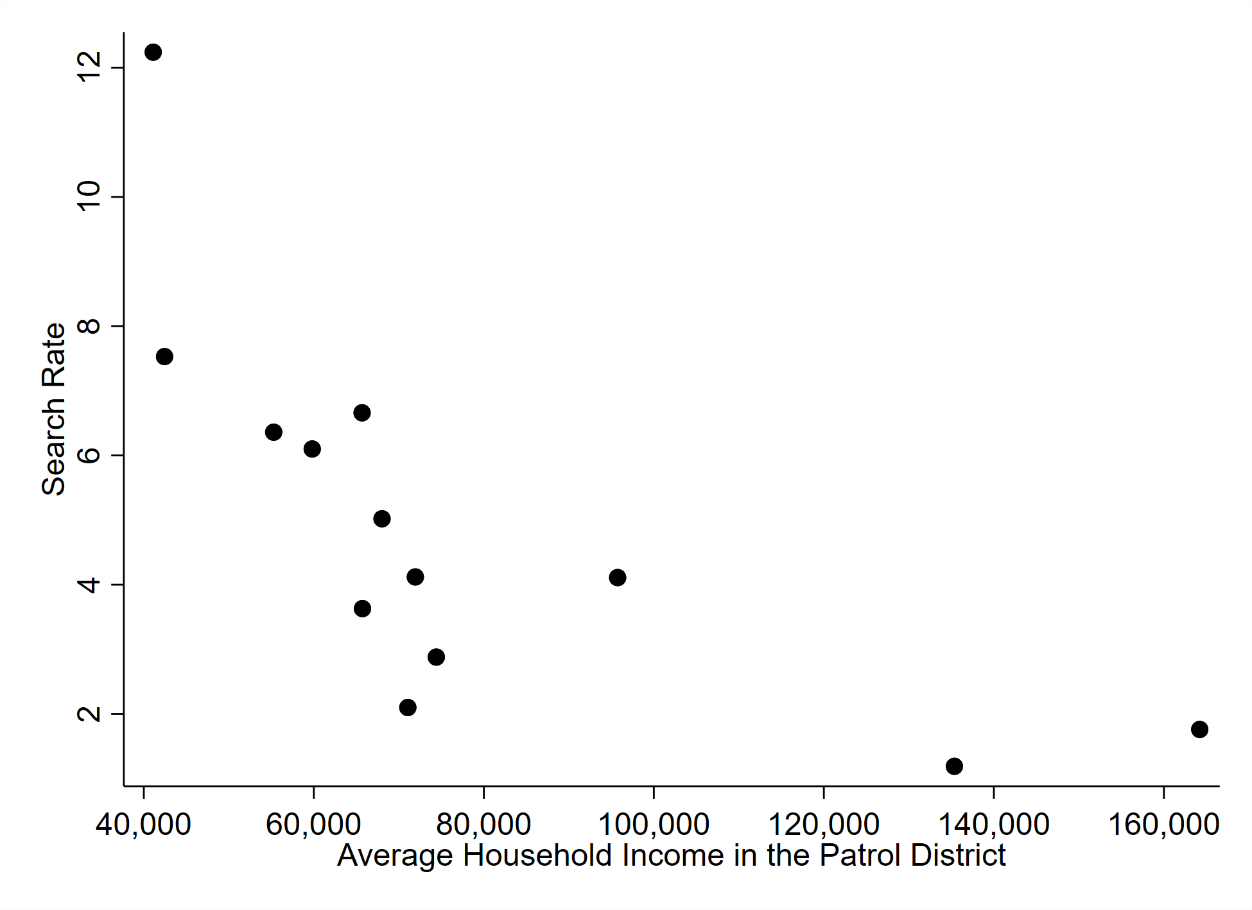
Source for household income: Calculated from the US Census based on Social Explorer Tables: SE 2016 Tract Estimates (SE), SE 2016 Tract Estimates.
Figure 2. Search Rates by Driver Characteristics, Black and White Male Officers Compared.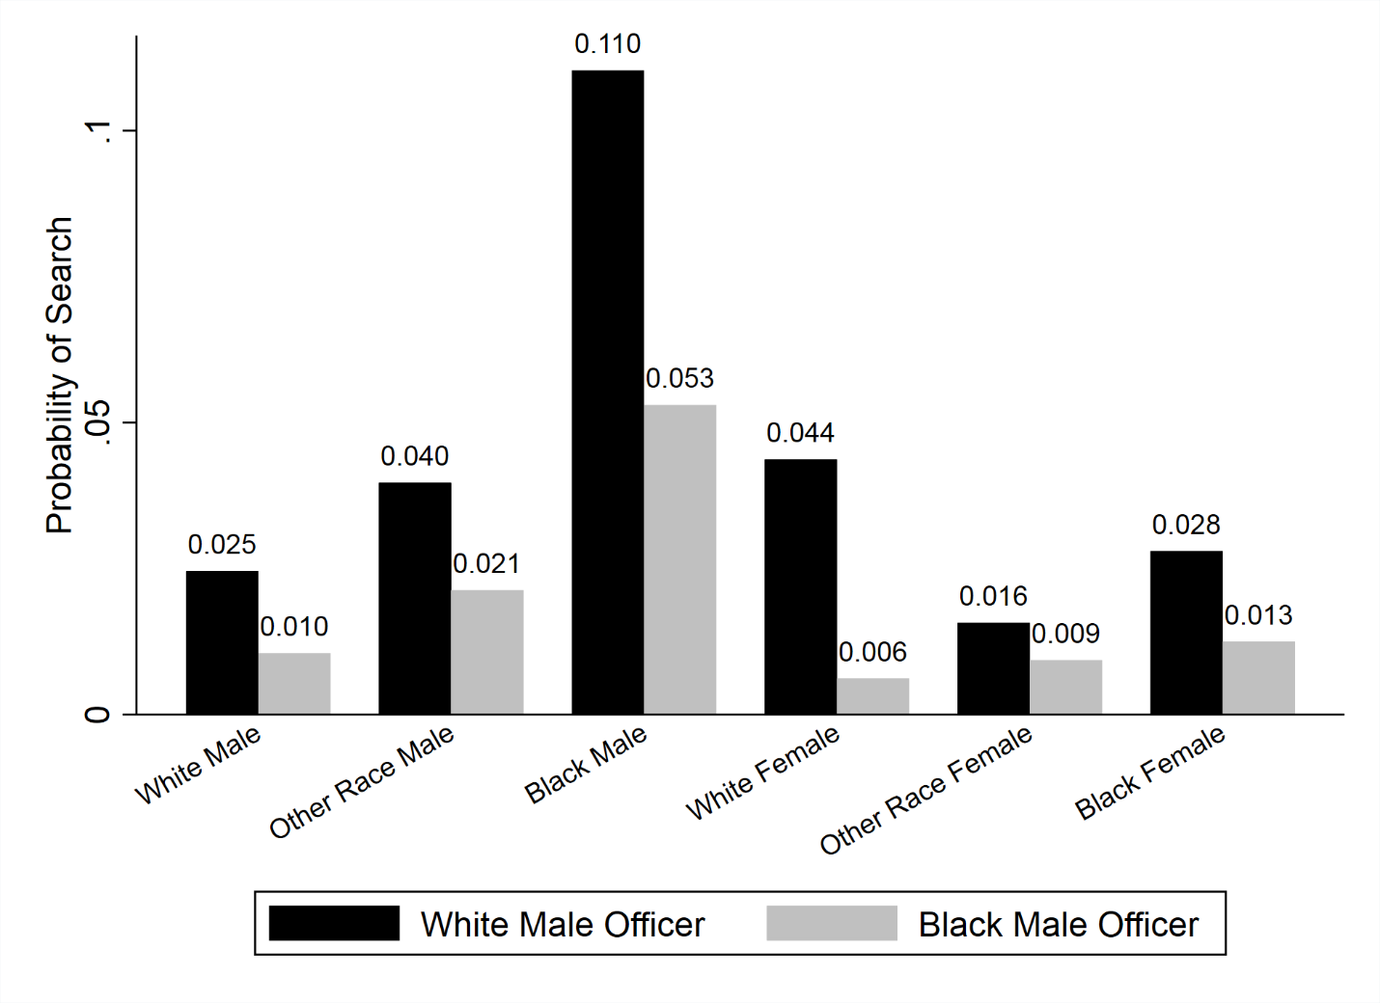
Figure 3. Predicted Search Rates by Characteristics of the Driver.
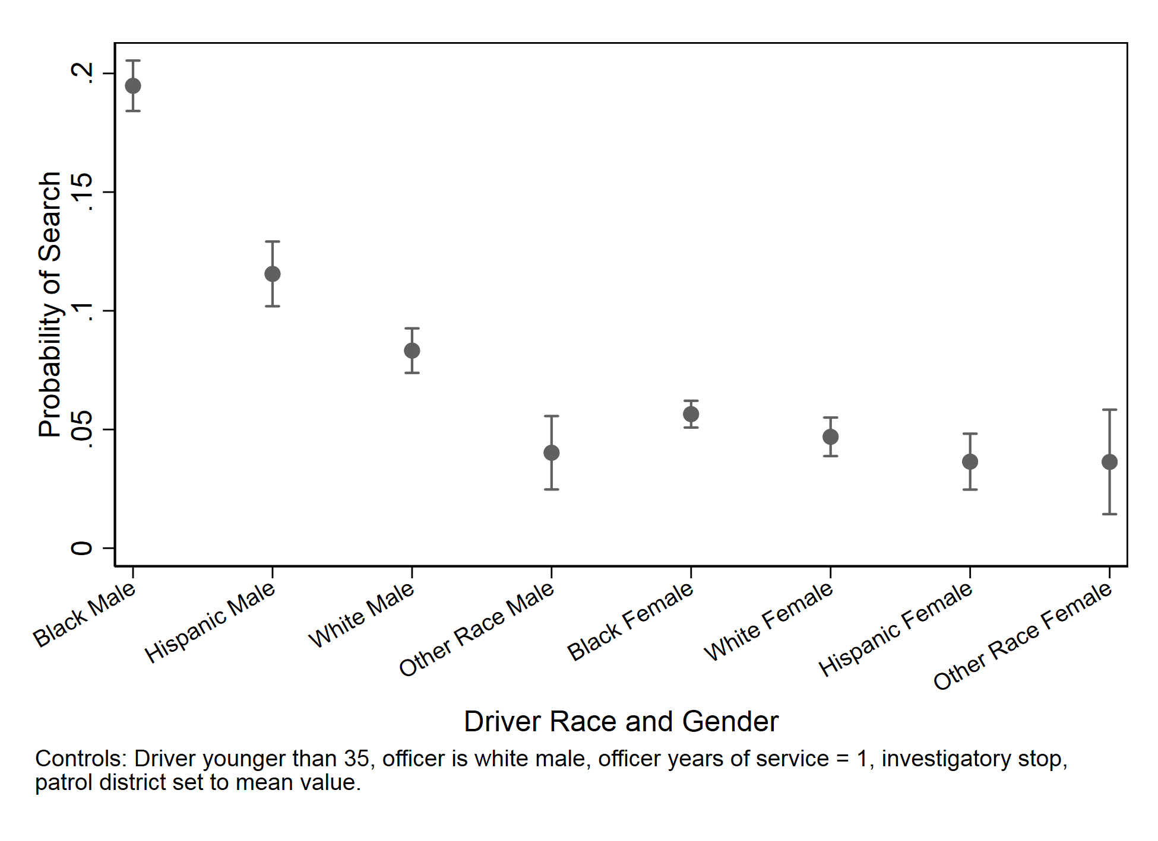

Figure 4. Predicted Search Rates by Characteristics of the Officer.
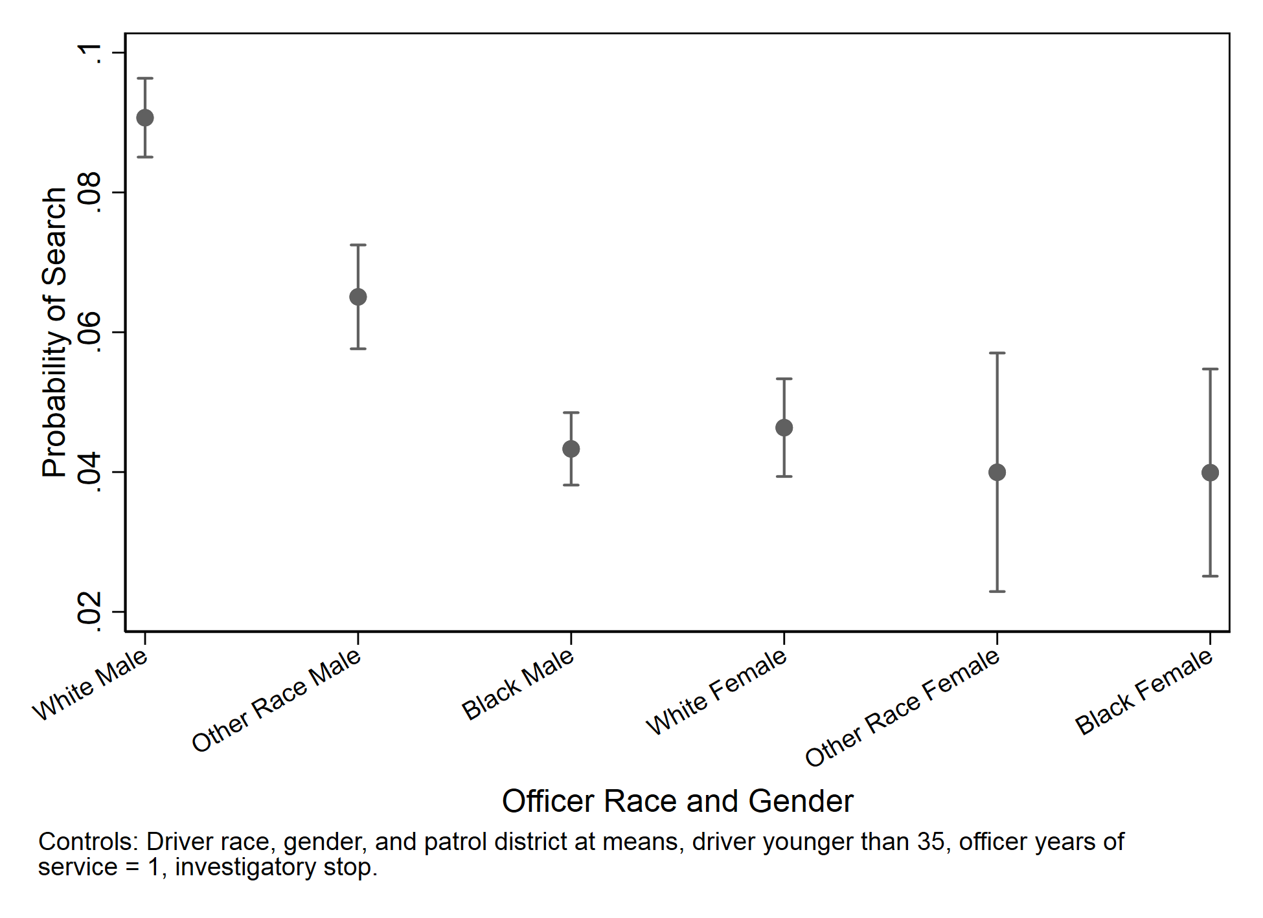

Figure 5. Probability of Search by Number of Targeted Characteristics.
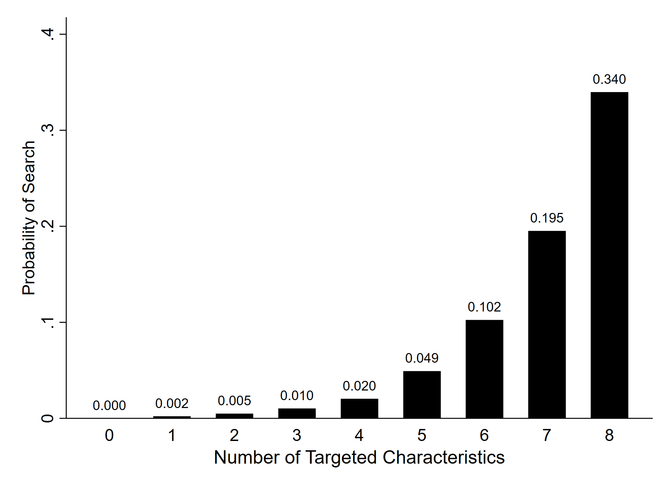
Note: See Table 3 for the list of “Targeted Characteristics.” The figure shows the probability of search for drivers with the indicated number of such characteristics, as in Table 4.

References
Balko, Radley. 2014. Rise of the Warrior Cop: The Militarization of America’s Police Forces. New York: Public Affairs.
Baumgartner, Frank R., Derek A. Epp, and Kelsey Shoub. 2018. Suspect Citizens: What 20 Million Traffic Stops Tell Us About Policing and Race. New York: Cambridge University Press.
Brown, Robert A. and James Frank. 2005. Police-Citizen Encounters and Field Citations: Do Encounter Characteristics Influence Ticketing? Policing: An International Journal of Police Strategies & Management 28, 3:435-454.
Brown, Robert A. and James Frank. 2006. Race and Officer Decision Making: Examining Differences in Arrest Outcomes between Black and White Officers. Justice Quarterly 23, 1:91-121
Brown, Robert A., Novak, Kenneth J., Frank, James. 2009. Identifying variation in police officer behavior between juveniles and adults. Journal of Criminal Justice 37: 200-208.
Close, Billy R. and Mason, Patrick L. 2006a. Searching for Efficient Enforcement: Officer Characteristics and Racially Biased Policing. Review of Law and Economics 3, 2: 263-321.
Close, Billy R. and Mason, Patrick L. 2006b. After the Traffic Stops: Officer Characteristics and Enforcement Action. Topics in Economic Analysis & Policy 6, 1: 1-41.
Collins, Patricia Hill, and Sirma Bilge. 2016. Intersectionality. Malden, MA: Polity Books.
Epp, Charles R., Steven Maynard-Moody, and Donald Haider-Markel. 2014. Pulled Over: How Police Stops Define Race and Citizenship. Chicago: University of Chicago Press.
Epp, Charles R., Steven Maynard-Moody, and Donald Haider-Markel. 2016. Beyond Profiling: The Institutional Sources of Racial Disparities in Policing. Public Administration Review 77, 2: 168–178.
Gibson, James L., and Michael J. Nelson. 2018. Black and Blue: How African Americans Judge the U.S. Legal System. New York: Oxford University Press.
Glaser, Jack. 2006. The Efficacy and Effect of Racial Profiling: A Mathematical Simulation Approach. Journal of Policy Analysis and Management 25, 2: 395–416.
Glaser, Jack. 2015. Suspect Race: Causes and Consequences of Racial Profiling. New York: Oxford University Press.
Hong, Sounman. 2017. Black in Blue: Racial Profiling and Representative Bureaucracy in Policing Revisited. Journal of Public Administration Research and Theory 27: 547–561
Kanter, Rosabeth. 1977. Some Effects of Proportions on Group Life: Skewed Sex Ratios and Responses to Token Women. American Journal of Sociology 82, 5: 965-990.
Klahm, Charles, and Rob Tillyer. 2015. Rethinking the Measurement of Officer Experience and Its Role in Traffic Stop Searches. Police Quarterly 18, 4: 343-367.
Lundman, Richard. 2009. Officer gender and traffic ticket decisions: Police blue or women too? Journal of Criminal Justice 37, 342-352.
McElvain, James P., and Augustine J. Kposowa. 2004. Police officer characteristics and internal affairs investigations for use of force allegations. Journal of Criminal Justice 32, 3: 265-279.
Meares, Tracey L., Tom R. Tyler, and Jacob Gardener. 2016. Lawful or Fair? How Cops and Laypeople perceive Good Policing. Journal of Criminal Law and Criminology 105, 2: 297–344.
Morin, Rich, Kim Parker, Renee Stepler and Andrew Mercer. 2017. Behind the Badge. Washington, DC: Pew Research Center.11 January.
Moskos, Peter C. 2008. Two Shades of Blue: Black and White in the Blue Brotherhood. Law Enforcement Executive Forum 8, 5: 57–86.
Ott, E. Marlies. 1989. Effects of the Male-Female Ratio at Work: Policewomen and Male Nurses. Psychology of Women Quarterly 13, 1: 41-57.
Rahr, Sue and Stephen K. Rice. 2015. From Warriors to Guardians: Recommitting American Police Culture to Democratic Ideals. New Perspectives in Policing Bulletin. Washington, D.C.: U.S. Department of Justice, National Institute of Justice. NCJ 248654.
Rojek, Jeff, Richard Rosenfeld, and Scott Decker. 2012. Policing Race: The Racial Stratification of Searches in Police Traffic Stops. Criminology 50, 4, 993-1024.
Rosenfeld, Richard, Jeff Rojek, and Scott Decker. 2012. Age Matters. Journal of Research in Crime and Delinquency 49, 1: 31-55.
Rowe, Mike. 2012. Policing, race and racism. New York: Routledge.
Sunshine, Jason, and Tom R. Tyler. 2013. The Role of Procedural Justice and Legitimacy in Shaping Public Support for Policing. Law and Society Review 37, 3: 513-548.
Tillyer, Rob, and Robin S. Engel. 2013. The Impact of Drivers’ Race, Gender, and Age during Traffic Stops: Assessing Interaction Terms and the Social Conditioning Model. Crime and Delinquency 59, 3: 369-395.
Tillyer, Rob, Charles F. Klahm IV, and Robin S. Engel. 2012. The Discretion to Search: A Multilevel Examination of Driver Demographics and Officer Characteristics Journal of Contemporary Justice 28, 2: 184-205.
Van Maanen, John. 1975. Police Socialization: A Longitudinal Examination of Job Attitudes in an Urban Police Department. Administrative Science Quarterly 20, 2: 207-228.
Vitale, Alex S. 2018. The End of Policing. London: Verso.
Washington Post. 2018. Fatal Force. Interactive database available at: https://www.washingtonpost.com/graphics/2018/national/police-shootings-2018/?utm_term=.1feb22d958aa, last accessed October 22, 2018.
Wilkins, Vicky M. and Bryan N. Williams. 2008. Black or Blue: Racial Profiling and Representative Bureaucracy. Public Administration Review. 68, 4: 654-664.
Wilkins, Vicky M. and Bryan N. Williams. 2009. Representing Blue: Representative Bureaucracy and Racial Profiling in the Latino community. Administration and Society. 40, 8: 775-798.
Woods, Solomon. 2014. Does the Race of Police Officers Matter? Police Officers on Interactions with Citizens and Police Procedures. PhD diss., University of Kansas.
Yoder, Janice. 1991. Rethinking Tokenism: Looking Beyond Numbers. Gender and Society 5, 2: 178-192.

http://clt-charlotte.opendata.arcgis.com/datasets/c458bca429b542bbb31130c23510628a_7, downloaded September 18, 2018
The North Carolina data collection law specifies, ten types of traffic stops, or “stop purposes.” We define “traffic safety” stops as any of these: driving while impaired, safe movement, speeding, stop light / stop sign. All other stop types are referred to as “investigatory.” These include: checkpoint, investigation, other, seat belt, equipment, and regulatory. Almost 40 percent of Charlotte traffic stops are regulatory; 26 percent speeding; 11 percent equipment; 10 percent stop light / sign; and the remaining types have fewer than five percent each. Checkpoints and DWI stops are less than 0.5 percent of the stops.

